Name

Mathematics Stage 5 Core
Gradient-intercept
Form

Book 1 | Examine the gradient-intercept form  Find the equations of parallel and perpendicular lines | Version: 260422  Feedback:  https://MrDingMaths.com
Contents
Syllabus Content 2
Gradient-Intercept Form 3
Rearranging to Gradient-Intercept Form 8
Sketching Lines from the Equation without a Table 12
Finding the Equation of a Line from the Graph 19
Special Lines 30
Interpreting Linear Models 34
Constructing Linear Models 44
Parallel and Perpendicular Gradients 50
Finding Parallel and Perpendicular Lines 53

Syllabus Content
MA5-LIN-C-02 graphs and interprets linear relationships using the gradient/slope-intercept form
Examine the gradient-intercept form
- Interpret the coefficient of $x$($m$) as the gradient/slope, and the constant ($c$) as the $y$-intercept for equations of the form $y=mx+c$
- Find the equation of a straight line in the form $y=mx+c$, given the gradient/slope and the $y$-intercept of the line
- Graph equations of the form $y=mx+c$ by using the gradient and the $y$-intercept
- Determine the gradient and $y$-intercept of a straight line from its graph and apply these values to determine the equation of the line
- Explain the effect of increasing or decreasing the gradient with or without digital tools
- Recognise and describe linear relationships in real-life contexts
Find the equations of parallel and perpendicular lines
- Explain that 2 straight lines are perpendicular if the product of their gradients is −1
- Find the equation of a straight line that is parallel or perpendicular to another given line by applying $y=mx+c$

Gradient-Intercept Form

- Gradient-Intercept Form
Every linear relationship has this equation:
$$y=mx+c$$

coefficient of $x$ constant term
gradient $y$-intercept

- Determine gradient and $y$-intercept from an equation
$$y=2x+7$$  Gradient: 2  $y$-intercept: $\left(0,7\right)$ | $$y=2x-7$$  Gradient: 2  $y$-intercept: $\left(0,-7\right)$ | $$y=\frac{2x}{5}-7$$  Gradient: $\frac{2}{5}$  $y$-intercept: $\left(0,-7\right)$
Determine the gradient and $y$-intercept of these lines.
- $y=3x+2$ | - $y=3x-2$ | - $y=-3x+2$
- $y=2-3x$ | - $y=$ $\frac{5x}{4}$ $-1$ | - $y=7x$

- Determine equation of a line, given the gradient and $y$-intercept
Find the equation of a line with:
gradient 3 and $y$-intercept $(0,4)$.  $$y=3x+4$$ | gradient 3 and $y$-intercept $(0,-4)$.  $$y=3x-4$$ | gradient $-\frac{1}{2}$ and $y$-intercept $(0,0)$.  $$y=-\frac{x}{2}$$
Find the equation of a line with:
- gradient 3 and  $y$-intercept $(0,4)$. | - Gradient is $-2$ and  $y$-intercept is $\left(0,3\right)$ | - $y$-intercept is $(0,-1)$ and gradient is $5$
- $y$-intercept is $\left(0,2\right)$ and gradient is $\frac{2}{3}$ | - Gradient is 1 and  $y$-intercept is $\left(0,-4\right)$ | - $y$-intercept is $\left(0,-9\right)$ and gradient is $-\frac{5}{6}$

- Key Ideas
- Every straight-line graph has the equation ……………………………
- $m$ is the ………………… of the line, $c$ is the ………………… of the line.

Foundation
- Determine $m$ and $c$ of these lines.
- $y=4x+6$ $m=$ $c=$  4, 6 | - $y=-x-1$ $m=$ $c=$  $$-1, -1$$
- $y=6+4x$ $m=$ $c=$  4, 6 | - $y=$ $\frac{3}{4}$ $x-8$ $m=$ $c=$  $$\frac{3}{4}, -8$$
- $y=-4x+6$ $m=$ $c=$  $-4$, 6 | - $y=$ $\frac{3x}{4}$ $-8$ $m=$ $c=$  $$\frac{3}{4}, -8$$
- $y=-4x-6$ $m=$ $c=$  $$-4, -6$$ | - $y=-$ $\frac{3x+9}{8}$ $m=$ $c=$  $$-\frac{3}{8}, -\frac{9}{8}$$
- $y=-6-4x$ $m=$ $c=$  $$-4, -6$$ | - $y=$ $\frac{x+5}{6}$ $m=$ $c=$  $$\frac{1}{6},\frac{5}{6}$$
- $y=-4x$ $m=$ $c=$  $$-4, 0$$ | - $y=5.3x+6.5$ $m=$ $c=$  $$5.3, 6.5$$
- $y=x$ $m=$ $c=$  $$1, 0$$ | - $y=$ $\frac{3}{4}$ $x-$ $\frac{8}{3}$ $m=$ $c=$  $$\frac{3}{4}, -\frac{8}{3}$$

- For each line, state the gradient and the coordinates of the $y$-intercept.
- $y=3x+5$  $$m=3, \left(0,5\right)$$ | - $y=7-2x$  $$m=-2, \left(0,7\right)$$ | - $y=0.5-4x$  $$m=-4, \left(0,0.5\right)$$
- $y=19+3x$  $$m=3, \left(0,19\right)$$ | - $y=11+\frac{3}{5}x$  $$m=\frac{3}{5}, \left(0,11\right)$$ | - $y=54-\frac{2x}{3}$  $$m=-\frac{2}{3}, \left(0,54\right)$$
- $7-11x=y$  $$m=-11, \left(0,7\right)$$ | - $-100-134x=y$  $$m=-134, \left(0,-100\right)$$

- Write the equations of the lines with these gradients and $y$-intercepts.
- Gradient 7 and $y$-intercept $\left(0,2\right)$  $$y=7x+2$$ | - $y$-intercept $(0,-9)$ and gradient 4  $$y=4x-9$$
- Gradient $-5$ and $y$-intercept $(0,0)$  $$y=-5x$$ | - $y$-intercept $(0,11)$ and gradient $-1$  $$y=-x+11$$
- Gradient $-0.65$ and $y$-intercept $(0,-1.2)$  $$y=-0.65x-1.2$$ | - $y$-intercept $\left(0,\frac{7}{12}\right)$ and gradient $\frac{5}{6}$  $$y=\frac{5x}{6}+\frac{7}{12}$$

Development
- Consider these four graphs:
$$y=-4x$$ | $$y=-5x$$ | $$y=4-x$$ | $$y=5-x$$
  - Which two graphs have the same gradient?
$$y=4-x, y=5-x$$
  - Which two graphs have same $y$-intercept?
$$y=-4x, y=-5x$$
  - What do all four graphs have in common?
Negative gradient

- Consider these four graphs:
$$y=3x+1$$ | $$y=4+3x$$ | $$y=3x-1$$ | $$y=3x-5$$
  - Which two graphs have a $y$-intercept above the $x$-axis?
$$y=3x+1, y=4+3x$$
  - Which two graphs have a $y$-intercept below the $x$-axis?
$$y=3x-1, y=3x-5$$
  - What do all four graphs have in common?
Same gradient of 3

- Consider these four graphs:
$$y=5x+4$$ | $$y=-2x+4$$ | $$y=3x+4$$ | $$y=4-5x$$
  - Which two graphs slope downwards from left to right? (i.e, decreasing)
$$y=-2x+4, y=4-5x$$
  - Which two graphs slope upwards from left to right? (i.e., increasing)
$$y=5x+4, y=3x+4$$
  - What do all four graphs have in common?
Same $y$-intercept of 4

- Consider the equation $y=56-14x$
- Find the value of $y$ when $x=-3$  $$y=98$$ | - Factorise the right-hand side of the equation.  $$y=14\left(4-x\right)$$
- Solve the equation for $y=50.5$  $$x=\frac{11}{28}$$ | - Write down the gradient and $y$-intercept of the line.  $$m=-14, \left(0,56\right)$$

Mastery
- Parallel lines have the same gradient. Decide whether each pair of lines will be parallel.
Not parallel | 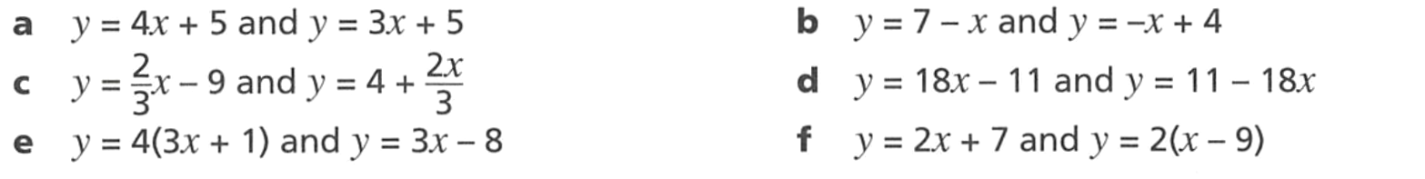  Parallel
Parallel | Not parallel
Not parallel | Parallel

- Decide whether each pair of lines will have the same $y$-intercept.
Yes | No
No | No
No | No

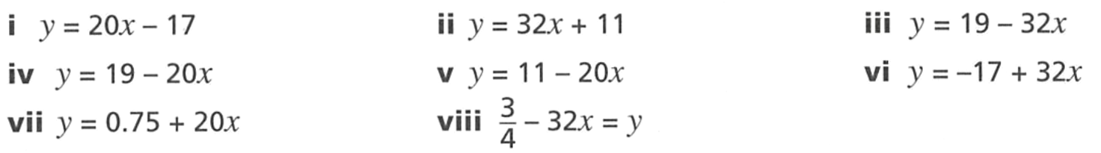
- Here are the equations for eight lines,

  - Identify four pairs of parallel lines.

i and vii
ii and vi
iii and viii
iv and v
  - Identify four pairs of lines that have the same $y$-intercept.

i and vi
ii and v
iii and iv
vii and viii

Rearranging to Gradient-Intercept Form

- Example Identify gradient and y-intercept after rearranging the equation
Rearrange the equation, then identify the gradient and $y$-intercept.
$y-7=2x$  $y=2x+7$  Gradient: 2  $y$-intercept: 7 | $3y+15-2x=0$  $3y=2x-15$  $y=$ $\frac{2x}{3}$ $-$ $\frac{15}{3}$  Gradient: $\frac{2}{3}$  $y$-intercept: $-5$

- Guided Practice
Rearrange the equation, then identify the gradient and $y$-intercept.
- $y+2x=5$  $$m=-2, c=5$$ | - $x-y=7$  $$m=1, c=-7$$
- $4x+2y=1$  $$m=-2, c=0.5$$ | - $-2x-5y=3$  $$m=-\frac{2}{5}, c=-\frac{3}{5}$$

Foundation
- Write each of these equations in the form $y=mx+c$
$$y = 2x - 9$$ | $$y = 8x + 11$$ | $$y = -x + 1$$ | $$y = 3x + 11$$
$$y = 4x - 12$$ | $$y = 10x +\frac{1}{2}$$ | $$y = 5x + 1$$ | $$y = 11x - 7$$

- Identify the gradient of each of these lines.
3 | 6 | $$-11$$ | $$-2$$
1 | $$-\frac{1}{2}$$ | $$-1$$ | 4

- Identify the $y$-intercept in each of these lines.
0 | 4 | 3 | 7
1 | 17 | $$\frac{5}{2}$$ | $$\frac{55}{2}$$

Development
- Write each of these equations in the form $y=mx+c$.
$$y = 9x + 10$$ | $$y = 2x + 7$$ | 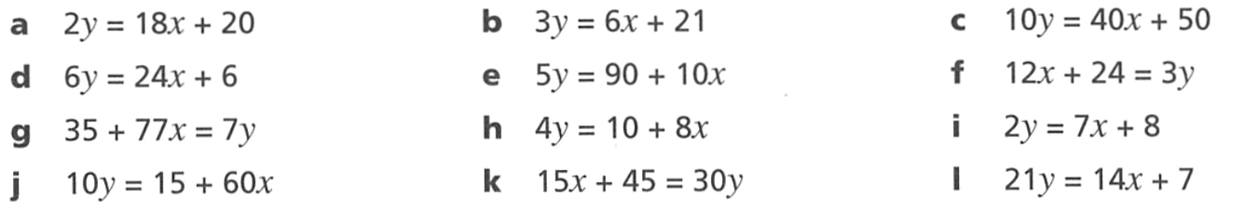  $$y = 4x + 5$$
$$y = 4x + 1$$ | $$y = 2x + 18$$ | $$y = 4x + 8$$
$$y = 11x + 5$$ | $$y = 2x +\frac{5}{2}$$ | $$y =\frac{7x + 8}{2}$$
$$y = 6x +\frac{3}{2}$$ | $$y =\frac{x+3}{2}$$ | $$y=\frac{2x + 1}{3}$$

- Determine the gradient and $y$-intercept of these equations.
You will need to rearrange any equations not in the form $y=mx+c$.
- $y=x+7$ $m=$ $c=$  $$m=1, c=7$$  - $y-x=7$ $m=$ $c=$  $$m=1, c=7$$  - $y-\frac{x}{2}=7$ $m=$ $c=$  $$m=\frac{1}{2}, c=7$$  - $2y-\frac{x}{2}=7$ $m=$ $c=$  $$m=\frac{1}{4}, c=\frac{7}{2}$$  - $2y+\frac{x}{2}=7$ $m=$ $c=$  $$m=-\frac{1}{4}, c=\frac{7}{2}$$ | - $3y+\frac{x}{2}=7$ $m=$ $c=$  $$m=-\frac{1}{6}, c=\frac{7}{3}$$  - $3y-2x=7$ $m=$ $c=$  $$m=\frac{2}{3}, c=\frac{7}{3}$$  - $3x+2y=-4$ $m=$ $c=$  $$m=-\frac{3}{2}, c=-2$$  - $3x-2y=-4$ $m=$ $c=$  $$m=\frac{3}{2}. c=2$$

Mastery
- HSC Standard 2 Sample Question Band 3
What is the gradient of the line $2x+3y+4=0$?

$$-\frac{2}{3}$$
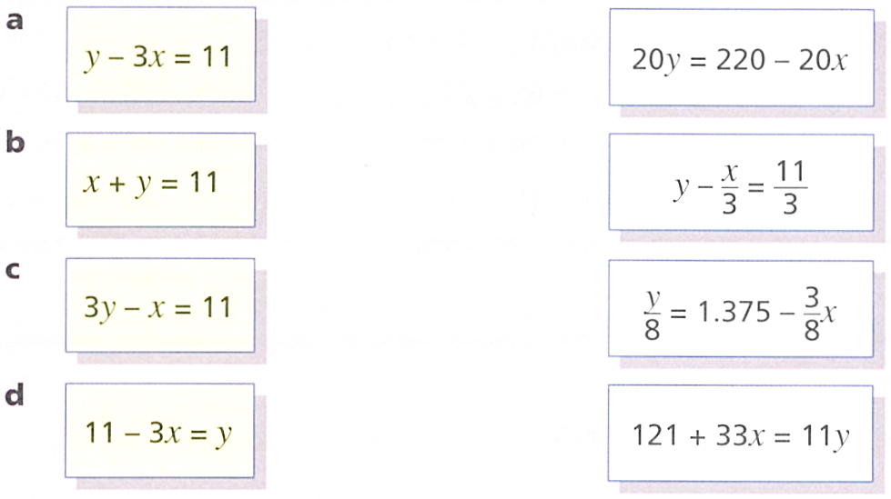
- Match the equations that represent the same straight lines.

$$20y=220-20x→B$$
$$y-\frac{x}{3}=\frac{11}{3}→C$$
$$\frac{y}{8}=1.375-\frac{3}{8}x→A$$
$$121+33x=11y→D$$
- A student has made the following mistakes when identifying the gradient and $y$-intercept. Determine the correct gradient and $y$-intercept.
- $y=$ $\frac{2x+1}{2}$ $m=2$  $$m=1$$ | - $y=0.5(x+3)$ $c=3$  $$m=0.5$$
- $3x+y=7$ $m=3$  $$m=-3$$ | - $x-2y=4$ $m=1$  $$m=\frac{1}{2}$$

Sketching Lines from the Equation without a Table

- Review
- Interpret the gradient
- $m=$ $\frac{3}{4}$  …… up for every 4 right | - $m=$ $\frac{5}{2}$  …… up for every …… …… | - $m=-$ $\frac{6}{5}$
- $m=2$ | - $m=-3$ | - $m=-$ $\frac{1}{2}$

- Plot the $y$-intercept on a graph
- $c=5$  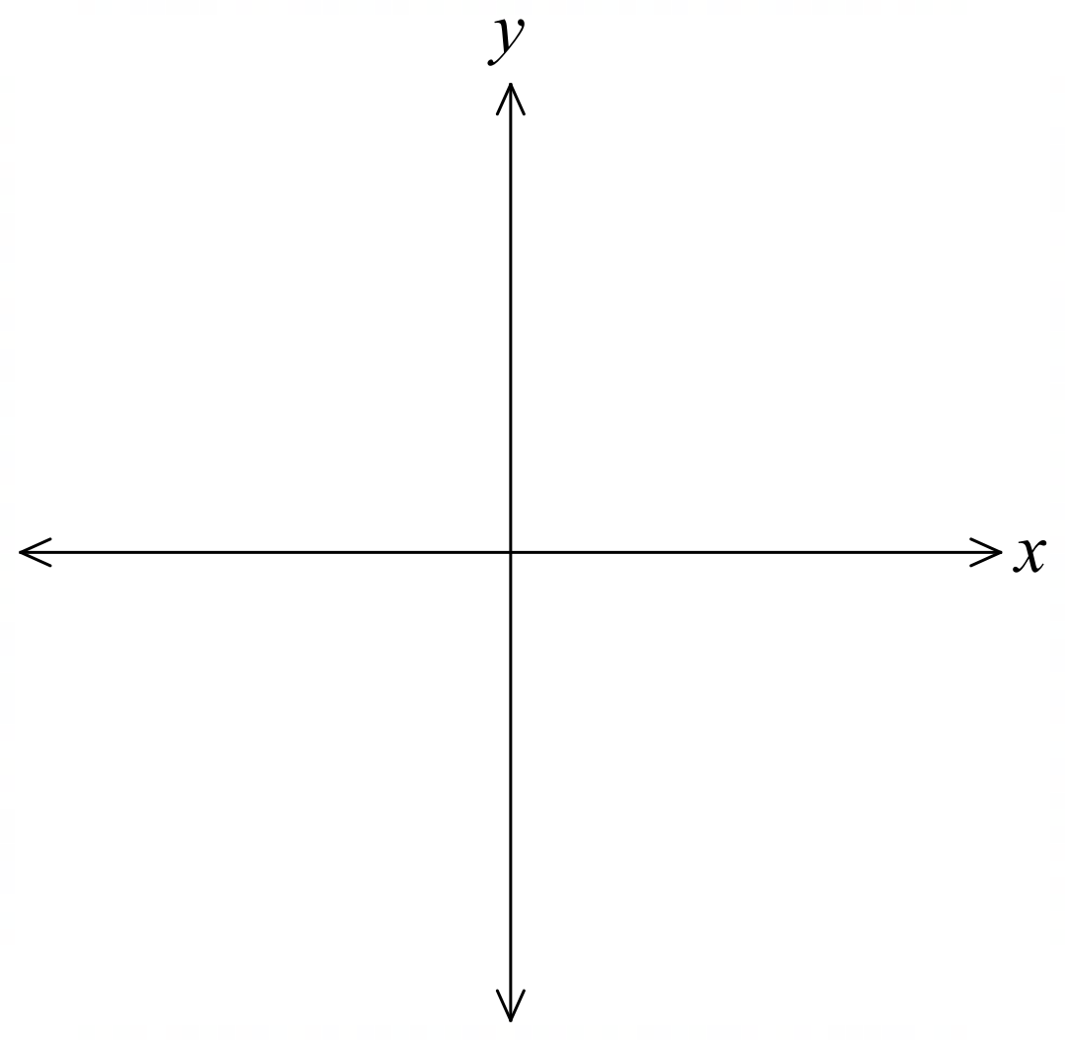 | - $c=-2$ | - $c=3.5$

- Identify gradient and $y$-intercept from the equation
- $y=-2x+1$ | - $y=\frac{x}{2}-4$ | - $y=\frac{3x}{4}-1$

- Sketching Lines without a Table
- Plot the $y$-intercept.
- Starting from the $y$-intercept, use the gradient to find another point.
  - The denominator is how much to move right (1 if the gradient is a whole number).
  - The numerator is how much to move up or down.
- Draw a straight line through both points and extend the line.

- Example Sketch lines from the equation using gradient and $y$-intercept
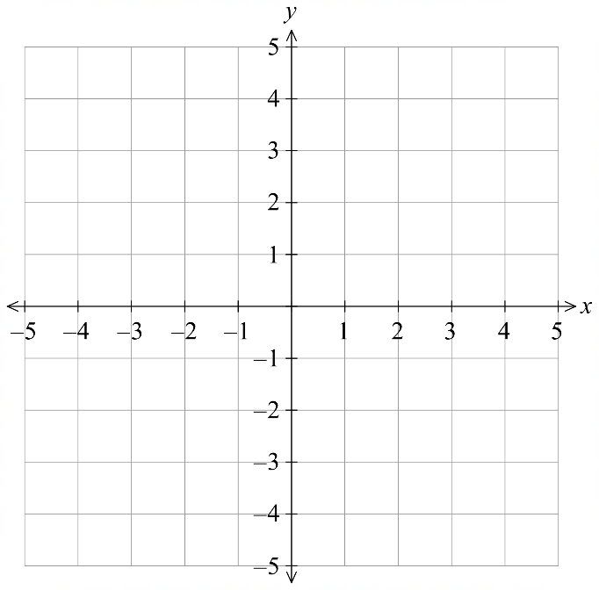
Sketch $y=3x-2$
1.
2.
1. Plot a point at $(0,-2)$

2. The gradient is 3. Starting at $(0,-2)$:
Move right 1 unit.
Move up 3 units.

3. Join the two points and extend the line.

- Guided Practice
- Sketch $y=-2x+1$  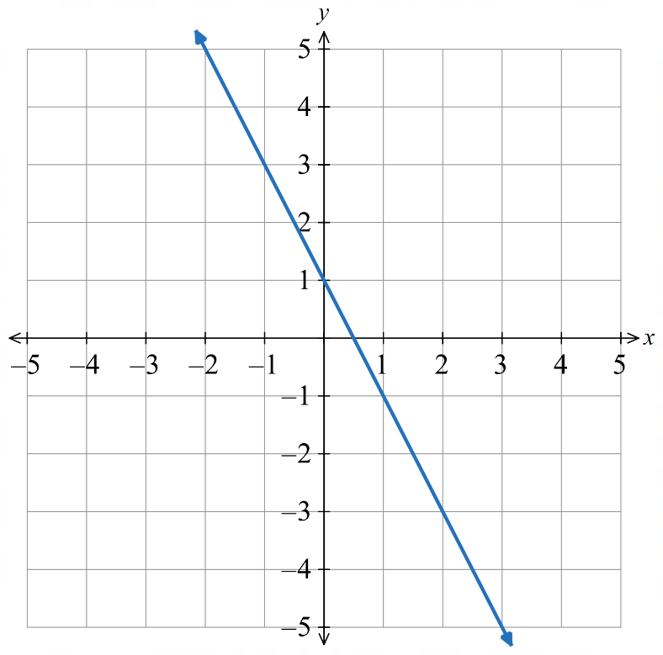 | - Sketch $y=\frac{3x}{4}-2$  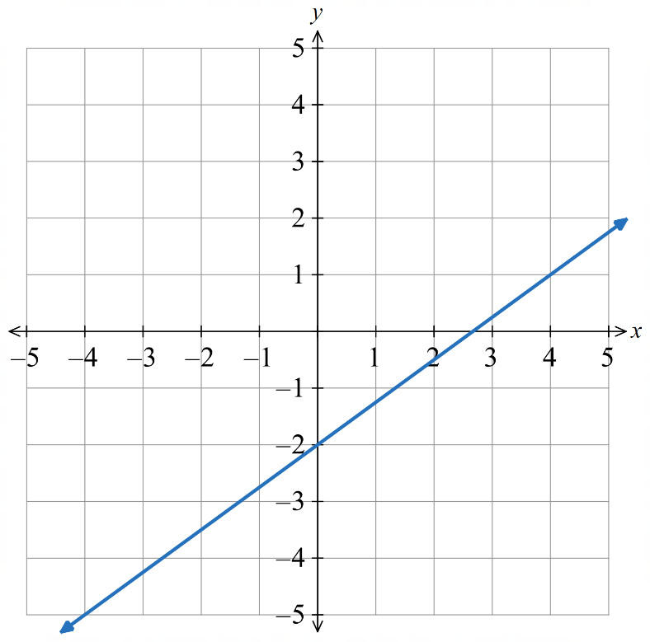

- Key Ideas
- To sketch a line from its equation, first plot the ……-………………………
- Then use the ………………… to find another point.
- Then ……………… the two points with a line.

Foundation
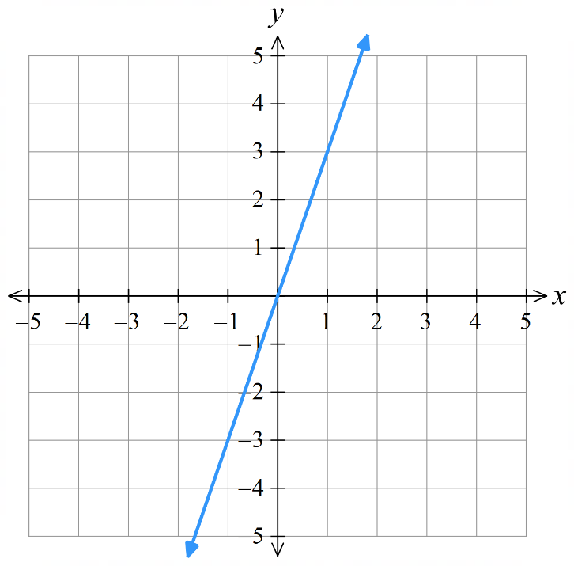
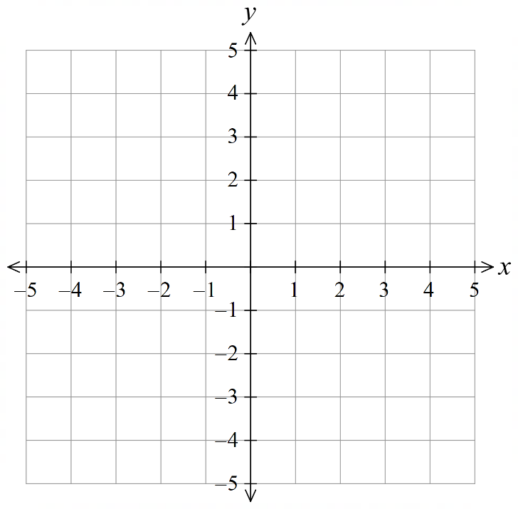
- Sketch these graphs without a table of values.
- $y=2x+1$  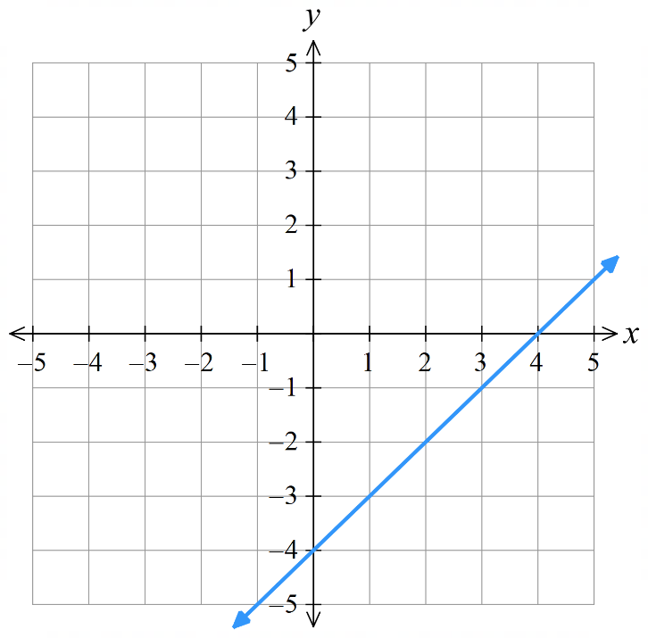  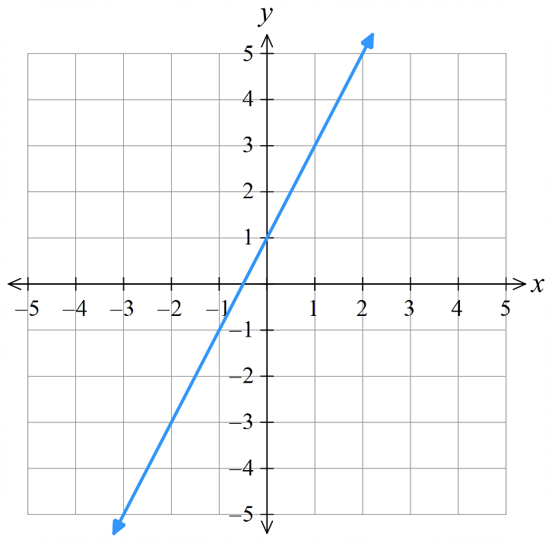 | - $y=x-4$ | - $y=3x$
- $y=4x-2$  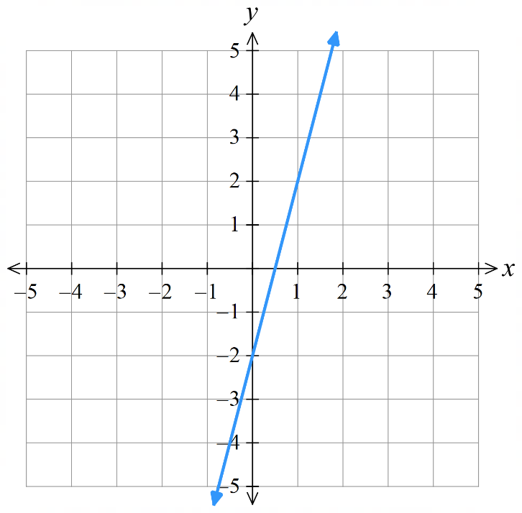  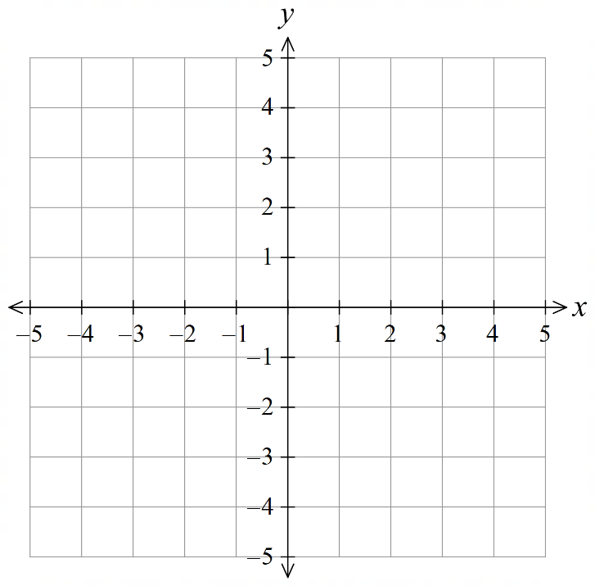 | - $y=-2x+1$  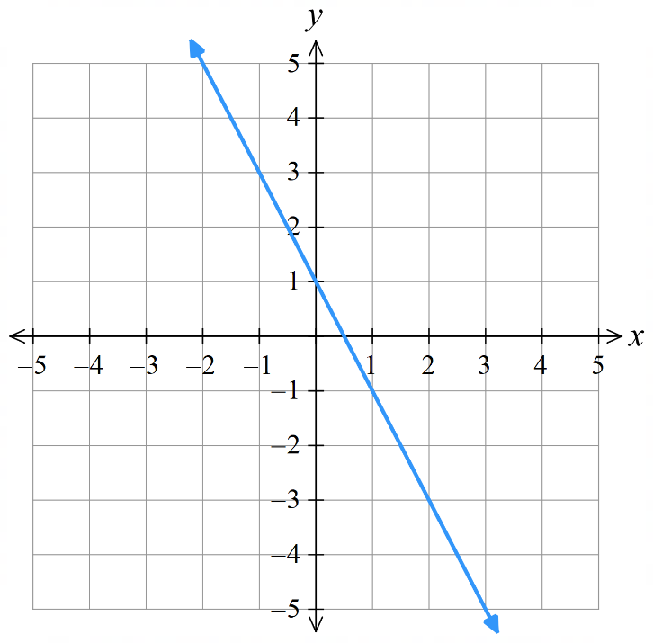 | - $y=\frac{1}{2}x+2$  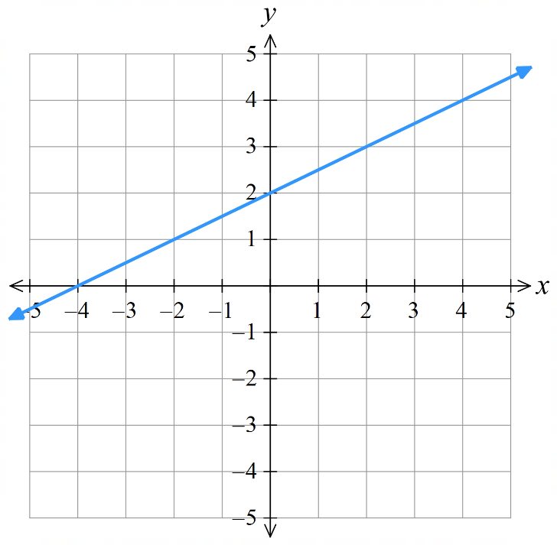
- $y=-\frac{1}{3}x-3$  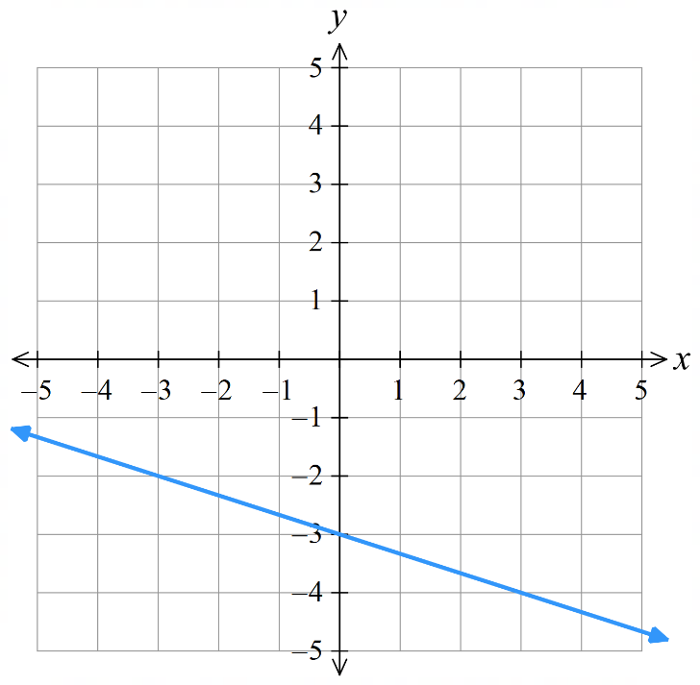 | - $y=\frac{4}{3}x-1$  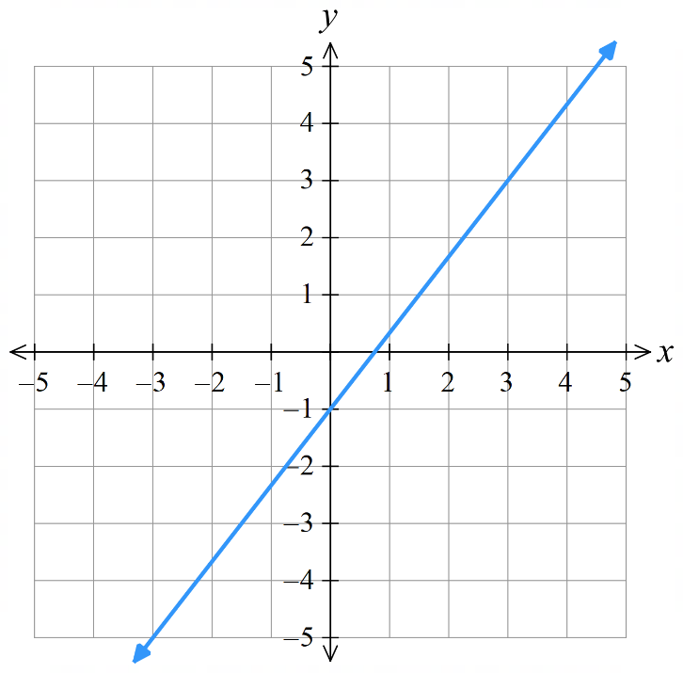 | - $y=-\frac{5}{2}x+2$  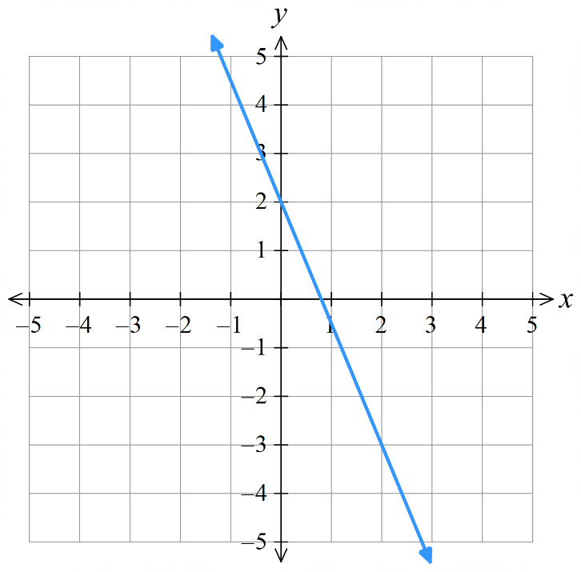

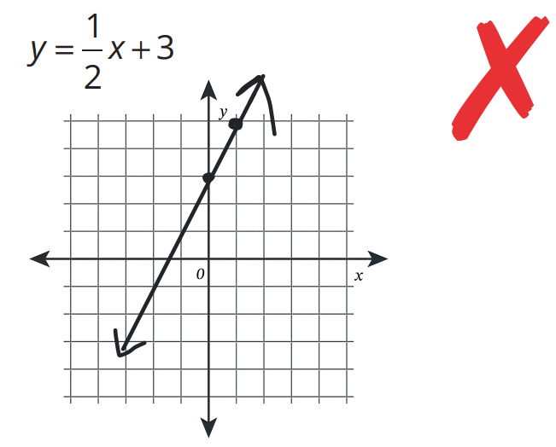  Mark graphed this equation: | Mark incorrectly graphed the equation.  What did he get wrong?  Gradient is 2, not $\frac{1}{2}$  How many times up and to the right from point (0, 3) should have Mark gone when graphing this slope? up ……… right ………  up 1 right 2  Draw the correct graph of $y=\frac{1}{2}x+3$ on the axis on the left.

  - At each point on the line $y=2x$, the ……-coordinate is two times the ………-coordinate.
The $y$-coordinate is two times the $x$-coordinate
  - Sketch the graph of $y=2x$ on the Cartesian plane below and label the line.
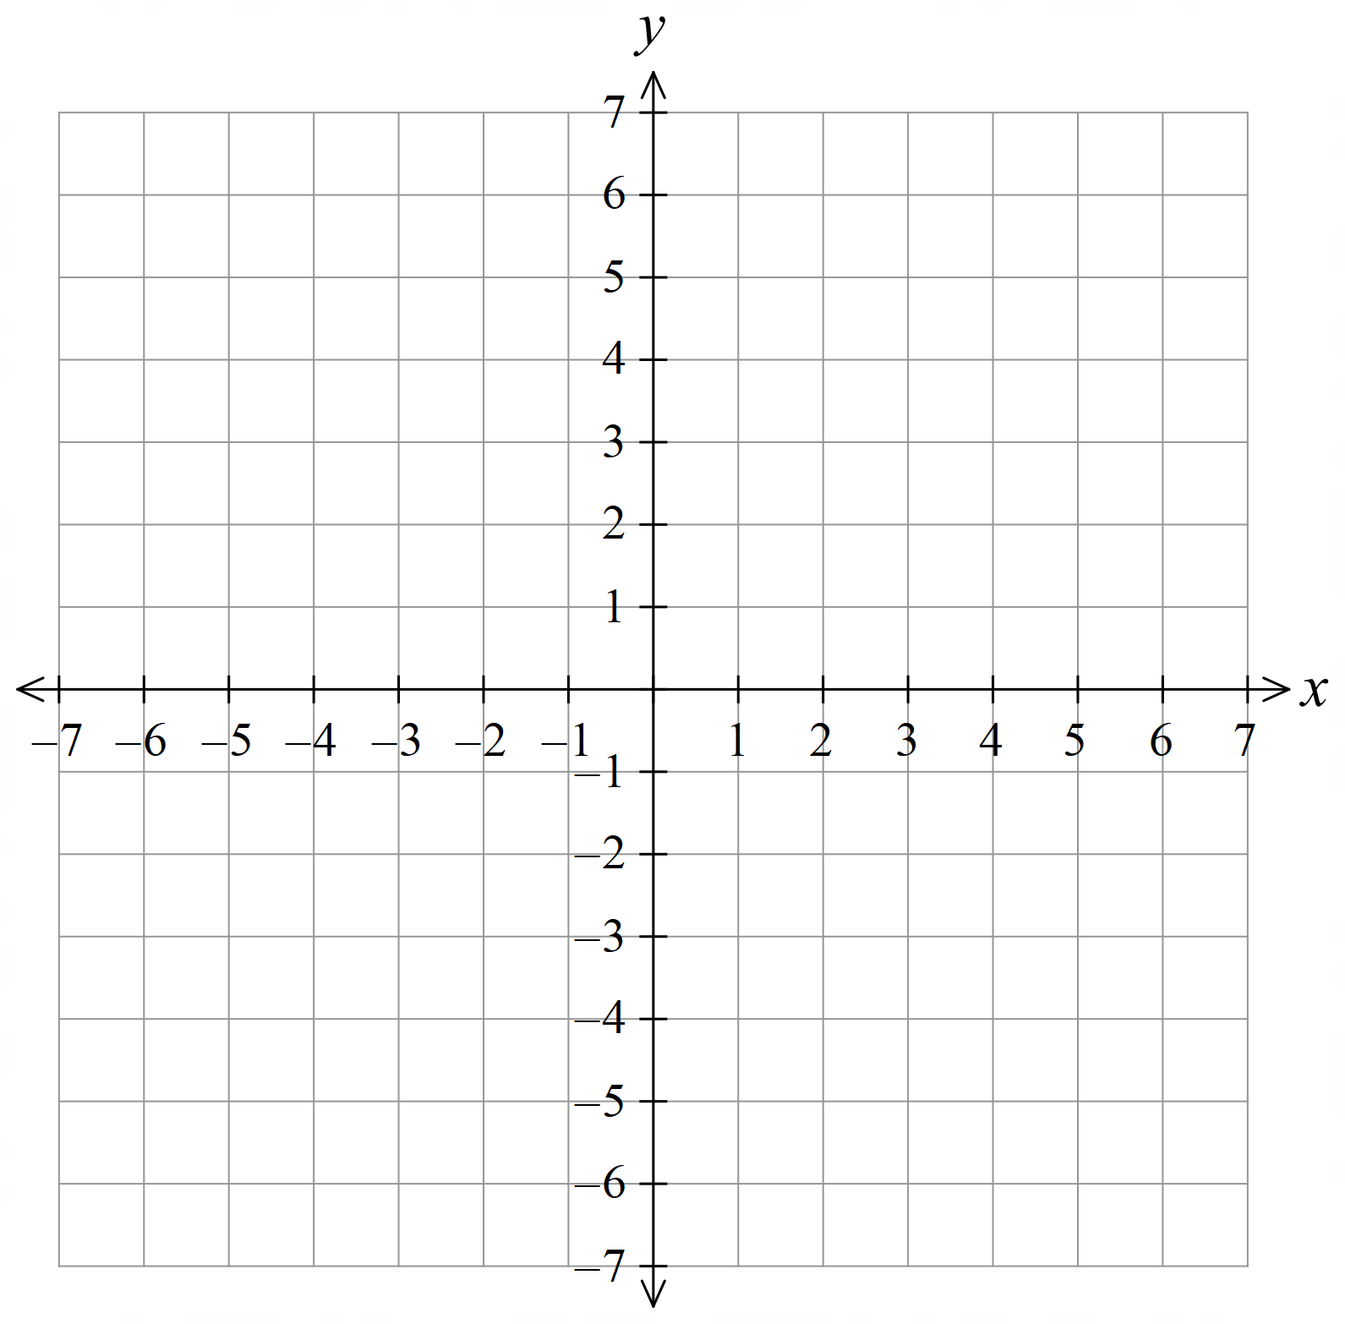
  - On the same axis, sketch and label:
    - $y=3x$
    - $y=5x$
    - $y=6x$
    - $y=\frac{1}{2}x$
    - $y=\frac{1}{4}x$

  - On a graph of the form $y=mx$, the number $m$ is the …………………… of the line.
gradient
The greater the value of $m$, the …………………… the line.
steeper
The lower the value of $m$, the …………………… the line.
Less steep

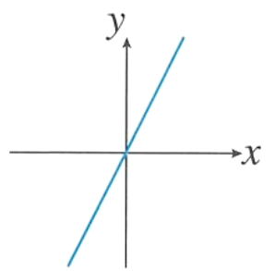
- Here is a sketch of $y=12x$. On the same axis, sketch $y=4x$ and $y=15x$.

$y=4x$ and $y=15x$ both pass through the origin since their $y$-intercept is 0.
$y=15x$ is steeper than $y=12x$
$y=4x$ is less steep than $y=12x$
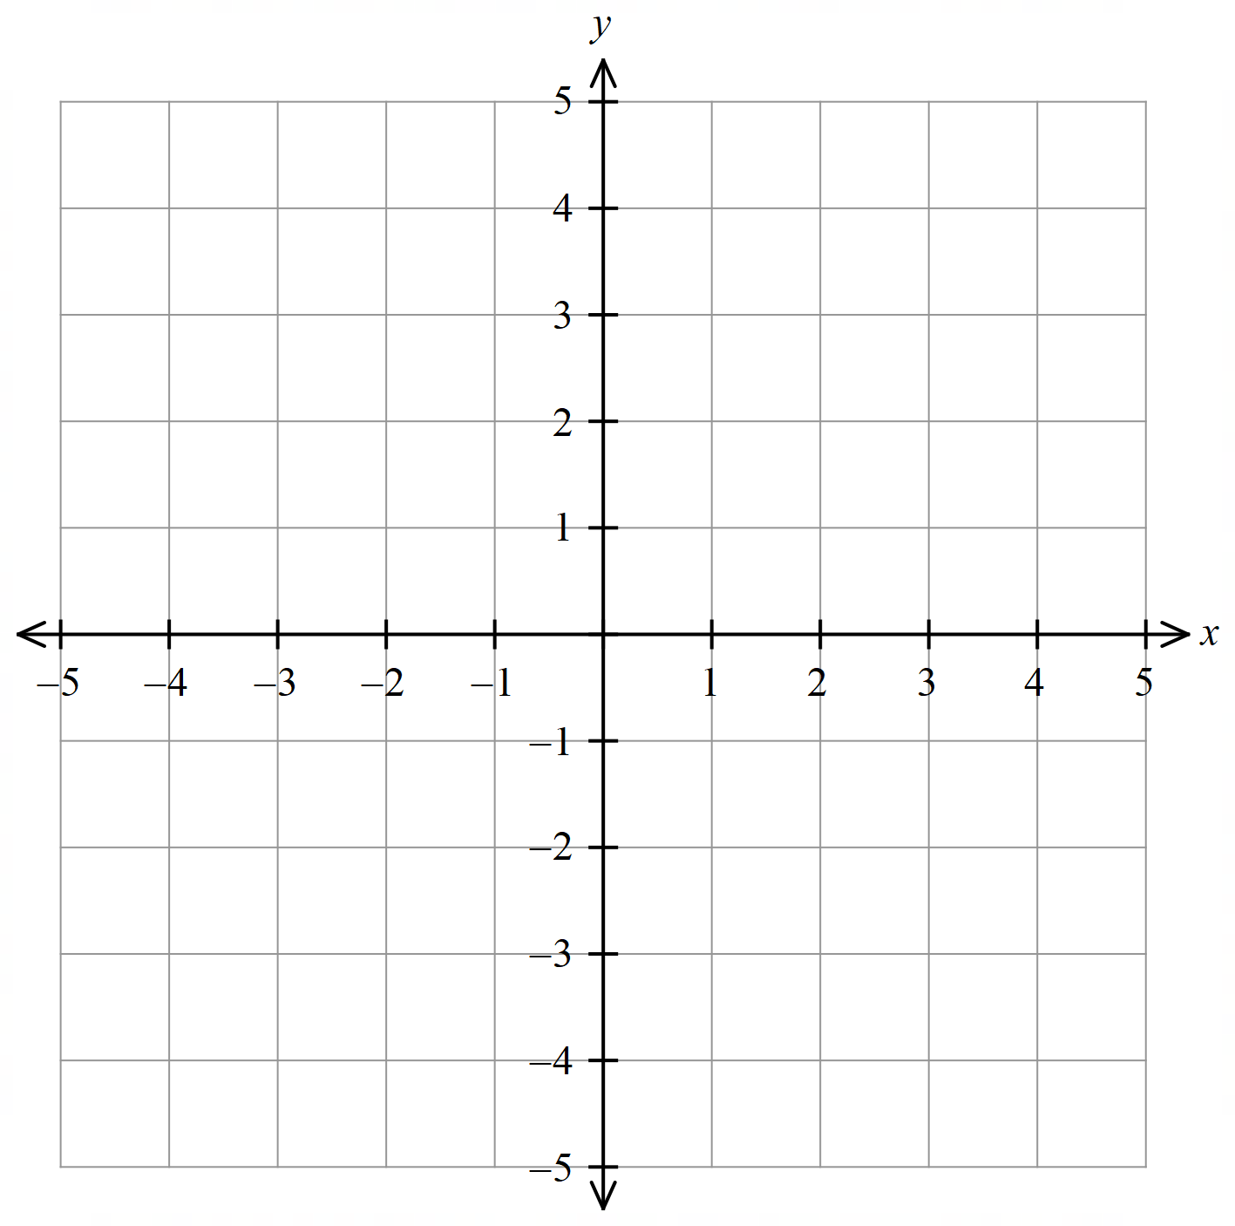
- On the same axis, sketch and label:
  - $y=x+1$
  - $y=x+2$
  - $y=x+3$
  - $y=x-1$
  - $y=x-2$
  - $y=x-3$

  - All of these graphs are parallel because …………………………………………………………
They have the same gradient, 1
  - On a graph of the form $y=x+c$, the number $c$ is the …………………… of the line.
$y$-intercept
If $c$ is ………………, the $y$-intercept is above the $x$-axis.
positive
If $c$ is negative, the $y$-intercept is ……………… the $x$-axis.
below
- Here is the graph of $y=x+a$.
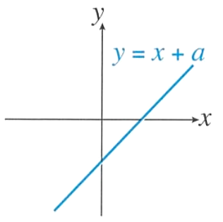
  - Explain why $a$ is negative.

$y$-intercept is below the $x$-axis.
  - If the value of $a$ is $-5$, On the same axis,
sketch $y=x+3$ and $y=x-12$
$y=x+3$ is parallel and above the original line, with $y$-intercept at 3
$y=x-12$ is parallel and below the original line, with $y$-intercept at $-12$
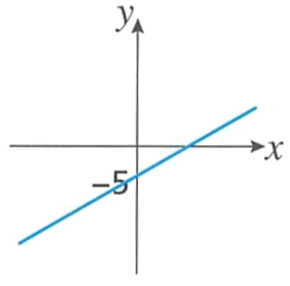
- Explain why this cannot be the graph of $y=7x+3$.

The equation has a $y$-intercept of $3$. On the graph, the $y$-intercept is $-5$.
- On the same axis, sketch and label:
  - $y=x$
  - $y=-x$
  - $y=2x$
  - $y=-2x$

What does a negative gradient mean?

The line slopes down from left to right.
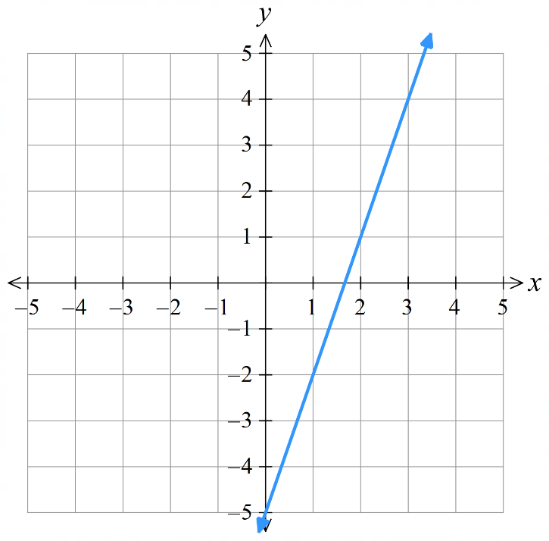
- Sketch these graphs without a table of values. (Rearrange to $y=mx+c)$
- $y-x=0$  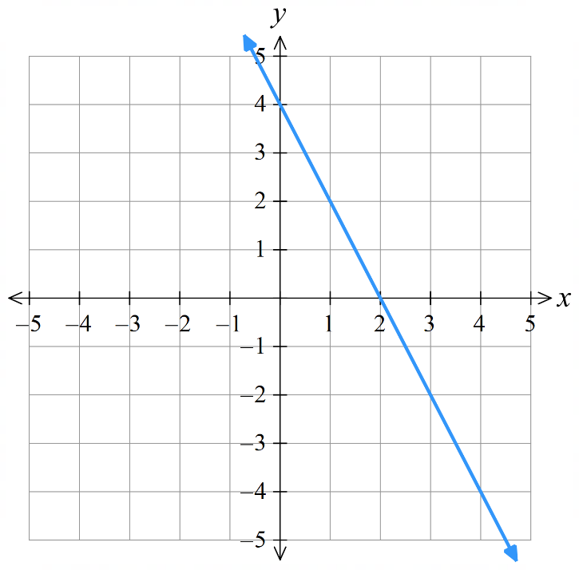  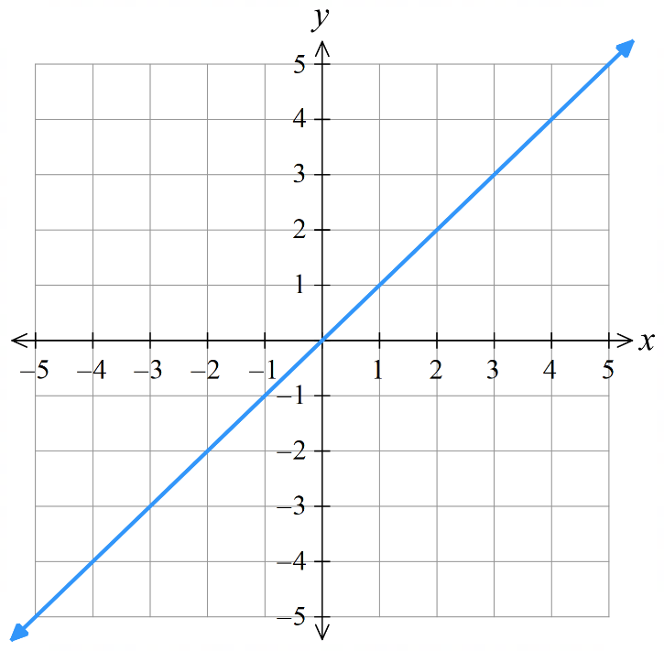 | - $4x+2y=8$ | - $6x-2y=10$
- $6y-4x=-8$  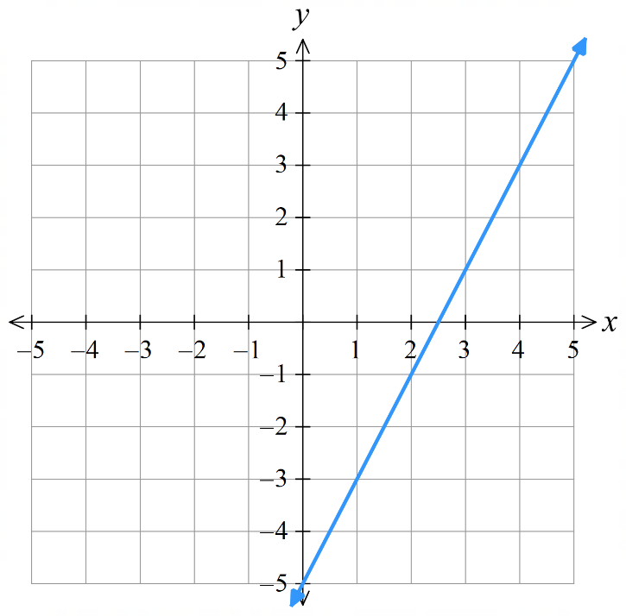  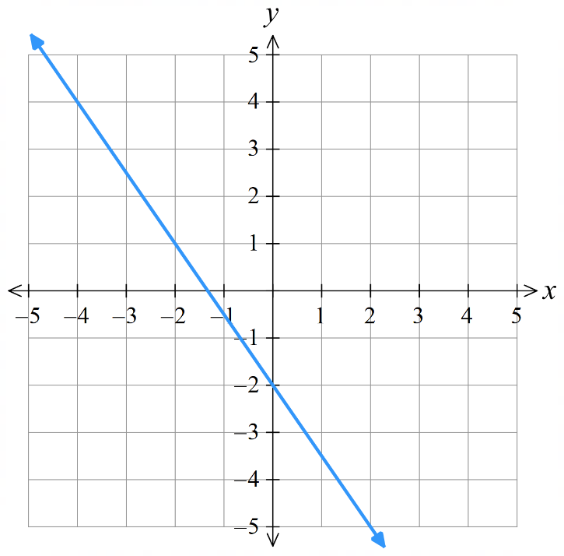  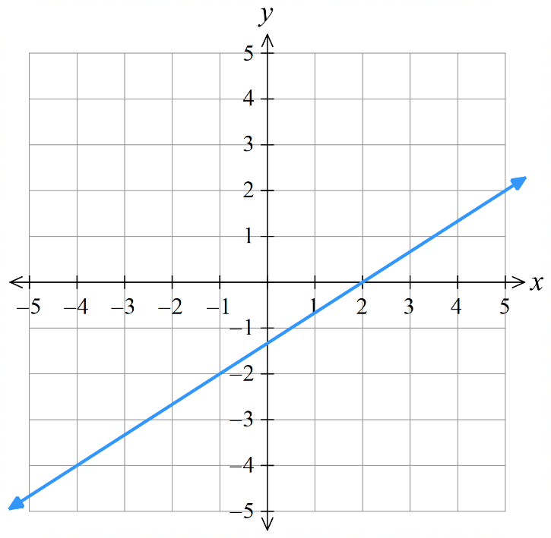 | - $3x+2y=-4$ | - $2x-y=5$

Development
- Sketch these graphs.
- $y=x+3$  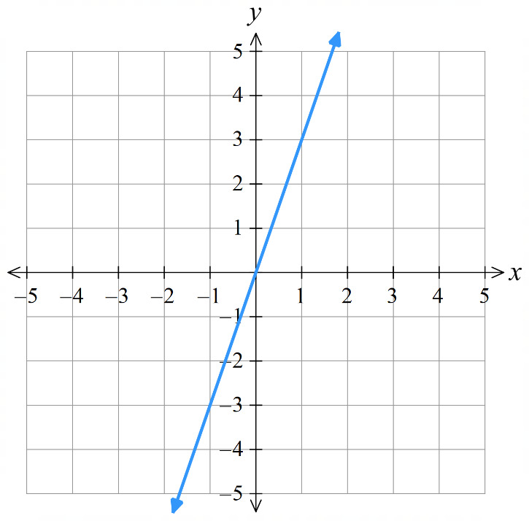  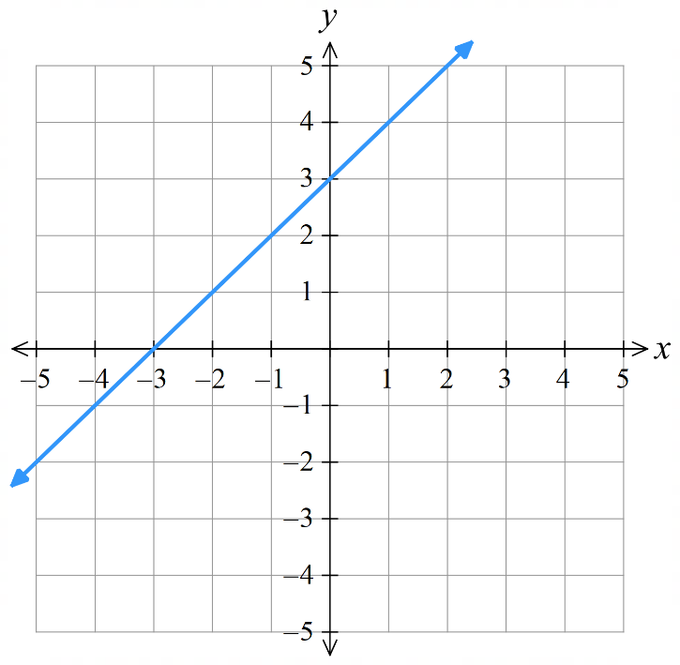  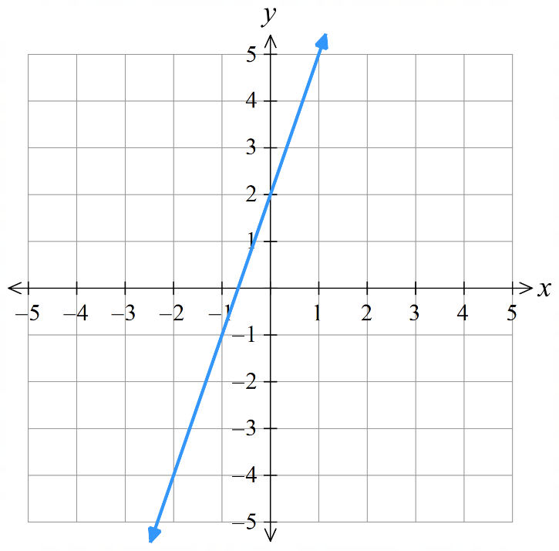 | - $y=3x$ | - $y=x-3$  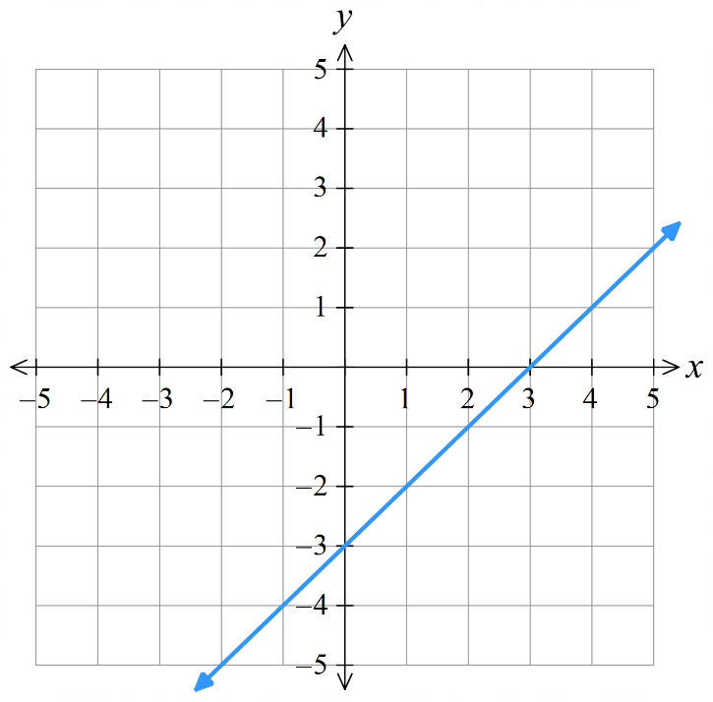
- $y=3-x$  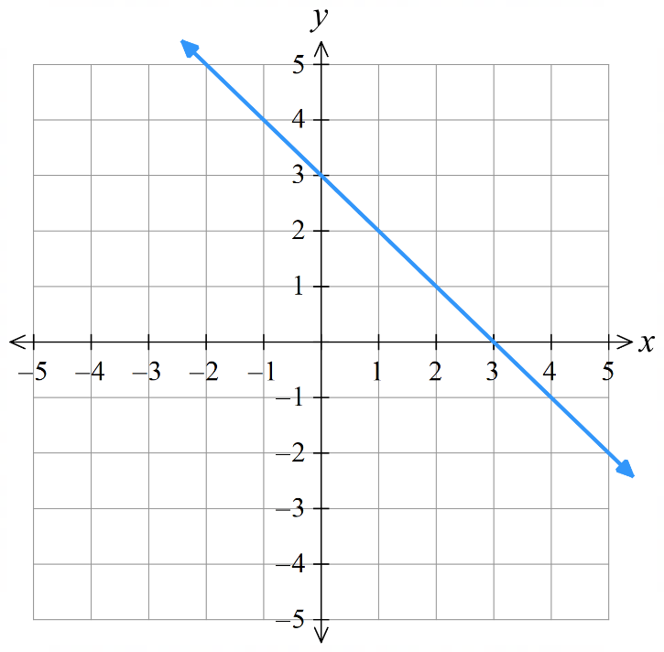 | - $y=3x+2$ | - $y=3+2x$  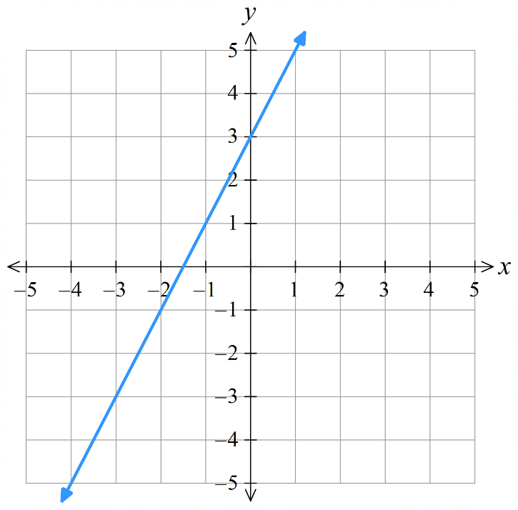
- $y=2\left(x+1\right)$  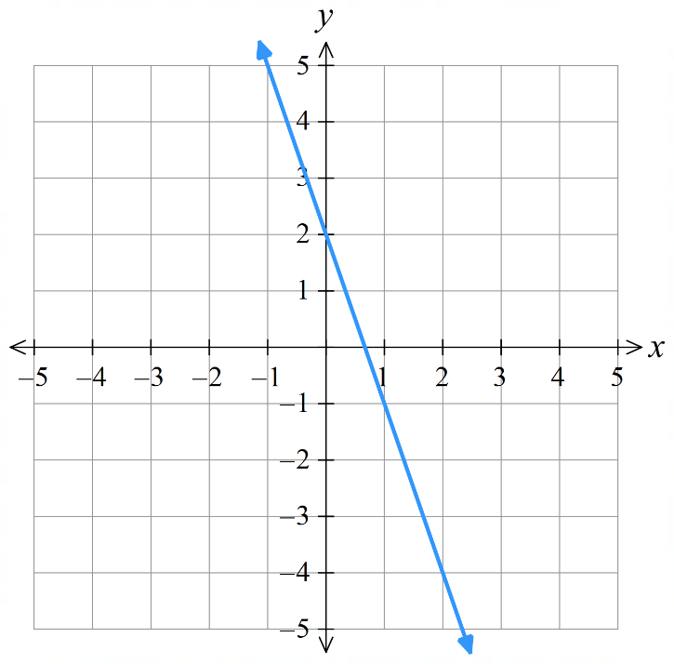  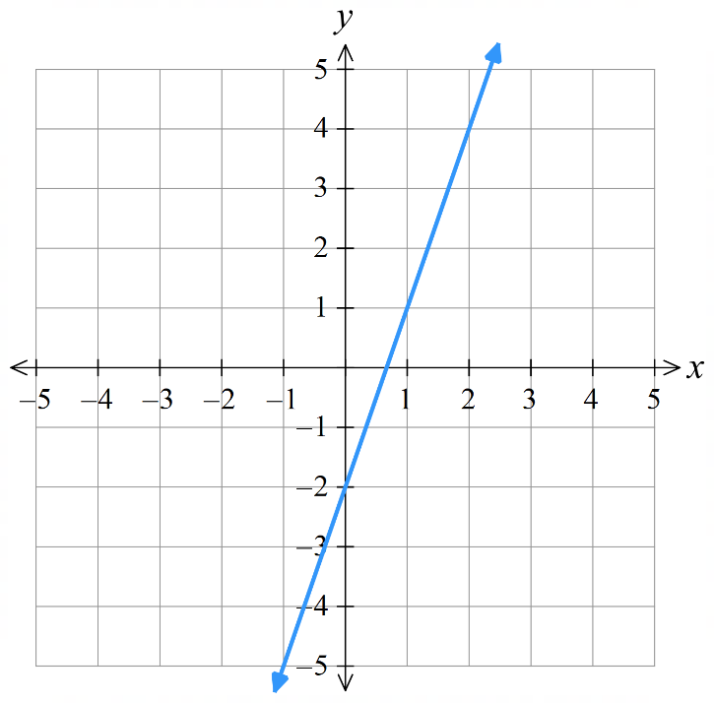  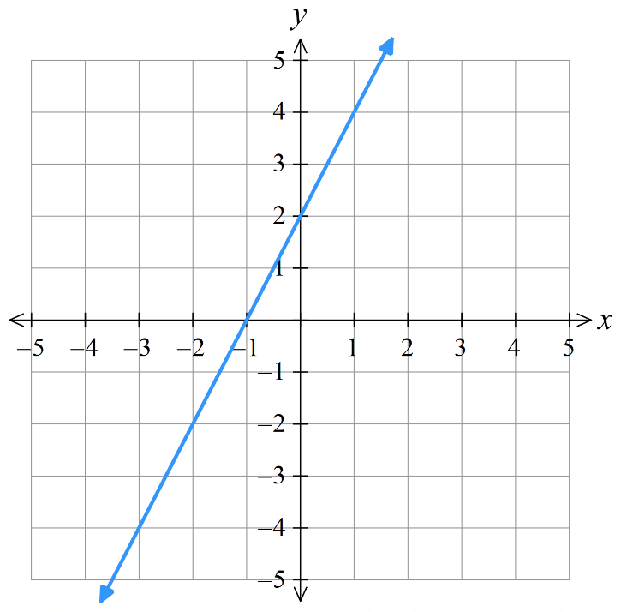 | - $y=3x-2$ | - $y=2x-3$  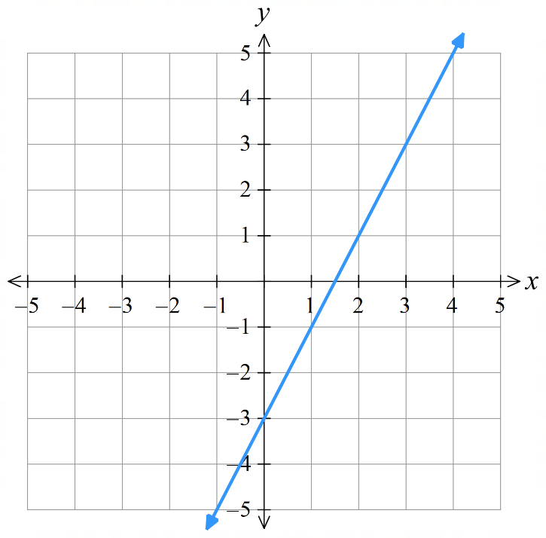
- $y=2-3x$ | - $y=2x+3$ | - $y=-2x$  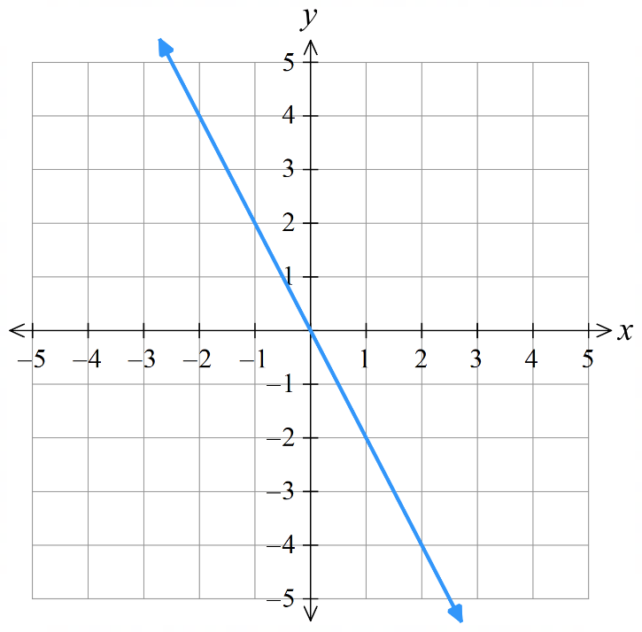  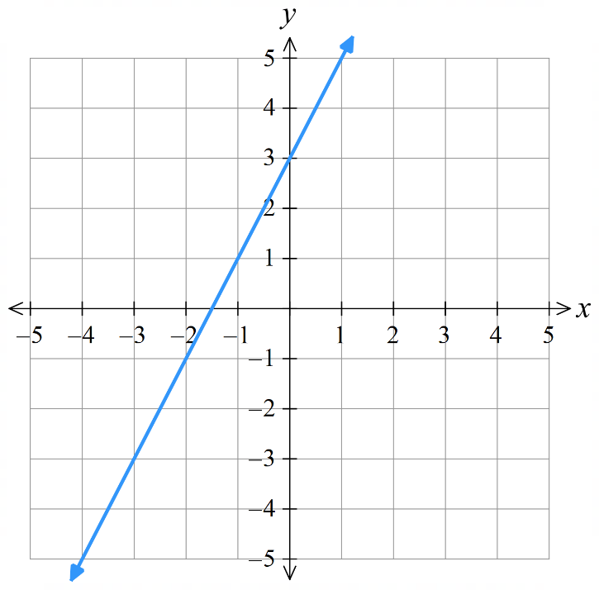

Finding the Equation of a Line from the Graph

- Review
- Calculate gradient from the graph.

- Identify $y$-intercept of a graph.

- Finding the Equation of a Line from the Graph
- Identify the $y$-intercept, this is $c$.
- Calculate the gradient, this is $m$.
  - Choose two points on the line that you can easily read, then create a triangle.
  - Going from left to right, determine the rise and the run.
  - Calculate gradient using the formula $m=\frac{Rise}{Run}$
- Write the equation $y=mx+c$.

- Example Determine equation of a line using gradient and $y$-intercept
Find the equation of this line 1. The $y$-intercept is at $(0,1)$
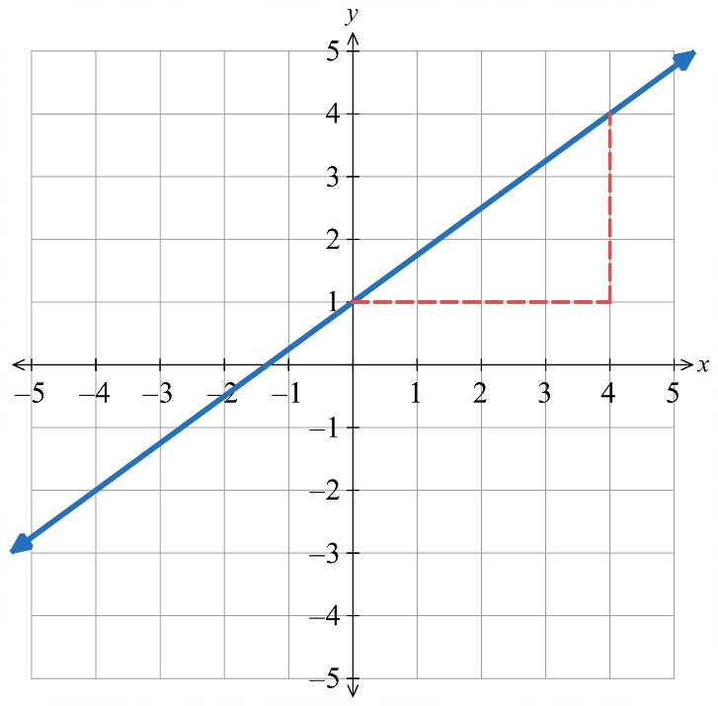
$c=1$

2. Calculate the gradient using another
point on the line: $(4,4)$

Rise: 3
Run: 4
$m=$ $\frac{3}{4}$

3. $y=\frac{3}{4}x+1$

- Guided Practice
Find the equation of these lines.
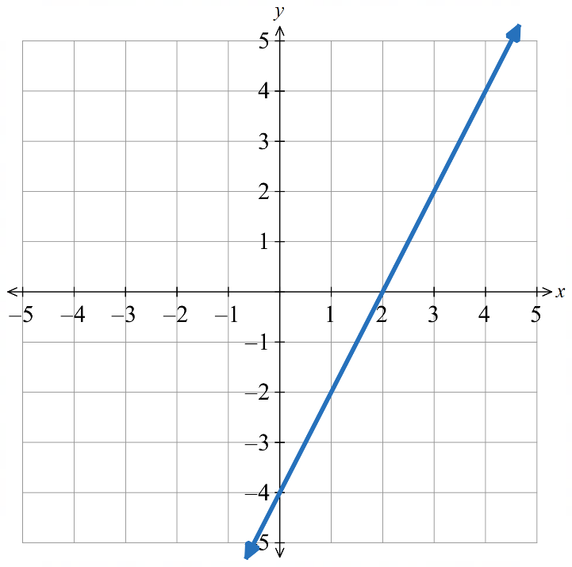  $y$-int: $c=$ ………  Gradient: $m=$ …………  Equation: ………………  $$y=2x-4$$ | 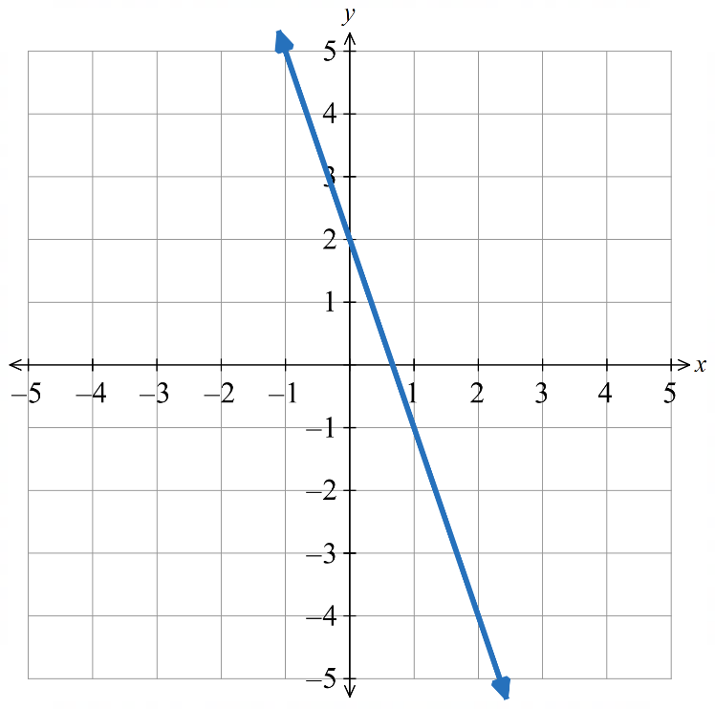  $y$-int: $c=$ ………  Gradient: $m=$ …………  Equation: ………………  $$y=-3x+2$$

- Key Ideas
- $c$ is the ……-…………………… of the line. It can be read off the graph.
- To find $m$, choose two points on the graph and calculate the ……………… of the interval.

Foundation
- Determine the equation of these lines.
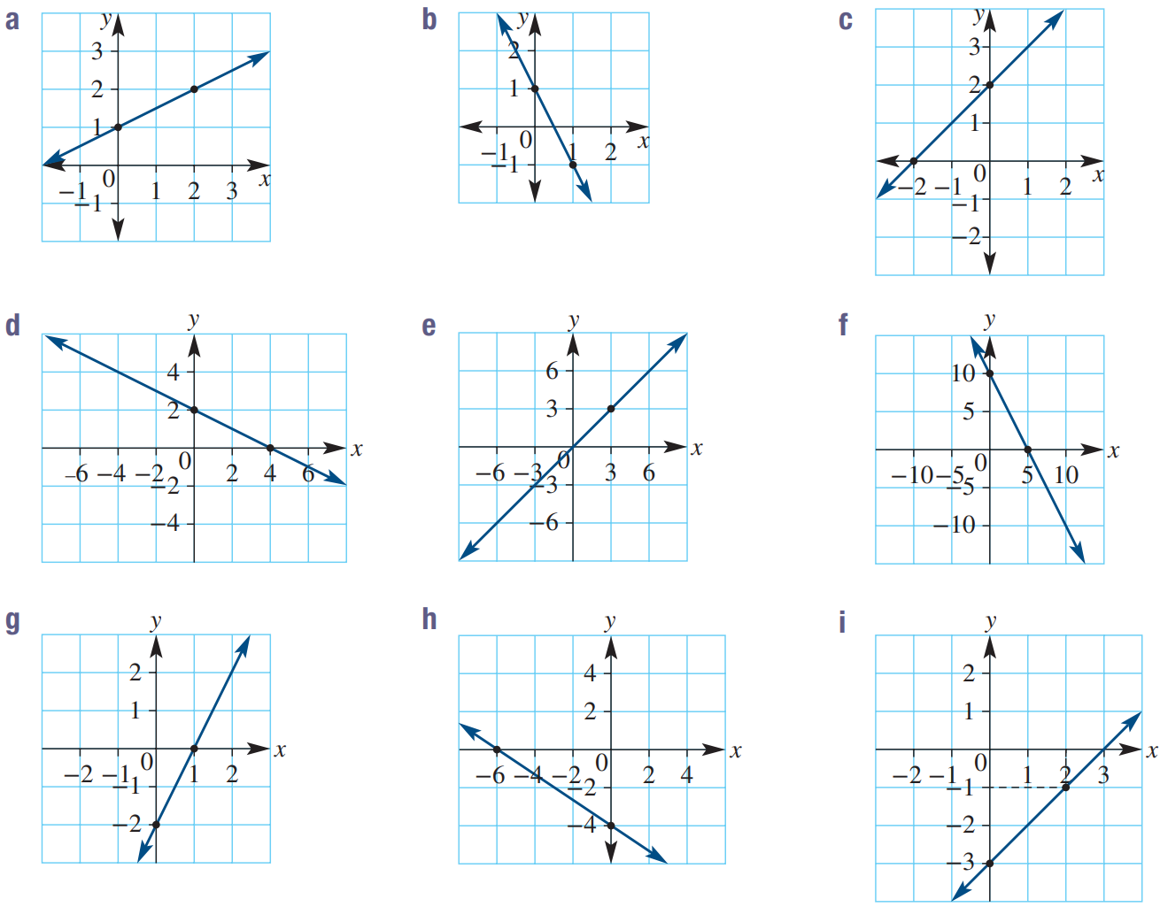  $c=$ ………  $m=$ …………  Equation: ……………  $$y=\frac{x}{2}+1$$ | $c=$ ………  $m=$ …………  Equation: ……………  $$y=x+2$$ | $c=$ ………  $m=$ …………  Equation: ……………  $$y=-2x+1$$
$$y=-\frac{x}{2}+2$$ | $$y=x$$ | $$y=-2x+10$$
$$y=2x-2$$ | $$y=-\frac{2x}{3}-4$$ | $$y=x-3$$
$$y=\frac{x}{3}-1$$ | 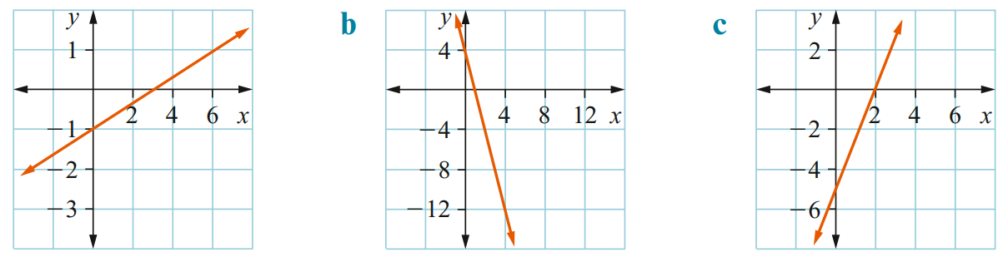  $$y=-4x+4$$ | $$y=\frac{5x}{2}-5$$

Development
- Find the gradient and $y$-intercept, then write the equation.
Remember that the run is always positive.
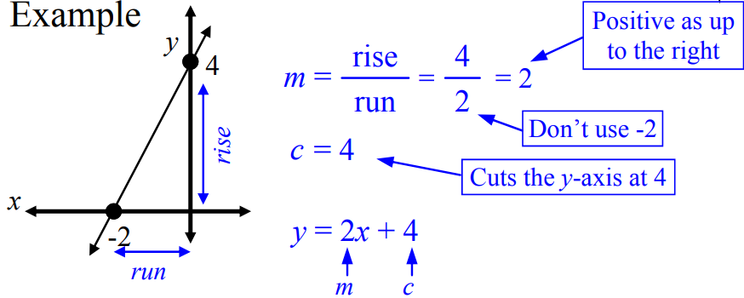 | 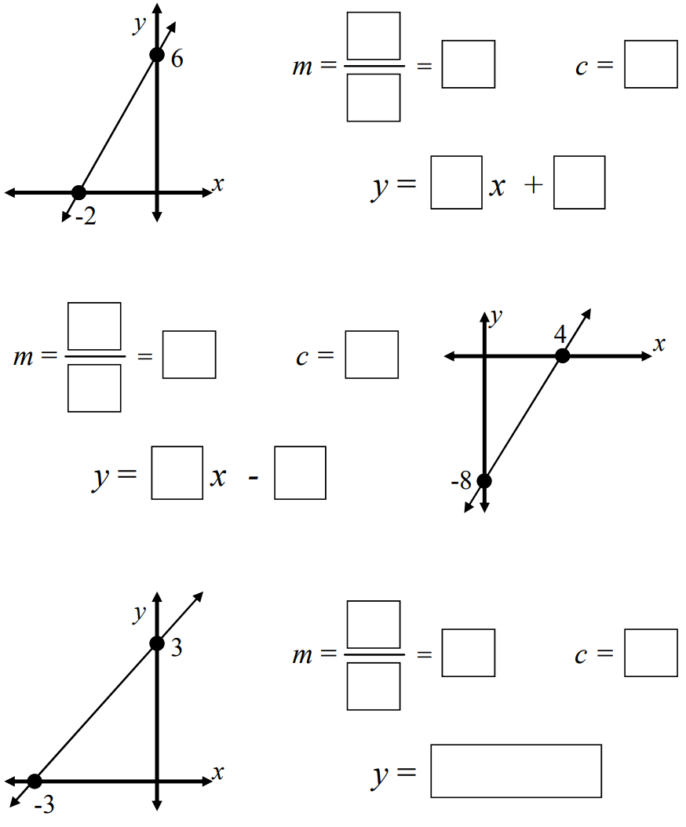  $$y=3x+6$$
$$y=2x-8$$ | $$y=x+3$$
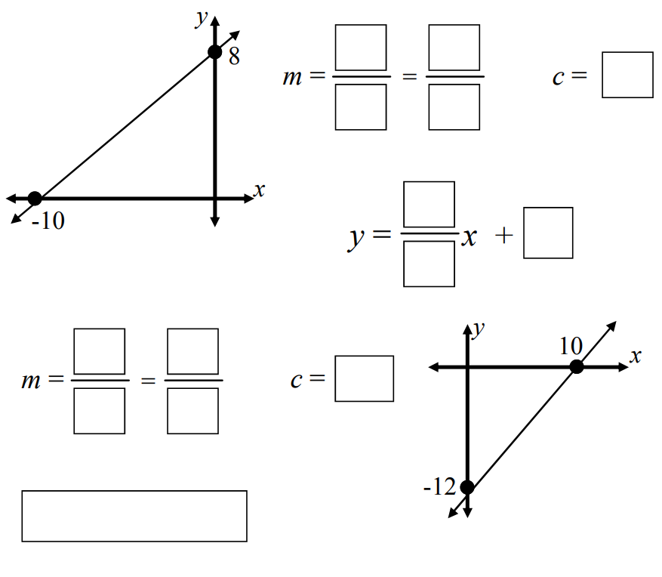  $$y=\frac{4}{5}x+8$$ | $$y=\frac{6}{5}x-12$$
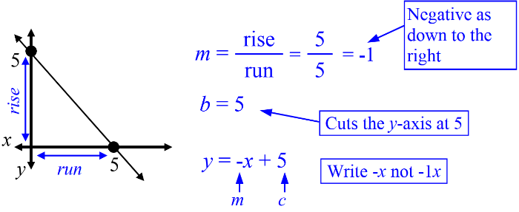 | 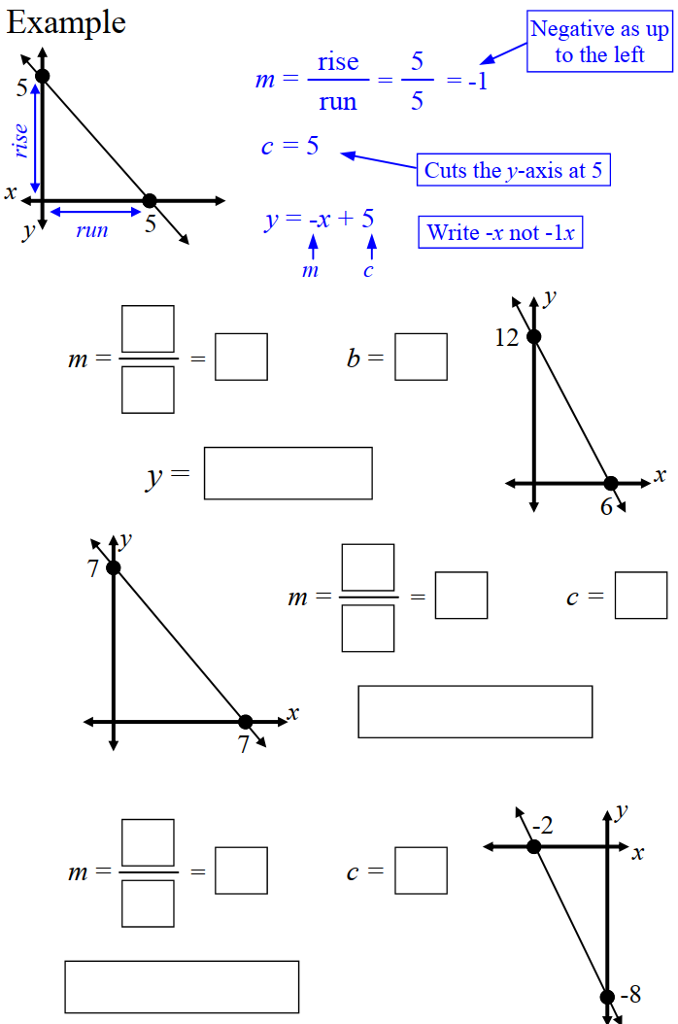  $$y=-2x+12$$
$$y=-x+7$$ | 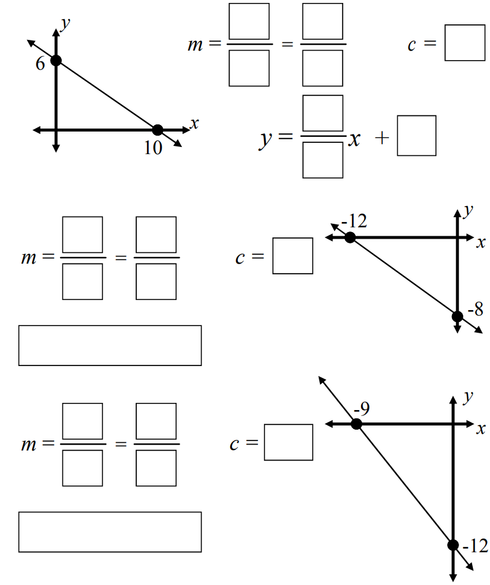  $$y=-\frac{3}{5}x+6$$
$$y=-\frac{2}{3}x-8$$ | $$y=-\frac{4}{3}x-12$$

- Find the gradient and $y$-intercept, then write the equation.
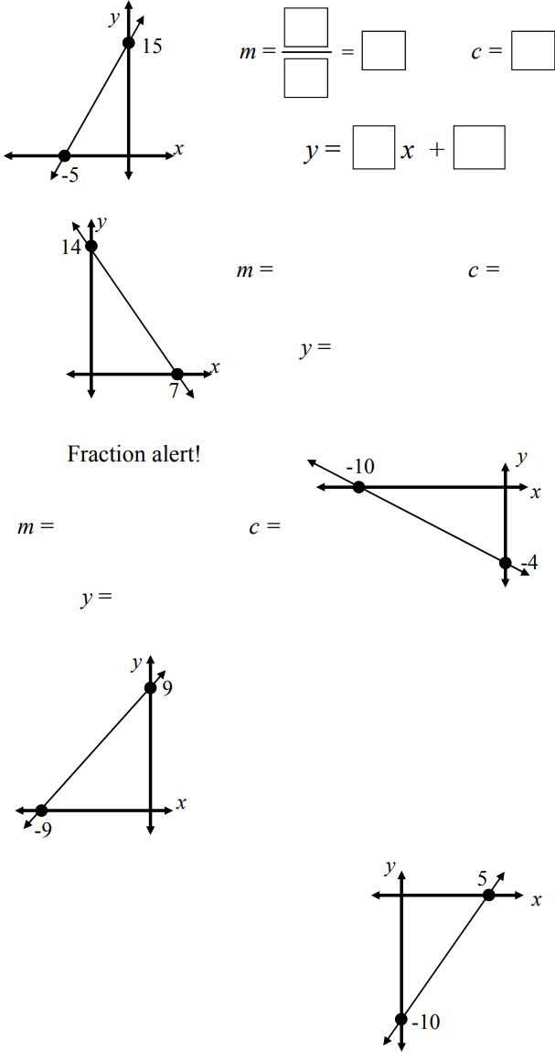  $$y=3x+15$$ | $$y=-2x+14$$ | $$y=-\frac{2x}{5}-4$$
$$y=x+9$$ | $$y=2x-10$$ | 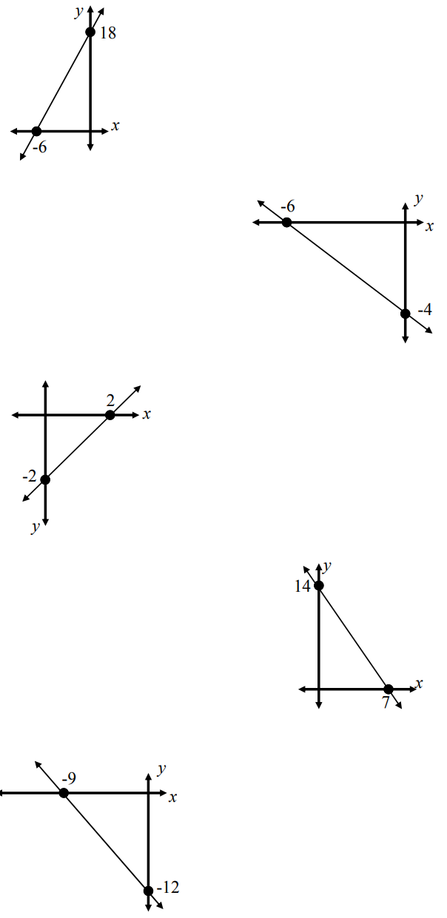  $$y=3x+18$$
$$y=-\frac{2x}{3}-4$$ | $$y=x-2$$ | $$y=-\frac{4x}{3}-12$$
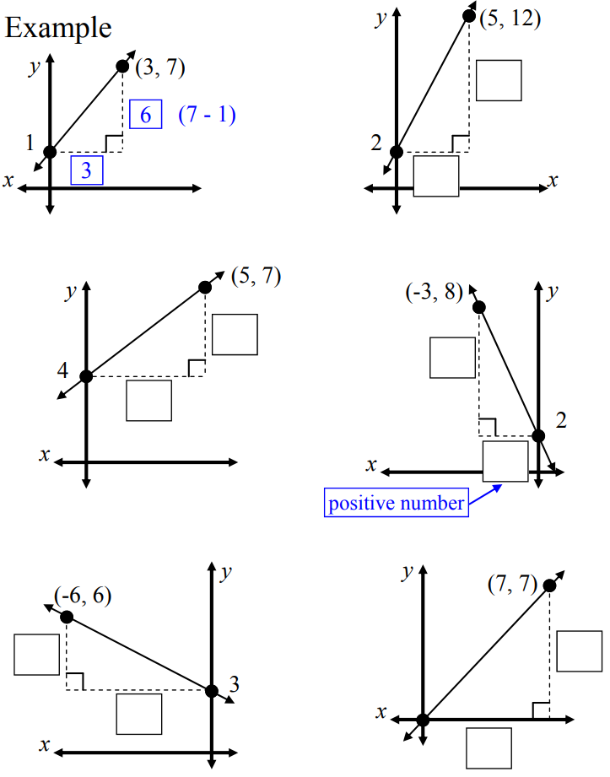  $$y=2x+1$$ | $$y=2x+2$$ | $$y=\frac{3x}{5}+4$$
$$y=-2x+2$$ | $$y=-\frac{x}{2}+3$$ | 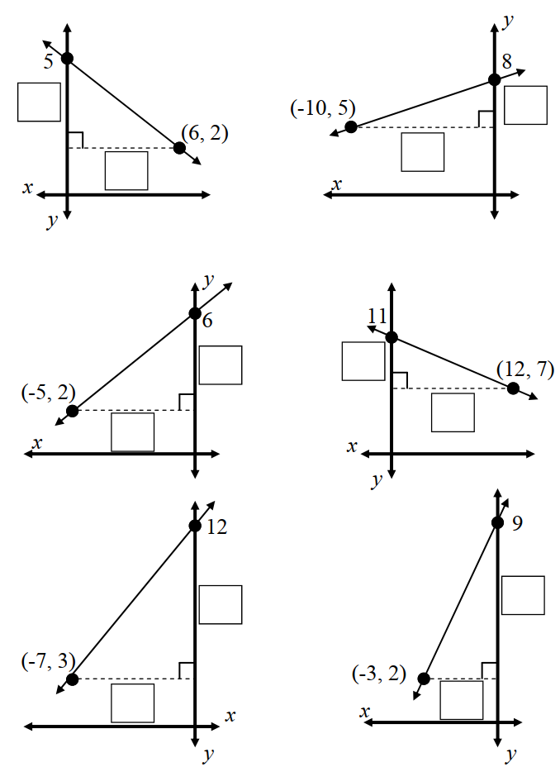  $$y=-\frac{x}{2}+5$$
$$y=\frac{3x}{10}+8$$ | $$y=\frac{4x}{5}+6$$ | $$y=-\frac{x}{3}+11$$
$$y=\frac{9x}{7}+12$$ | 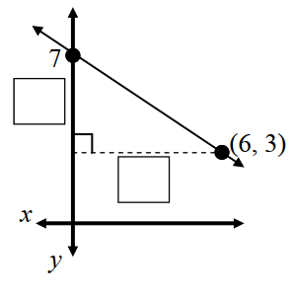  $$y=-\frac{2x}{3}+7$$ | 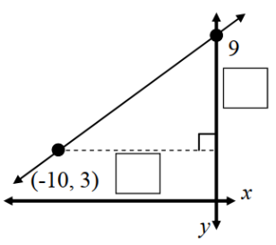  $$y=\frac{3x}{5}+9$$
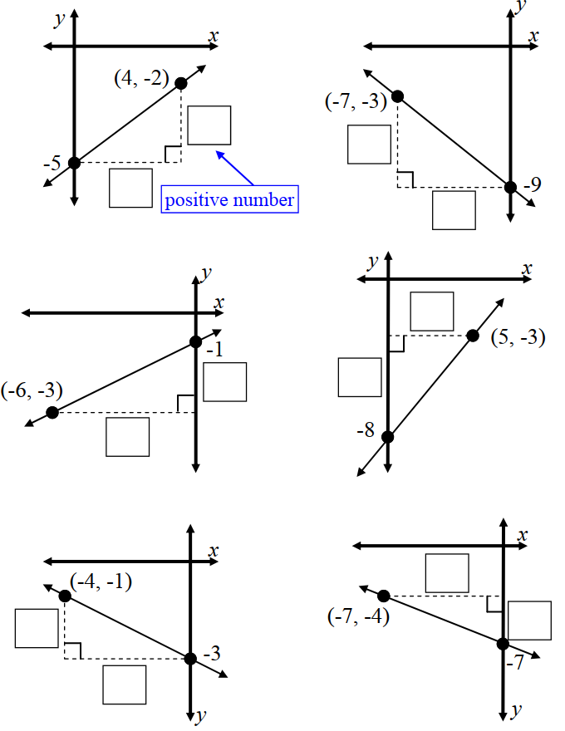  $$y=\frac{3x}{4}-5$$ | $$y=-\frac{6x}{7}-9$$ | $$y=\frac{x}{3}-1$$
$$y=x-8$$ | $$y=-\frac{x}{2}-3$$ | $$y=-\frac{3x}{7}-7$$
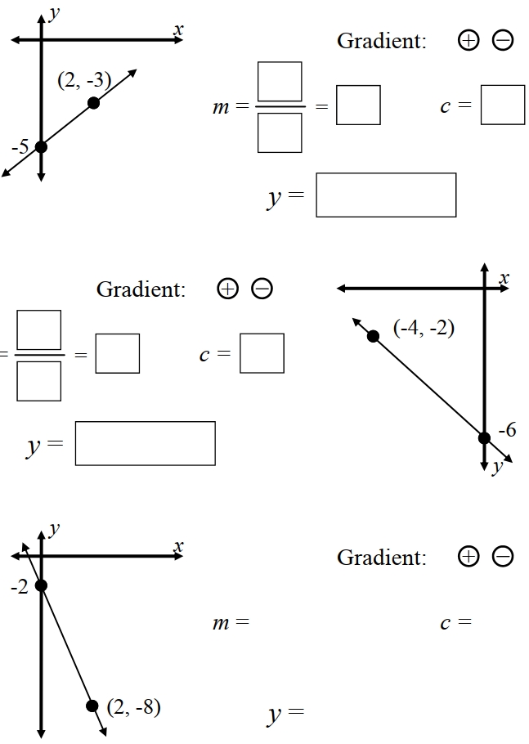  $$y=x-5$$ | $$y=-x-6$$ | $$y=-3x-2$$
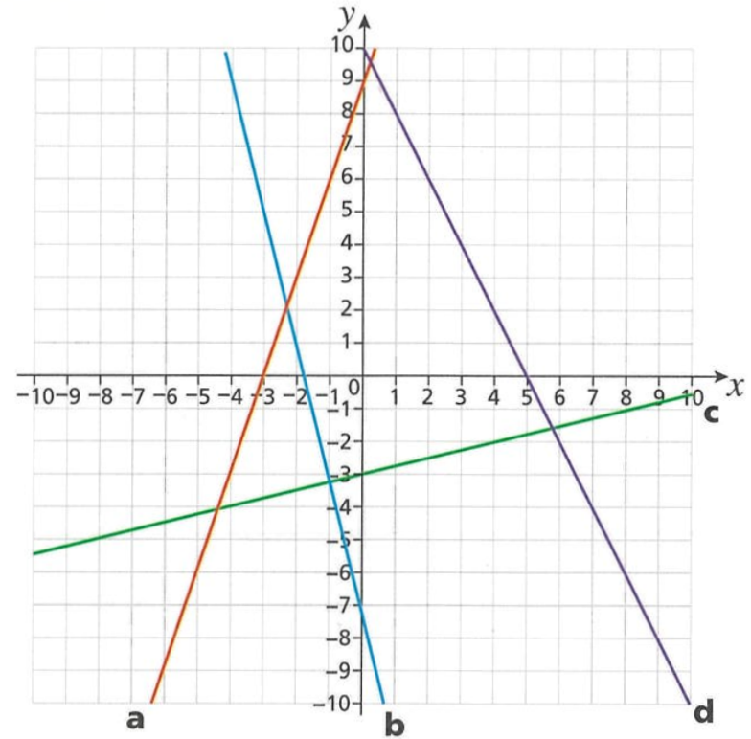
- Find the equation for each line.

a: $y=3x+9$
b: $y=-4x-7$
c: $y=\frac{x}{4}-3$
d: $y=-2x+10$
- Determine the gradient and $y$-intercept of these lines and hence find the equation.
$$y=2x+4$$ | $$y=3x$$ | 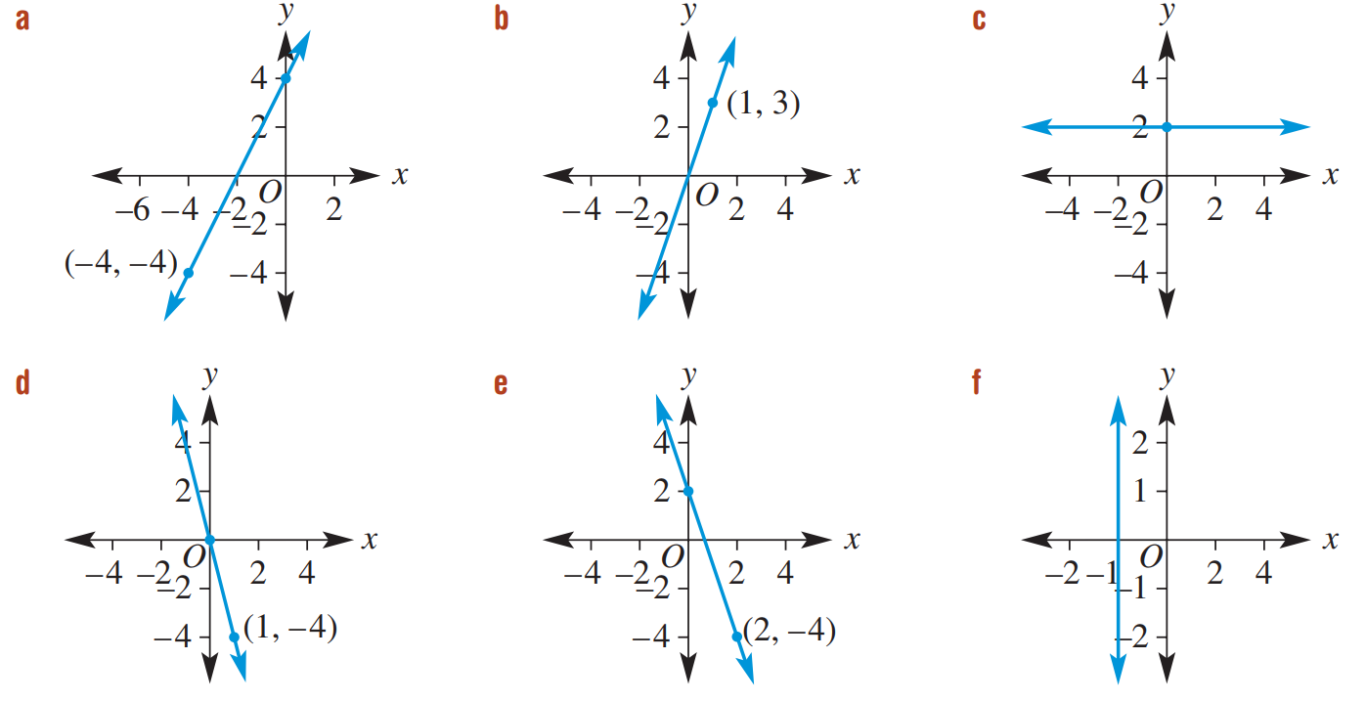  $$y=-3x+2$$
$$y=-4x$$ | $$y=2$$ | $$x=-1$$

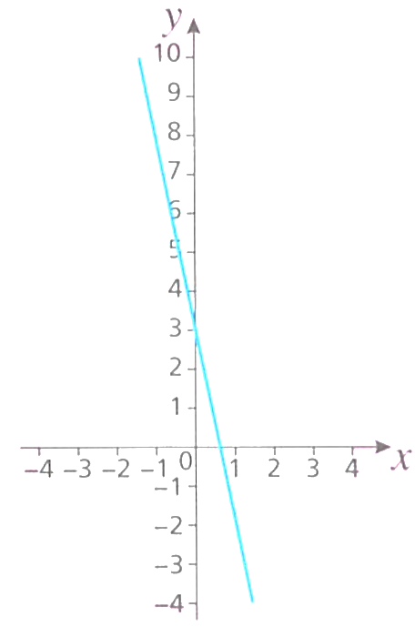
  - Nick has found the gradient of this line to be 5.
Without calculation, explain why Nick must be incorrect.

The gradient is negative
  - Nicole has found the gradient of the line to be $-\frac{1}{5}$.
This is incorrect. What mistake do you think Nicole has made?

Nicole did $\frac{run}{rise}$ instead of $\frac{rise}{run}$

- Beca says that the equation of this line is $y=\frac{1}{2}x$.
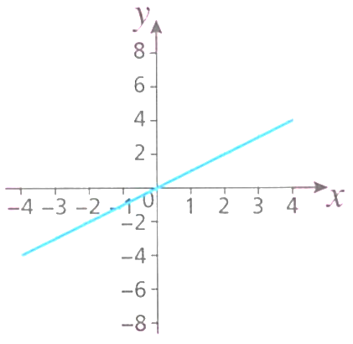
  - Explain why she is incorrect.

The gradient is 1
  - What makes this question tricky?

The $y$-axis and $x$-axis scales are different.

- Determine the equation of these lines.
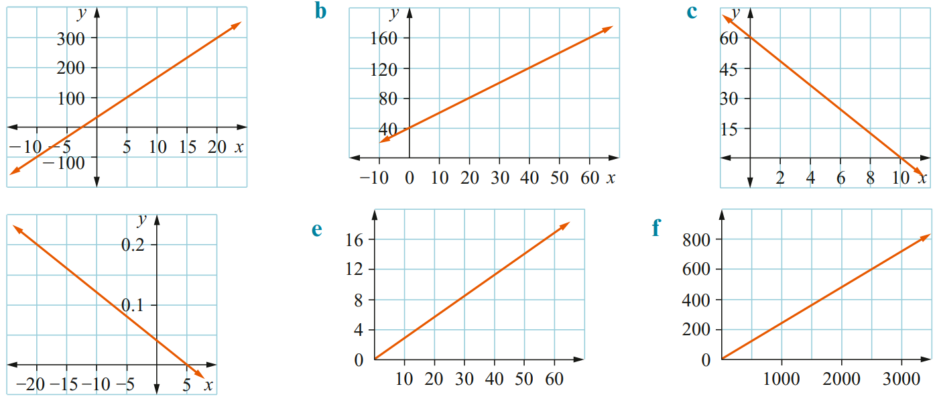  $c=40$  $m=$ ……………………  $y=$ ……………………  $$y=13x+40$$ | $$y=2x+40$$ | $$y=-6x+60$$
$$y=-0.008x+0.04$$ | $$y=\frac{7x}{25}$$ | $$y=\frac{6x}{25}$$

Mastery
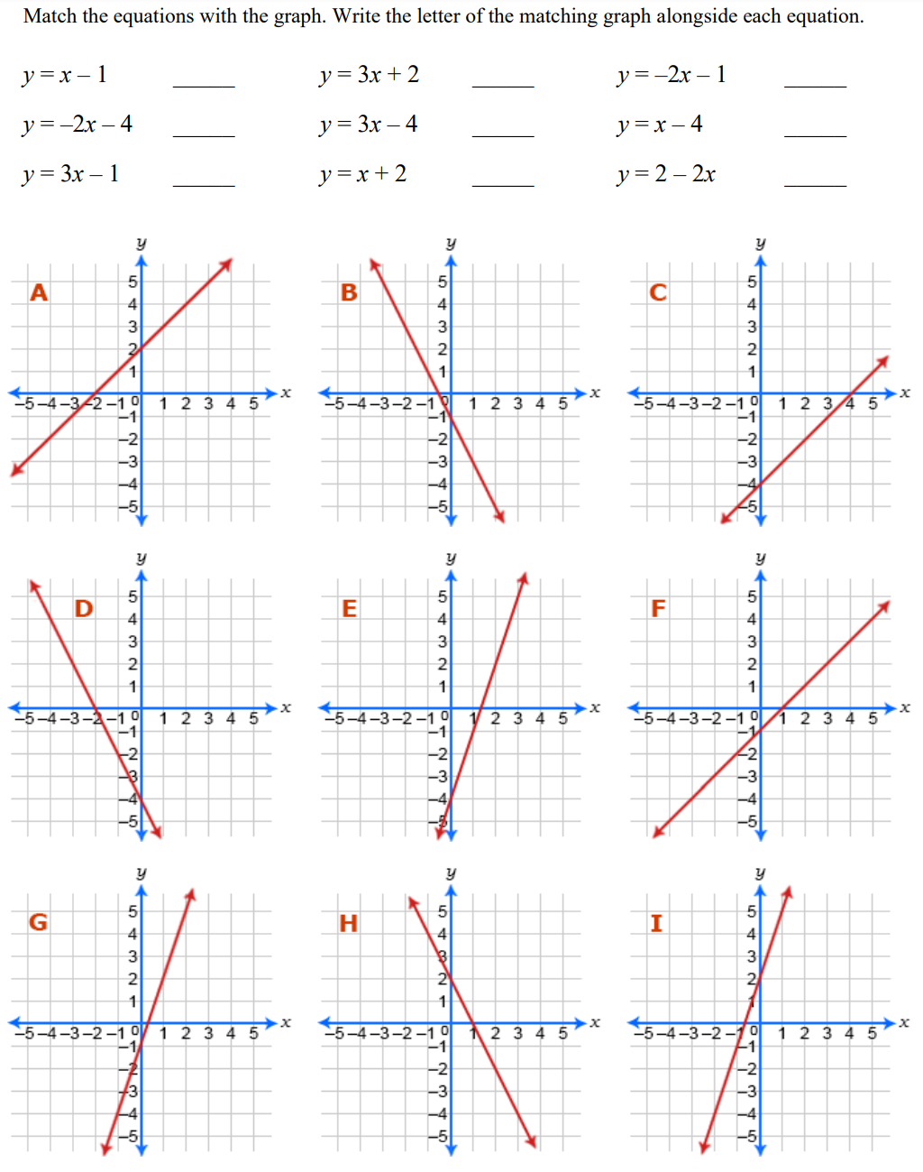

F I B
D E C
G A H

- 2021 HSC Standard 1
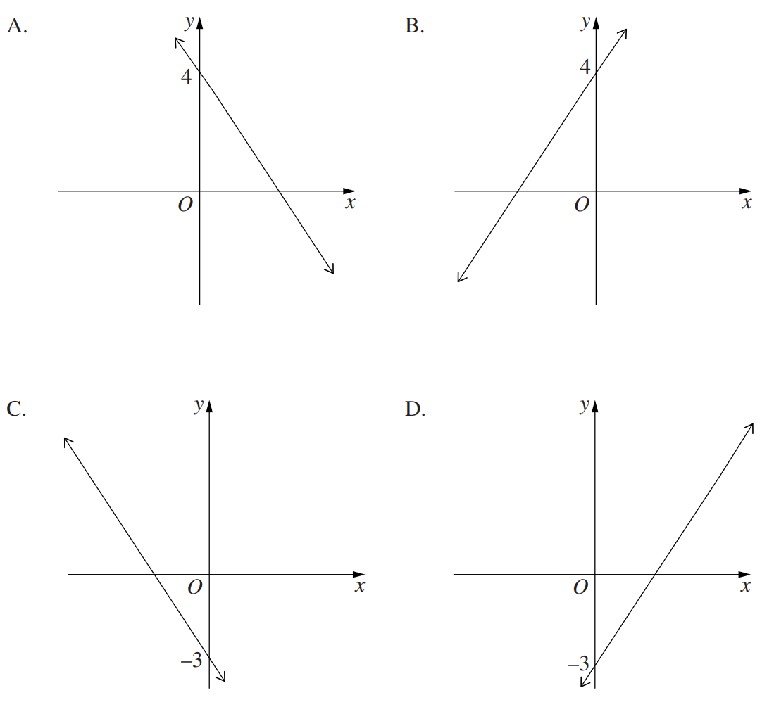
Which of the following best represents the graph of $y=-3x+4$

A
- HSC Standard 2 Sample Question Band 4
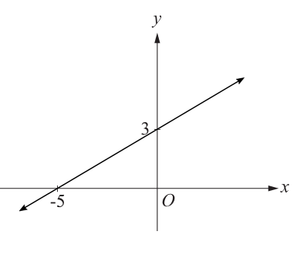
What is the equation for the line shown?

$$y=\frac{3x}{5}+3$$
- 2016 HSC Standard 2 Band 4
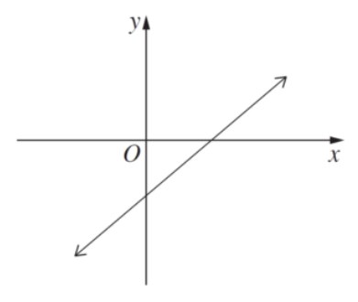
The graph shows a line of the form $y=mx+b$.
Which statement is true?
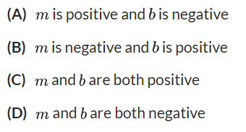

A
- 2006 HSC Standard 2 Band 4
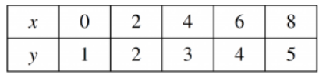
What equation is shown by the table?

$$y=\frac{x}{2}+1$$
- 2022 HSC Standard 2 Band 5
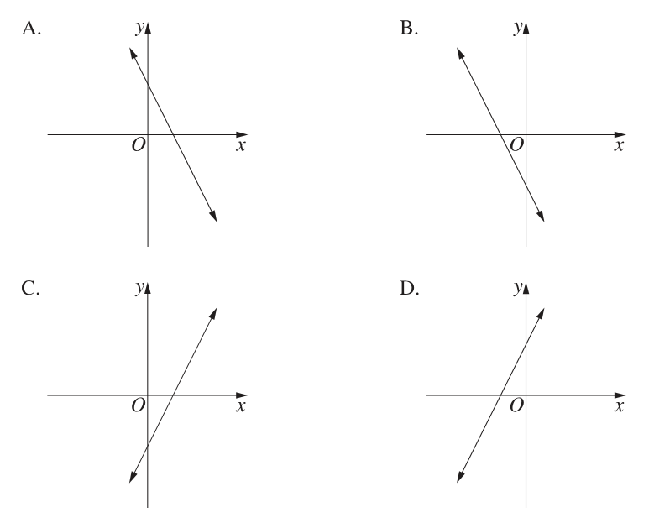
Which of the following could be the graph of $y=-2x+2$?

A
- Determine the equation of the line, then use it to find the point on the line.
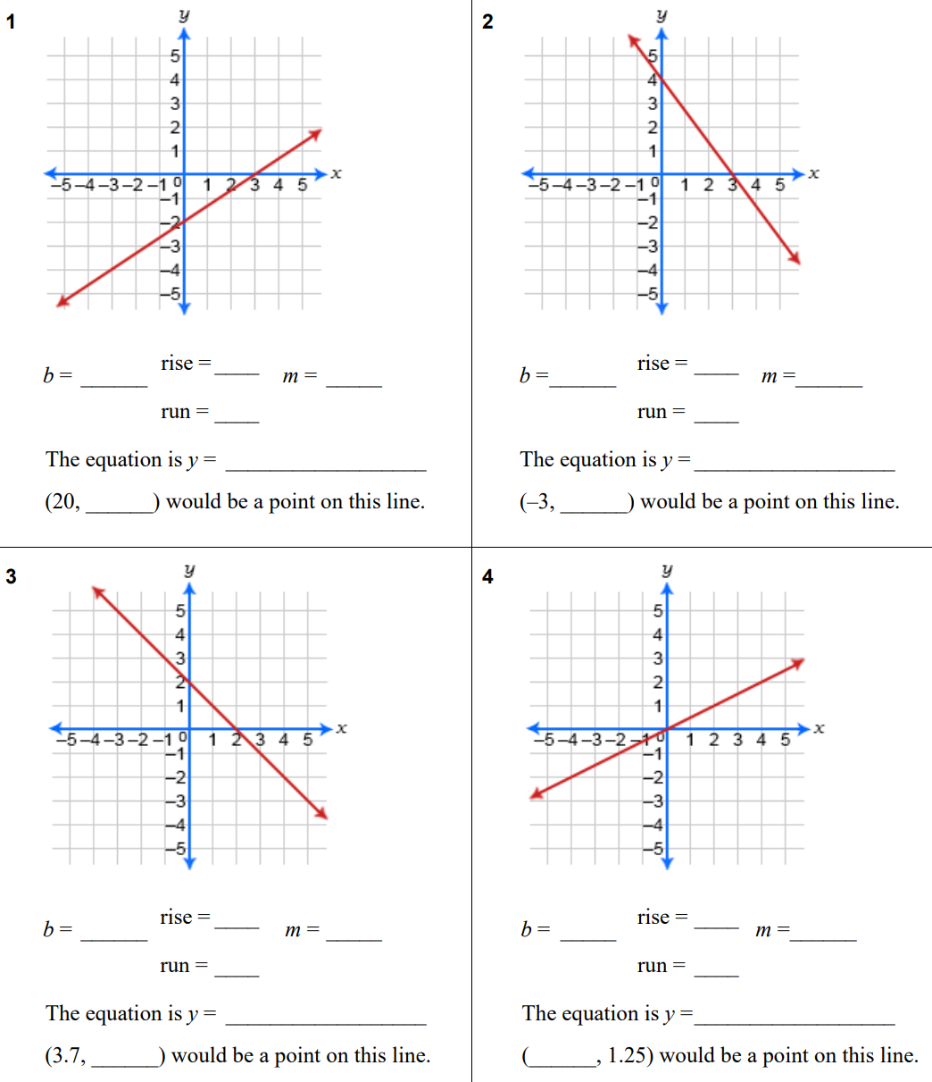  $m=$ ……………… $c=$ ………………  $y=$ ………………  $$y=\frac{2x}{3}-2$$  $(30 , )$ would lie on this line.  18  $( , 4 )$ would lie on this line.  9 | $$y=-\frac{4x}{3}+4$$  $(-6 , )$ would lie on this line.  12  $( ,-8)$ would lie on this line.  9
$$y=-x+2$$  $(-3.7, )$ would lie on this line.  5.7  $( , 18 )$ would lie on this line.  $$-16$$ | $$y=\frac{x}{2}$$  $( ,1.25)$ would lie on this line.  2.5  $(25 , )$ would lie on this line.  $$12.5$$

Special Lines

- Special Lines
Horizontal Line  $$y=c$$  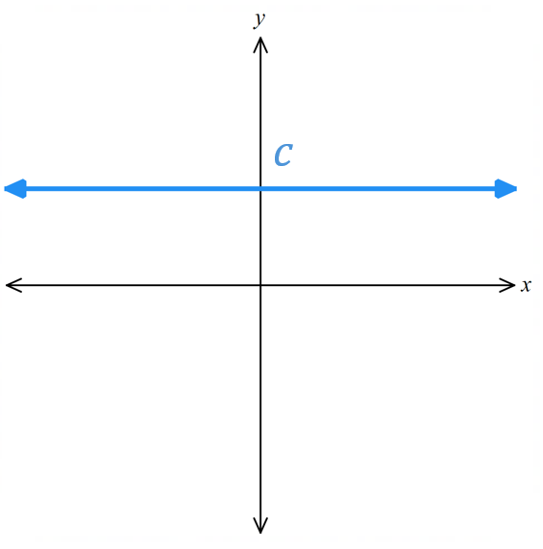 | Vertical Line  $$x=k$$  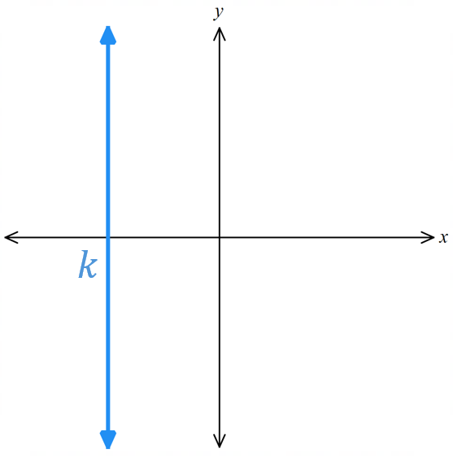 | Straight line through origin  $$y=mx$$  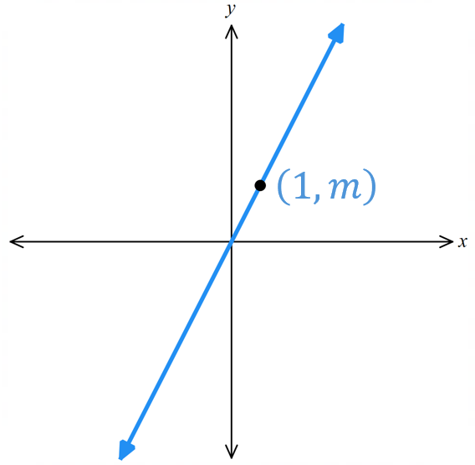

- Sketch Special lines
For each equation, sketch the line, showing the intercept for horizontal/vertical lines, and the coordinate at $x=1$ for lines through the origin.
- $x=-1$ | - $y-2=0$ | - $2y=-3$
- $x+2y=0$ | - $3x-5y=0$ | - $2x=5$

Foundation
- Sketch these special lines.
- $y=-3$  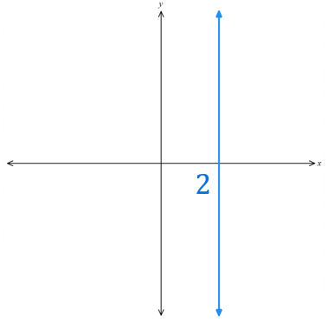  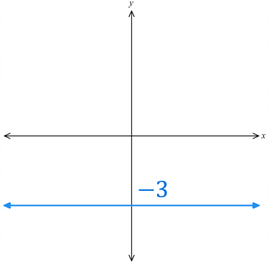 | - $x=2$ | - $y=0$  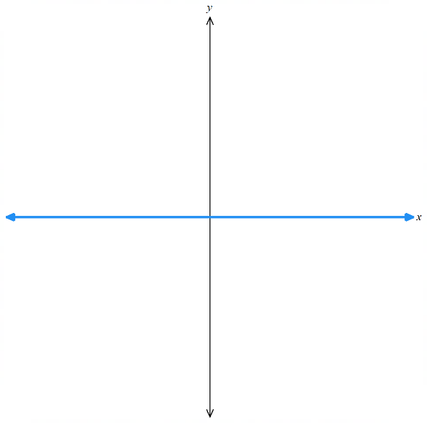  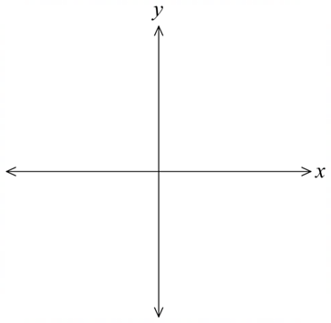
- $y=-3x$  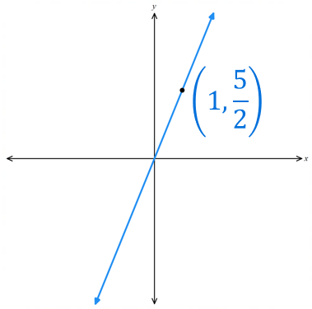  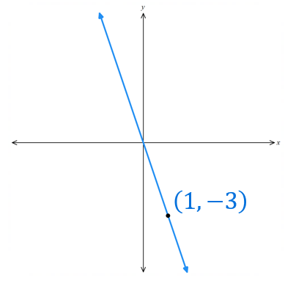 | - $y=\frac{5x}{2}$ | - $y=\frac{5}{2}x$
- $4-y=0$  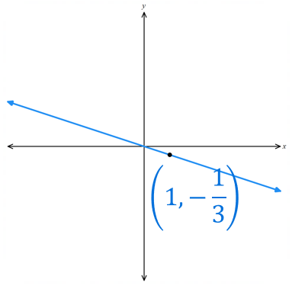  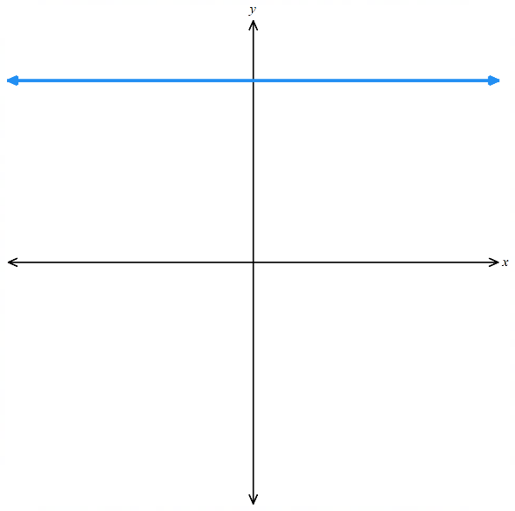 | - $x=-3y$ | - $x=0$  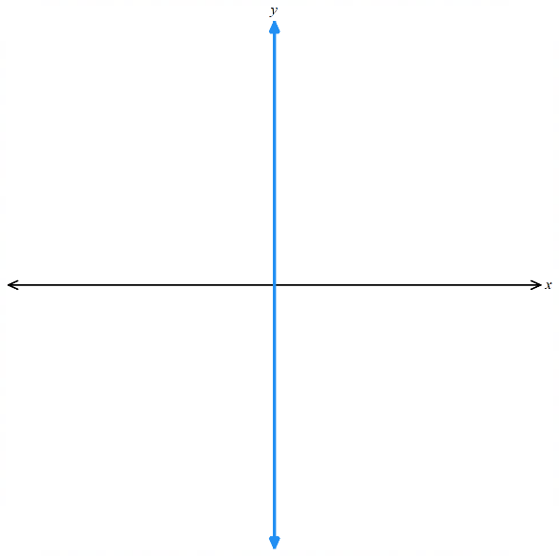
- $2y=-3$  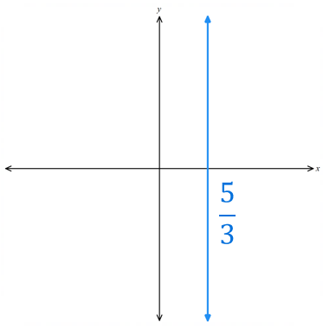  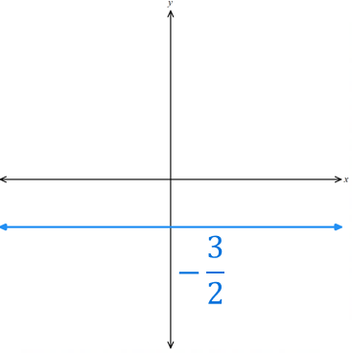 | - $3x=5$ | - $x=\frac{2}{3}$  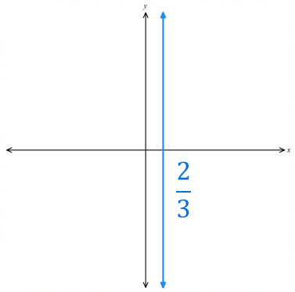

Development
- Match the equation to the graph.
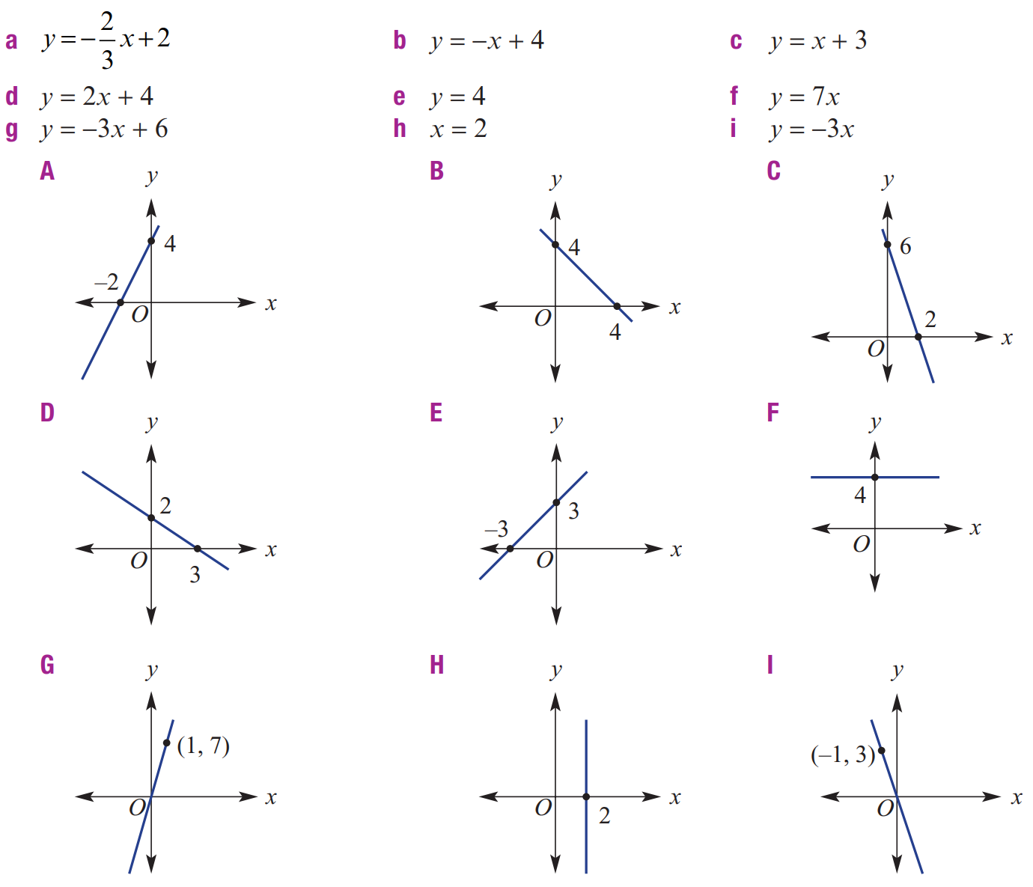

a-D, b-B, c-E
d-A, e-F, f-G
g-C, h-H, i-l

Mastery
- Match the equation to the graph.
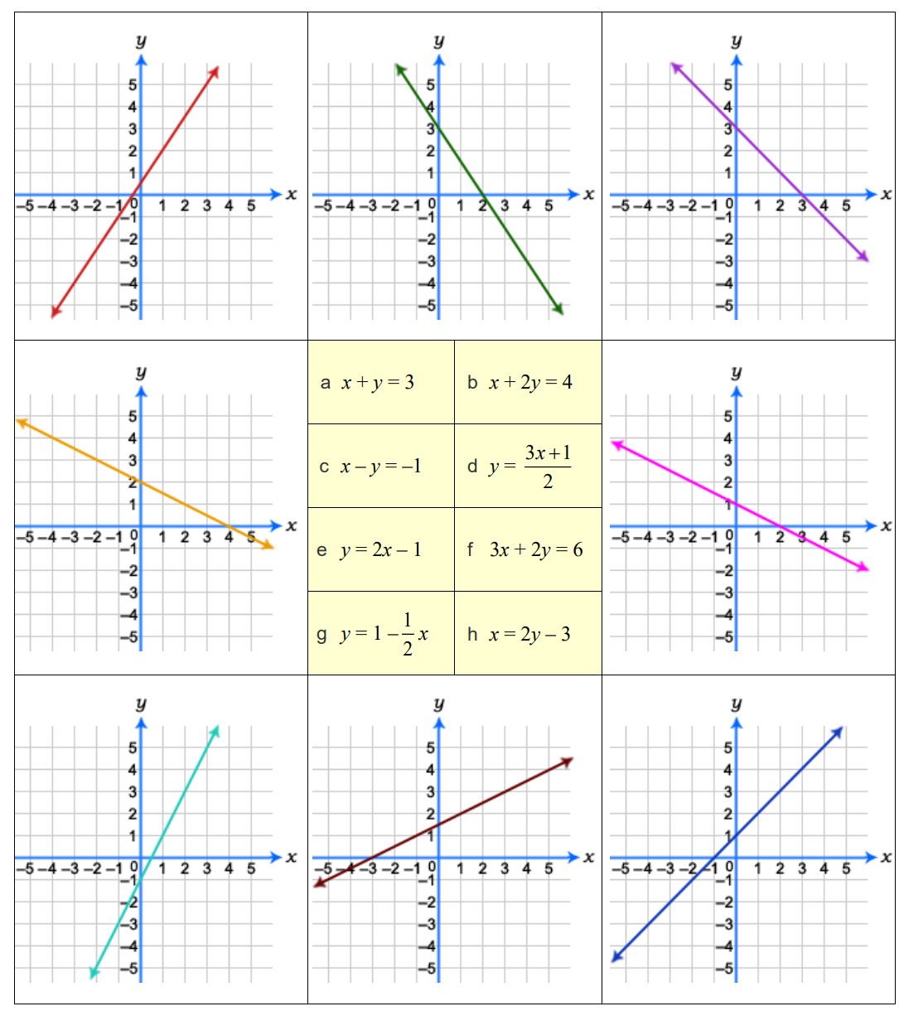

Clockwise from top left:
$$d, f, a, g, c, h, e, b$$

Interpreting Linear Models

- Interpreting Linear Models
Linear relationships model many real-life scenarios.
The gradient is the rate; it represents the change in $y$ per unit increase in $x$.
The $y$-intercept is the initial or fixed value at $x=0$.

- Interpret the gradient and $y$-intercept of a linear model
Identify the meaning of the gradient and $y$-intercept of these linear models.
- Taxi hire cost  Gradient: 2  Meaning: 2 …………… per ……………  $y$-intercept: 10  Meaning: …… for … …………  Equation relating $C$ and $t$:  $$y=mx+c$$  …… $=$ … … $+$ … | 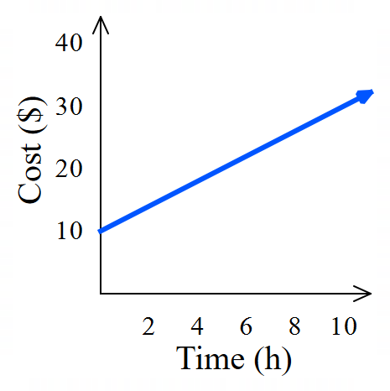  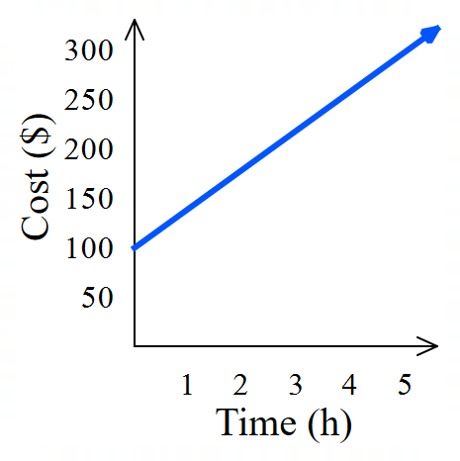  - Plumber hire cost  Gradient: 40  Meaning: ………………………………………  $y$-intercept: 100  Meaning: ………………………………………  Equation relating $C$ and $t$:  $$y=mx+c$$  …… $=$ … … $+$ …
- Volume of water in a tank  Gradient: $-75$  Meaning: ………………………………………  $y$-intercept: 1000  Meaning: ………………………………………  Equation relating $V$ and $t$: | 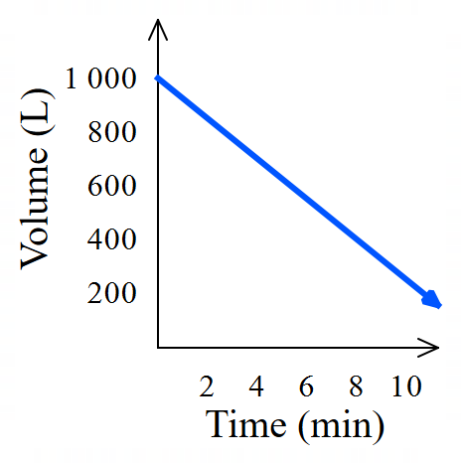  - Population of Australia  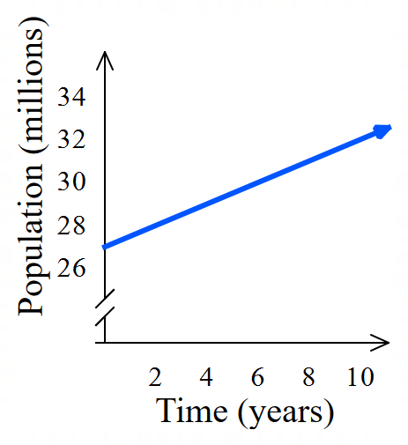  Gradient: $0.5$  Meaning: ………………………………………  $y$-intercept: 27  Meaning: ………………………………………  Equation relating $P$ and $t$:

Foundation
- Identify what the gradient and $y$-intercepts of these graphs represent, then write the equation.
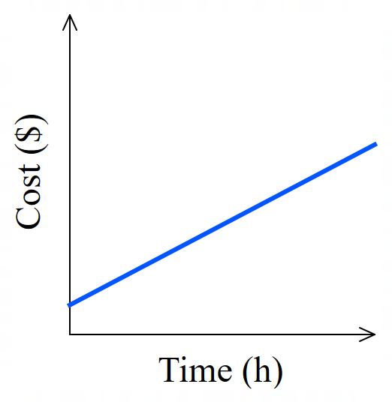  Gradient: 0.5  Meaning:  0.5 …………………… per ……………………  0.5 dollars per hour  $y$-intercept: 2  Meaning:  ……………………………………………………  $2 for 0 hours (initial cost)  Equation relating cost $C$ and time $t$:  $$y=mx+c$$  …… $=$ … … $+$ …  $$C=0.5t+2$$ | 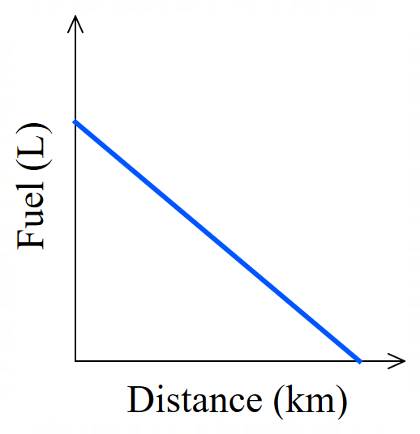  Gradient: $-0.8$  Meaning:  $-0.8$ L per km  $y$-intercept: 15  Meaning:  15 L at 0 km (initial volume)  Equation relating fuel $f$ and distance $d$:  $$y=mx+c$$  …… $=$ … … $+$ …  $$f=-0.8d+15$$
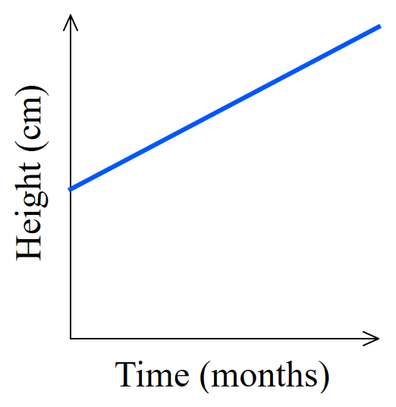  Gradient: 2.5  Meaning:  2.5 cm per month  $y$-intercept: 50  Meaning:  50 cm at 0 months (initial height)  Equation relating height $h$ and time $t$:  $$h=2.5t+50$$ | 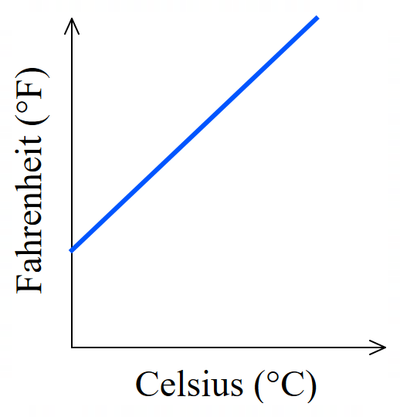  Gradient: 1.8  Meaning:  $$1.8 °F per 1°C$$  $y$-intercept: 32  Meaning:  $32°F$ at $0°C$  Equation relating $F$ and $C$:  $$F=1.8C+32$$

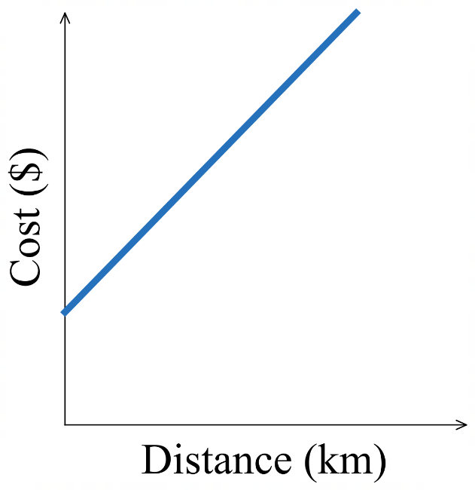  Gradient: 3  Meaning:  3 dollars per km  $y$-intercept: 5  Meaning:  $5 for 0 km (initial cost)  Equation relating cost $C$ and distance $d$:  $$C=3d+5$$ | 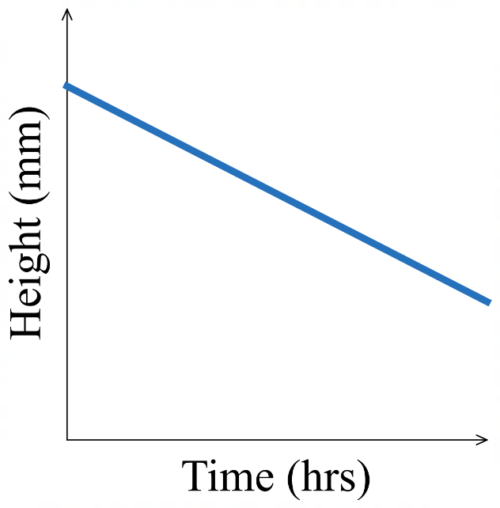  Gradient: $-10$  Meaning:  $-10$ mm per hr  $y$-intercept: 80  Meaning:  80 mm at 0 hrs (initial height)  Equation relating height $h$ and time $t$:  $$h=-10t+80$$
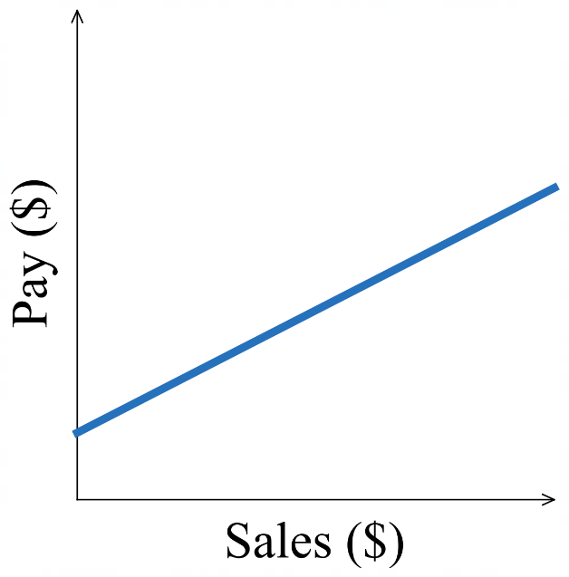  Gradient: 0.1  Meaning:  $0.10 pay per dollar sales  $y$-intercept: 300  Meaning:  $300 pay for $0 sales (initial pay, or retainer)  Equation relating pay $P$ and sales $s$:  $$P=0.1s+300$$ | 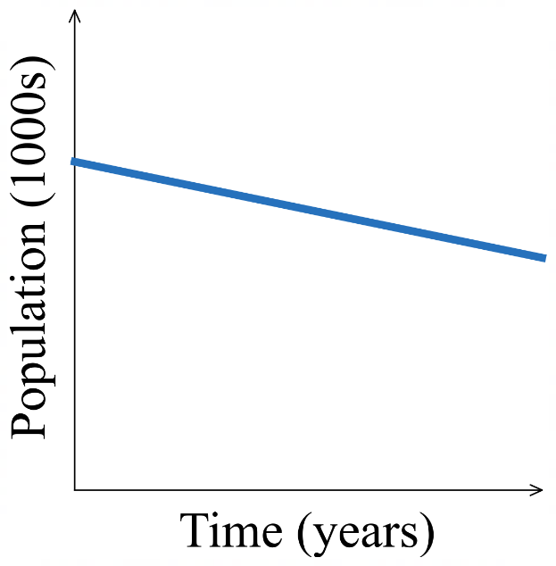  Gradient: $-2$  Meaning:  $-2000$ people per year  $y$-intercept: 50  Meaning:  $50 000$ people at 0 years (initial population)  Equation relating $P$ and $t$:  $$P=-2t+50$$

- Example Interpret a linear model
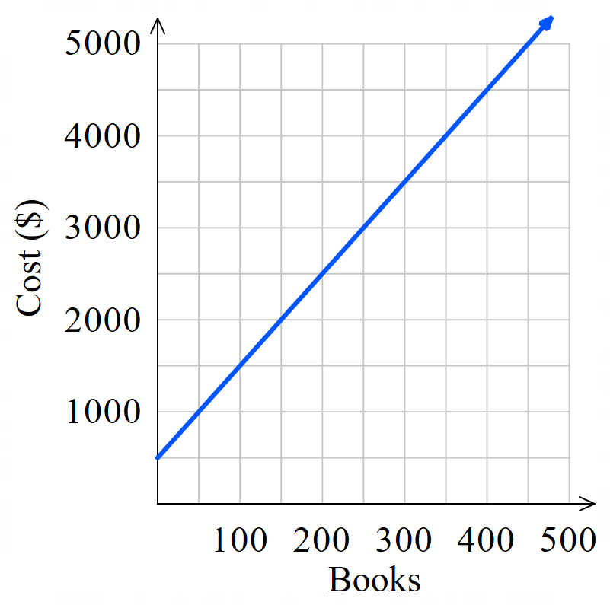
The linear model shows the cost of setting up a book printing business.
  - Find the cost of printing 400 books.
$4500
  - Find the number of books that can be printed for
$3000.
250 books
  - Find the $y$-intercept. What is its meaning?
$500.
This is the fixed cost for setting up the printing.

  - Find the gradient of the line, what is its meaning?
By choosing (0,500) and (400, 4500):
$$m=\frac{cost}{books}=\frac{4000}{400}=10$$
cost per book is $10.
  - Write an equation relating cost $C$ and number of books $n$.
$m=10, c=500$ $C=10n+500$

- Guided Practice
The linear model shows the volume of a chemical tank over time.
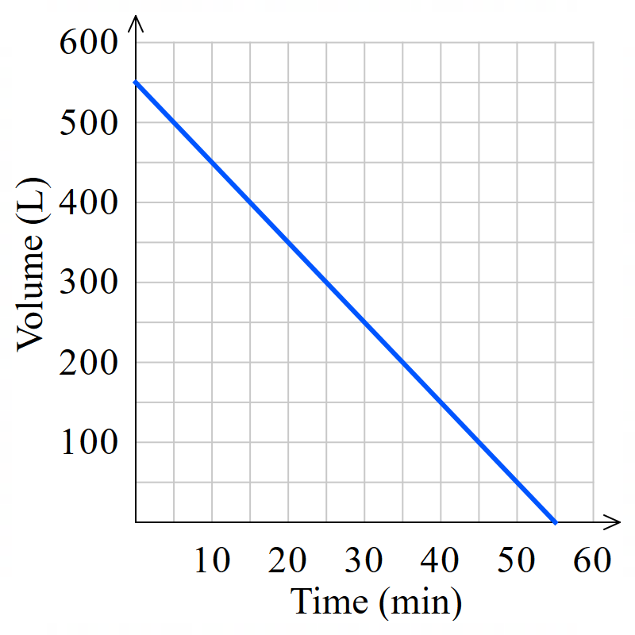
- Find the volume after 30 minutes.

250 L
- When is the volume 200 L?

35 minutes
- Find the $y$-intercept. What is its meaning?

550 L; Initial volume.
- Find the gradient of the line, what is its meaning?

$-10$ litres per minute
- Write an equation relating volume $V$ and time $t.$

$$V=-10t+550$$

Foundation
- The graph shows the cost of a taxi journey for a given number of miles,
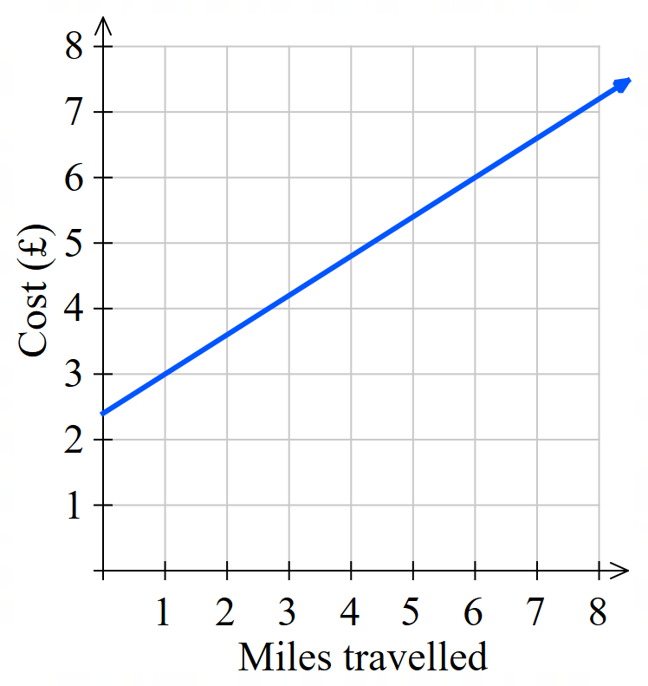
  - How much does it cost to enter the taxi?

£2.50
  - Use the graph to find the cost of
    - a 1-mile journey
£3
    - a 6-mile journey

£6
  - Using the two data points in part b, find the gradient and interpret what it means in the context of the question.

$m=0.6$. £0.60 per mile

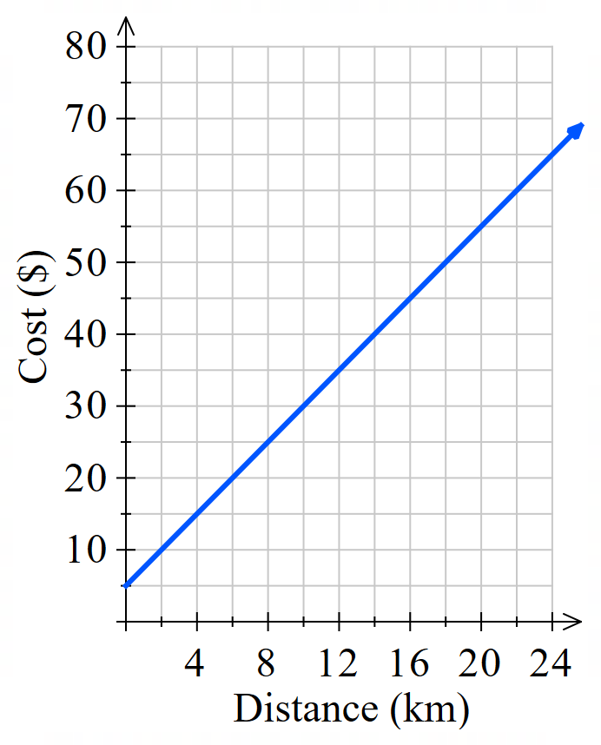
- The linear model shows the cost of hiring a taxi.
  - From the graph, find the cost of travelling 22 km.

$60
  - How far can a passenger travel for $30?

10 km
  - Find the $y$-intercept.
What is its meaning in this situation?

$5. Initial cost of hiring the taxi.
  - Identify the gradient. What is its meaning in this situation?

2.5. $2.50 per km.
  - Write an equation relating cost $C$ and distance $d$ .

$$C=2.5d+5$$

- Nikki’s balance in her bank account is shown in the graph.
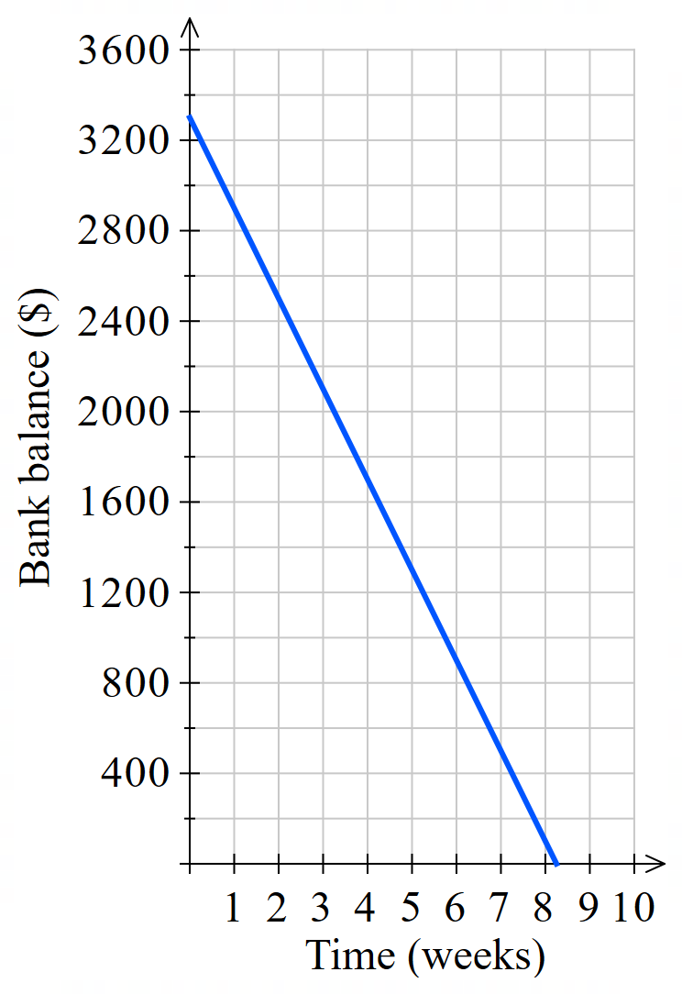
  - How much money does she have after 3 weeks?

$2100
  - When did she have $700 in her account?

After 6.5 weeks
  - What is the $y$-intercept?
What does it represent in this scenario?

$3300. Initial amount in the account.
  - What is the gradient?
What does it represent in this scenario?

$-400$. Her bank balance is reducing by $400 per week.
  - Write an equation relating bank balance $b$ and time in weeks $t$.

$$b=-400t+3300$$
- This model shows the height of a burning candle.
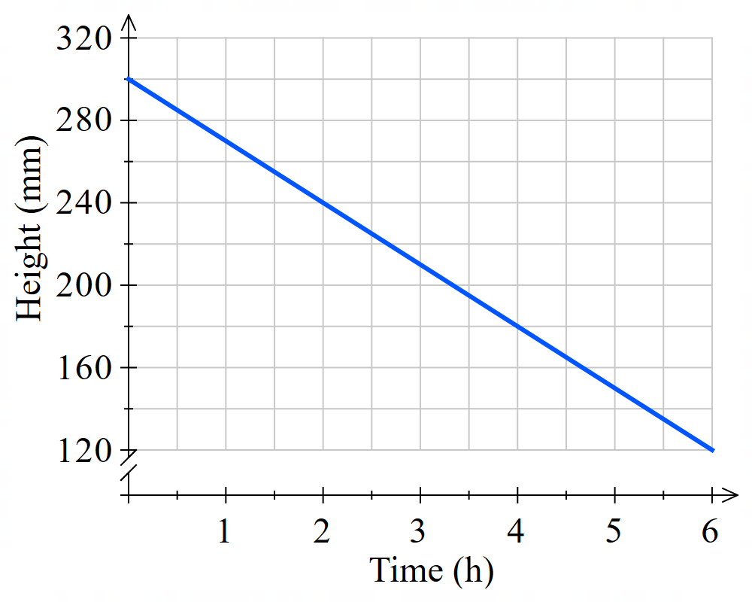
  - What is the height of the candle initially?

300 mm
  - How long does it take for the height to decrease to 180 mm?

4 hours
  - How long does it take for 180 mm of the candle to be used?

6 hours
  - At what rate is the candle’s height decreasing per hour?

30 mm / hour
  - Write an equation relating height $h$ and time $t$.

$$h=-30t+300$$
  - Predict when the candle will be completely used up.

10 hours

Development
- The graph shows the mass of a box when some identical matchsticks are put into it.
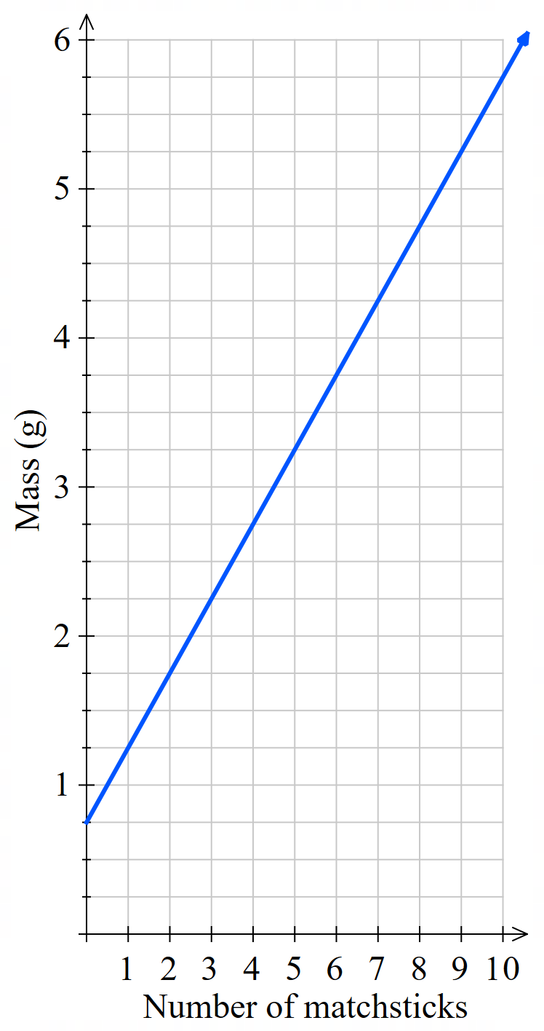
  - Use the graph to determine the mass of
    - the empty box

0.75 g
    - one matchstick

0.5 g
  - Find the equation relating mass $M$ and number of matchsticks $n$.

$$M=0.5n+0.75$$

- The linear model shows how an employee is paid on commission.
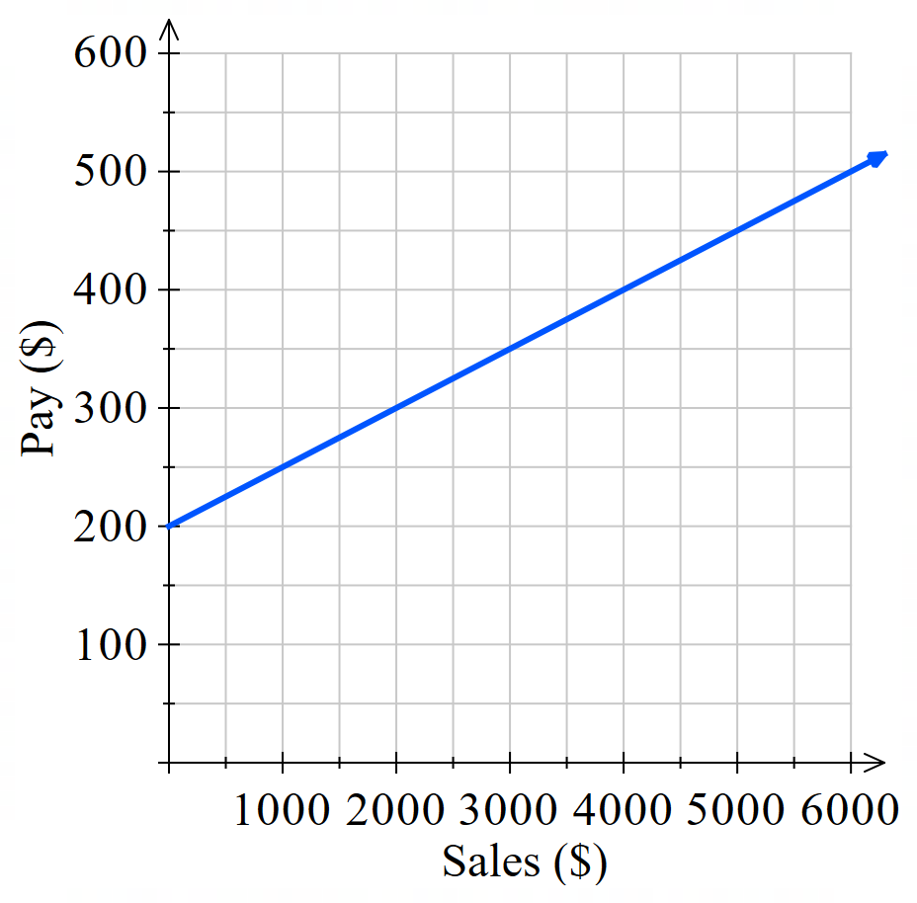
  - What was the value of sales if the salesperson was paid $300 for the week?

$2000
  - What is the salesperson’s pay if she sold $5000 worth of goods?

$450
  - What retainer is this employee paid?

$200
  - What is this employee’s rate of commission?

5%
  - Write an equation relating pay $P$ and sales $S$.

$$P=0.05S+200$$
- The Supertight Tie Company has a fixed cost of $1200 per day and a variable production cost of $3 per tie. The daily cost can be modelled using the equation $C=3n+1200$.
  - Explain what each term in the equation $C=3n+1200$ represents.
$C:$ …………………………… $n:$ ……………………………
total cost number of ties
$3:$ …………………………… $1200:$ ……………………………
cost per tie fixed cost
  - Complete the table of values for $C=3n+1200$ and draw the graph.
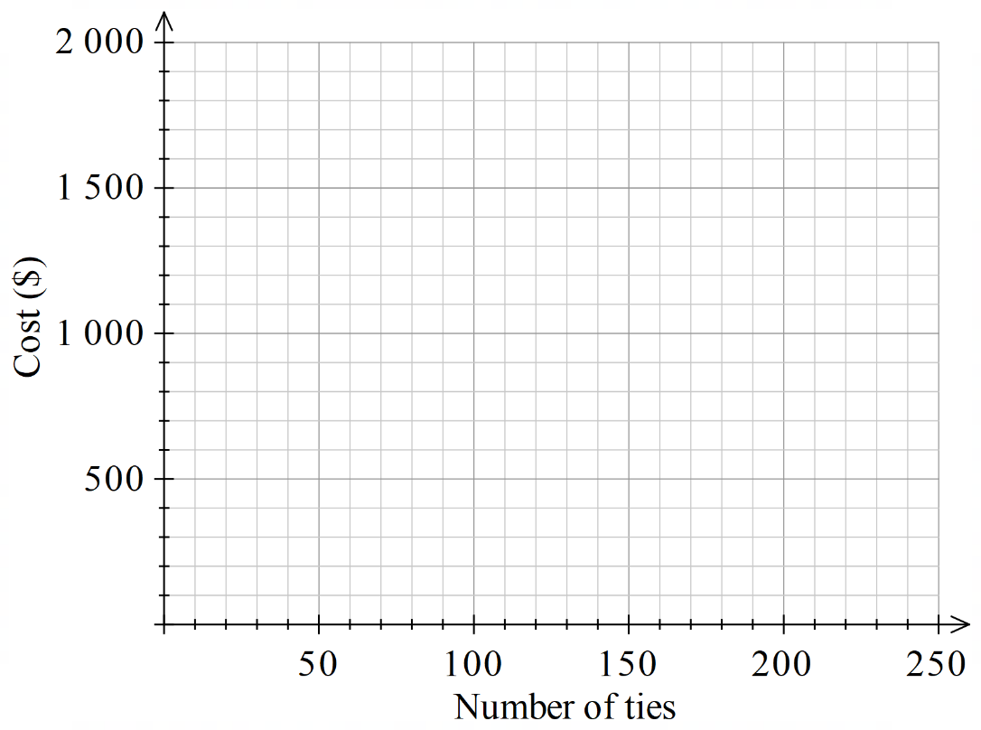
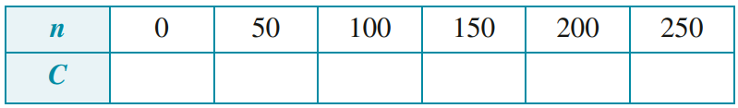

  - Use the graph to find the number of ties
produced when daily cost is $1400.

70 ties

- Tina travels 200 km to her friend’s home at an average speed of 80 km/h.
Tina’s distance from her friend’s home after travelling for $t$ hours can be modelled using the equation $D=200- 80t$.
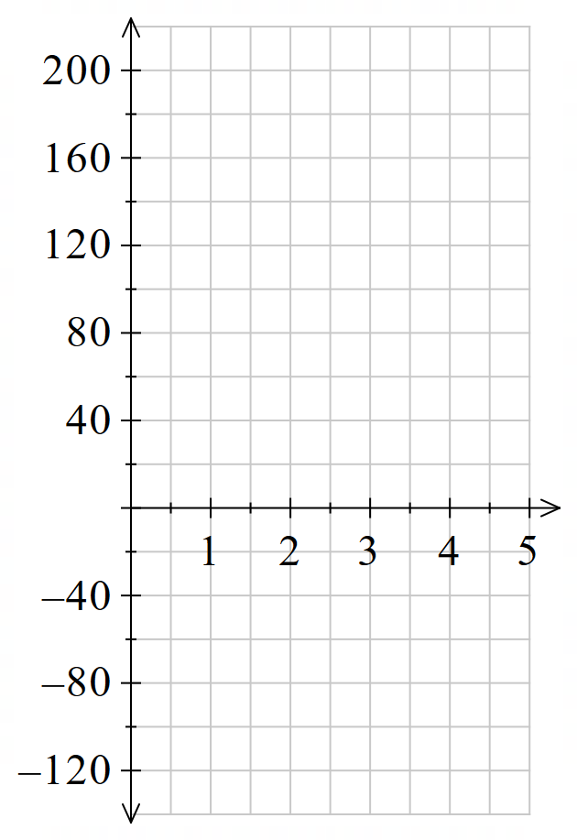
  - Draw the graph of $D=200- 80t$. Remember to label the axes.

  - Use the graph to find how far Tina is
from her friend’s home after 1.5 hours.

80 km
  - Use the graph to find how long it takes
for Tina to reach her friend’s home.

2.5 hours
  - What would be the value of $D$ after 4 hours?
Hence explain the limits of this model.

$-120$ km.
Distance won’t become negative, since Tina would stop at her friend’s house.
The model is only valid between at $0≤t≤2.5$.

Mastery
- The number of deer in a forest has decreased months according to the graph shown.
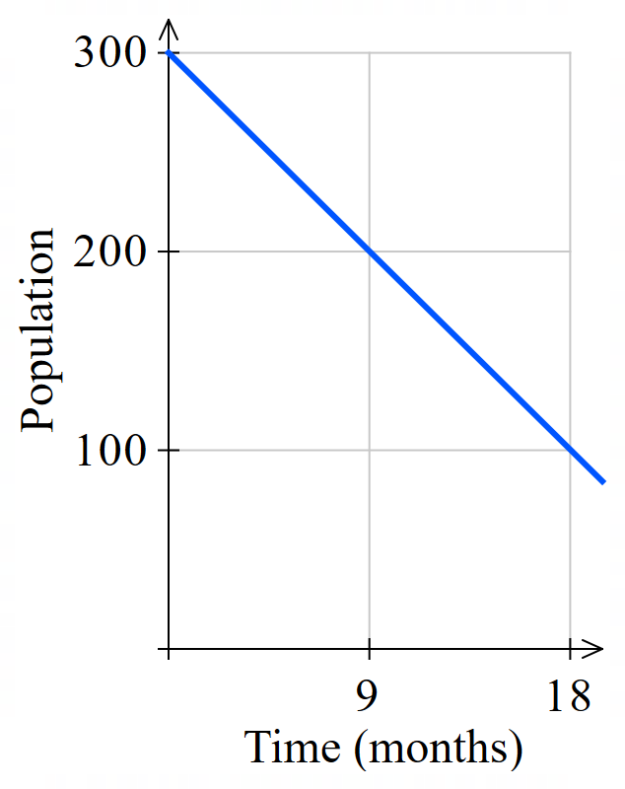
  - How many deer were there to begin with?

300
  - How many deer were there after 18 months?

100
  - How many deer disappeared during the 18-month period?

200
  - How many deer disappear each month?

$11$ $\frac{1}{11}$ deer per month
  - Write an equation relating number of deer $d$ and time $t$.

$$d=-11\frac{1}{11}t+300$$
  - Use your equation to estimate when the deer will be come extinct in this forest.

after a total of 27 months

- The number of people in a village has decreased over recent years according to the graph.
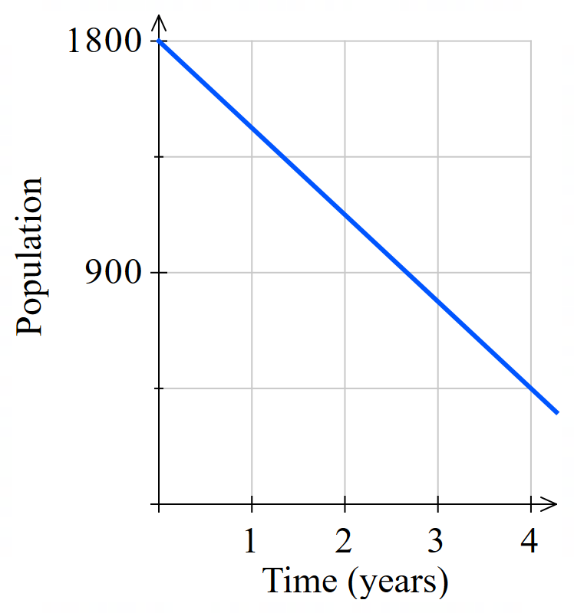
  - Write an equation relating number of people $p$ and time $t$.

$$p=-337.5t+1800$$
  - Use your equation to determine the number of people in the village after 2 years.

1125 people
  - Use your equation to determine when the population will first reach 180 people.

4.8 years
- 2016 HSC Standard 2 Band 5
The graph shows the life expectancy of people born between 1900 and 2000.
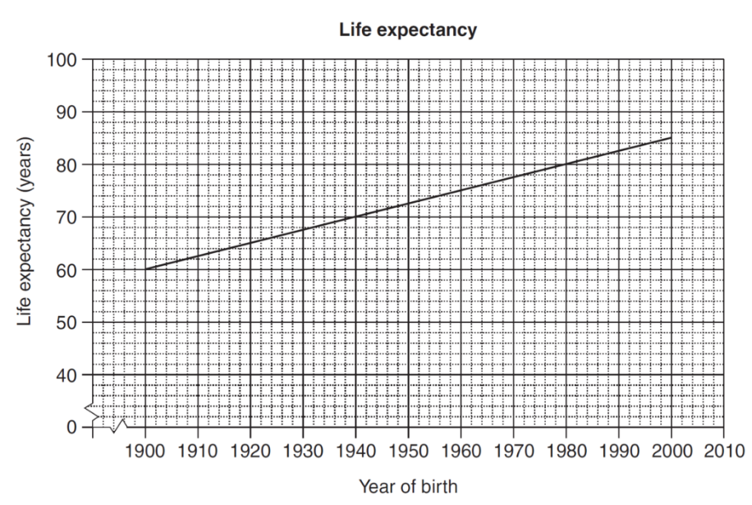

According to the graph, what is the life expectancy of a person born in 1932?
68 years
With reference to the value of the gradient, explain the meaning of the gradient in this context.

0.25 years increase in life expectancy per year
- This graph shoes the relationship between degrees Celsius and degrees Fahrenheit.
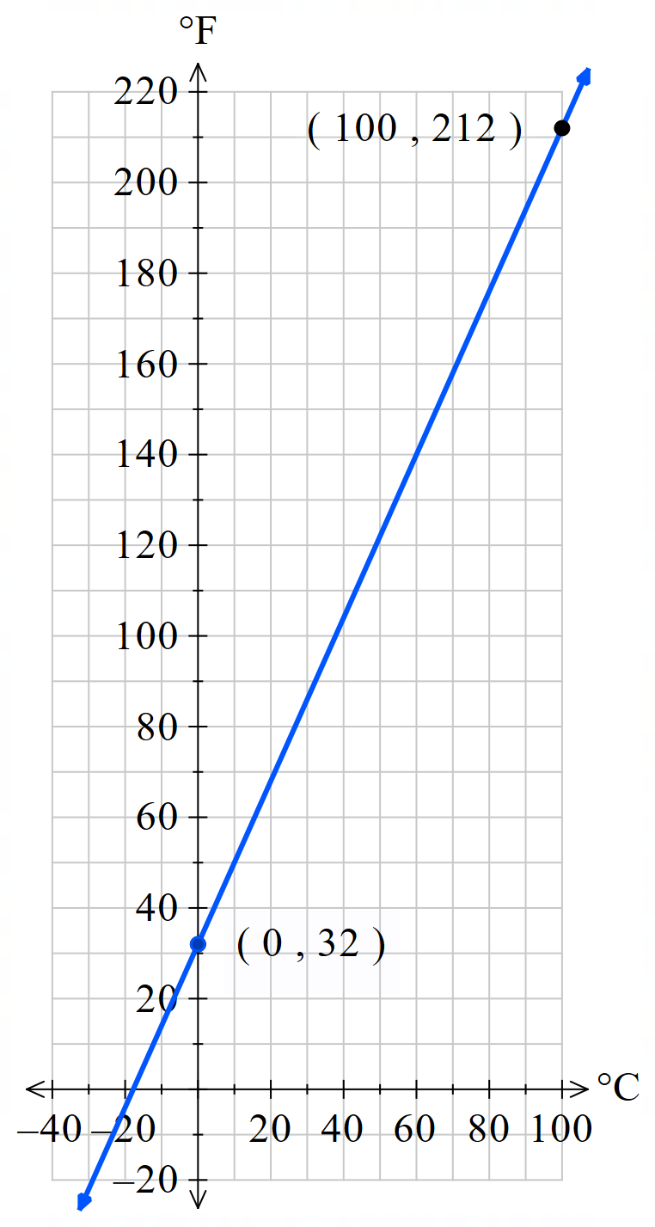
The freezing point of water is $0°C$ or $32°F$, while the boiling point is at $100°C$ or $212°F$.
  - What is the $y$-intercept of the line?

32
  - What is the gradient of the line?

1.8
  - Write an equation $y=mx+c$ to
relate Celsius and Fahrenheit.

$$F=1.8C+32$$
  - Use your equation to convert $48°C$ to Fahrenheit.
Does this match the graph?

107.8. Yes
  - Use your equation to convert $200°F$ to Celsius.
Does this match the graph?

93.33. Yes

Constructing Linear Models

- Linear Modelling
- Read the scenario in its entirety. Highlight the variables and the numbers.
- Identify the dependent variable $y$. It changes based on another variable.
- Identify the independent variable $x$. It causes the change.
- Determine the gradient $m.$ This is the rate given by the question. “$m$ per $x$”
- Determine the $y$-intercept $c$. This is the initial or fixed value given by the question.
Rate of change; $m$ per $x$
Initial or fixed value at $x=0$
Dependent variable
Independent variable
$$y=mx+c$$

- Example Construct a linear model from a given scenario
A muffin shop has fixed costs of $100 a day and a production cost of $1.50 per muffin.
Write an equation relating cost $C$ and number of muffins $n$.
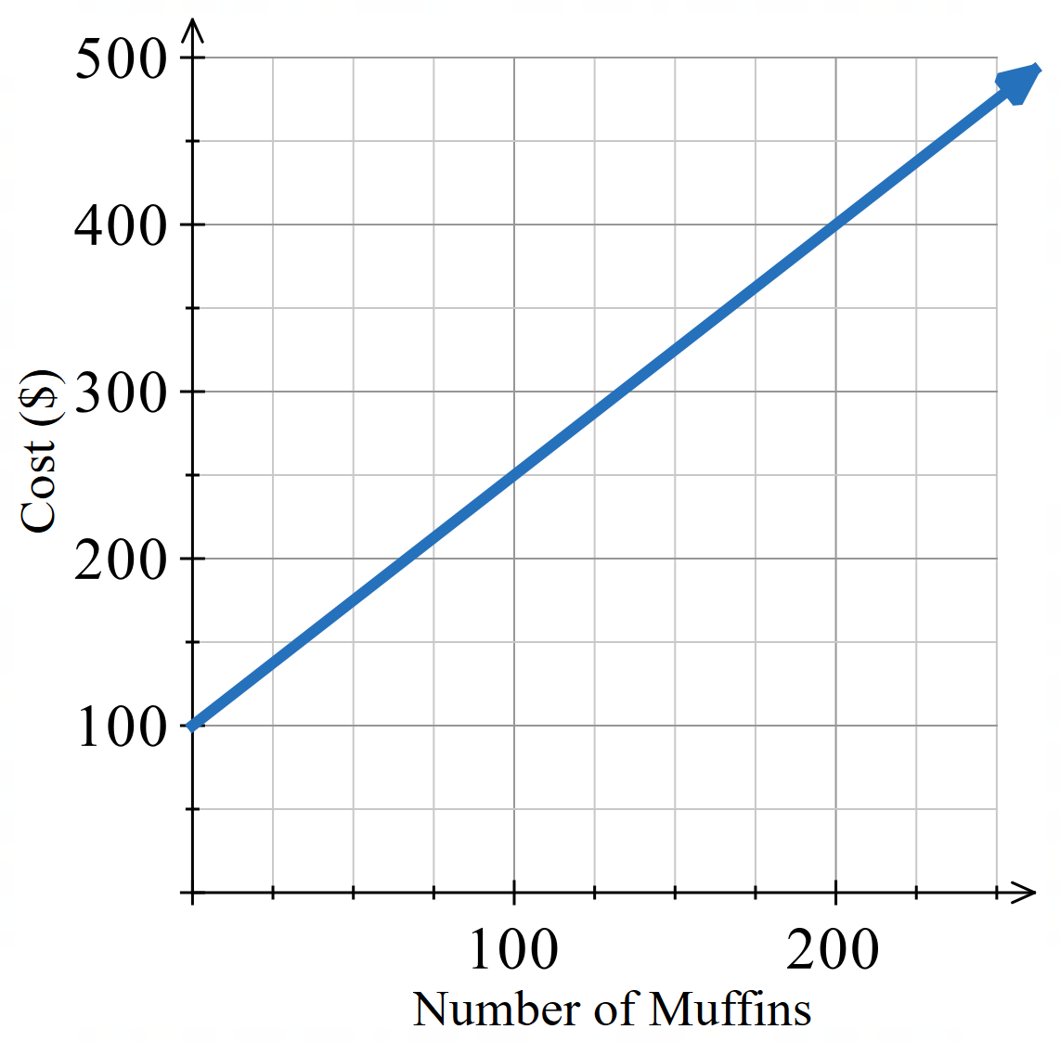
Dependent var: Cost $C$
Independent var: Number of muffins $n$
Variable cost $m=1.5$
Fixed cost $c=100$
$y=mx+c$
$C=1.5n+100$

Use your equation to determine the number of
Muffins that can be produced for $300.
$300=1.5n+100$
$200=1.5n$
$$\frac{200}{1.5}=n$$
$$133≈n$$

- Guided Practice
- Mr Ding has a soft toy factory that has a fixed cost of $500 a day and a production cost of $2 per soft toy.
Write an equation relating cost $C$ and number of soft toys $n$.
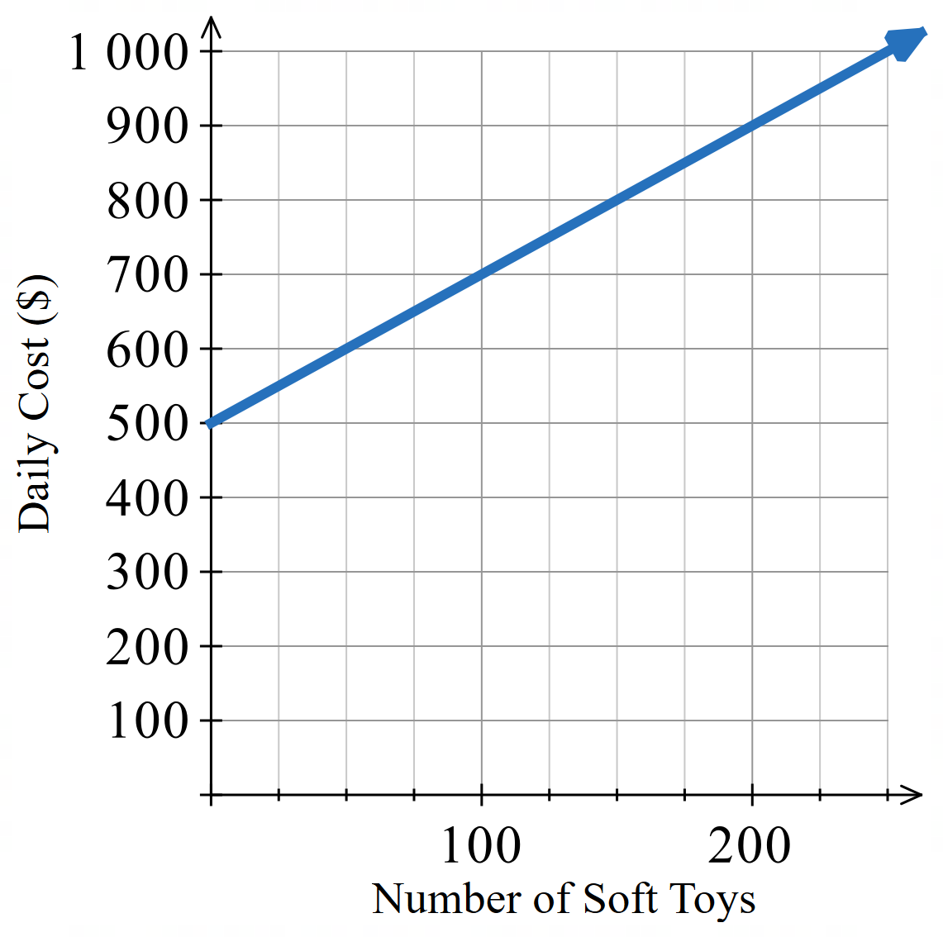

$$C=2x+500$$
Use your equation to determine how many soft
toys he can produce with a daily budget of $800.
How does this compare with the graph?

150
- Mr Ding is converting Australian Dollars ($AUD) to Japanese Yen (¥JPY)
$0 buys ¥0. For each $1, he can buy ¥110.
Write an equation relating Australian dollars $D$ and Japanese Yen $Y$.
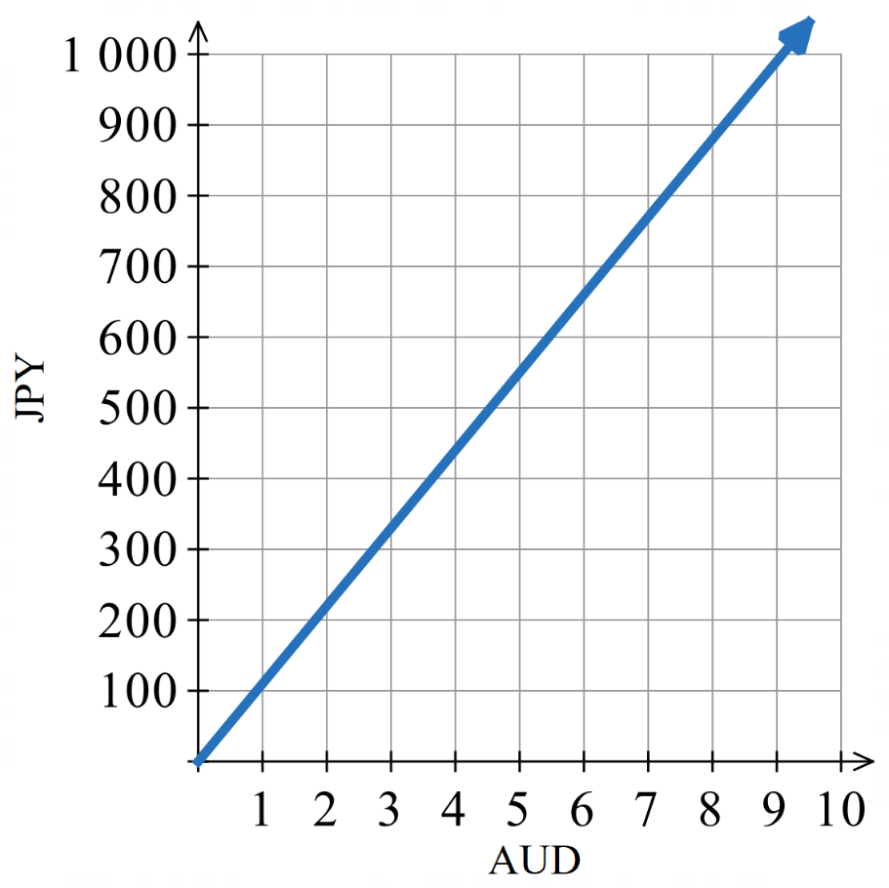

$$JPY=110 AUD$$
How much AUD can you buy with ¥800?

$$\$7.27$$
How much JPY can you buy with $9?

$$¥990$$

Foundation
- A sandwich shop has a monthly fixed expense of $2000 and the cost of making each sandwich is $1.20.
  - Write an equation modelling this information. Use $C$ for monthly cost in dollars and $n$ for the number of sandwiches made.
$$C = 1.2n + 2000$$
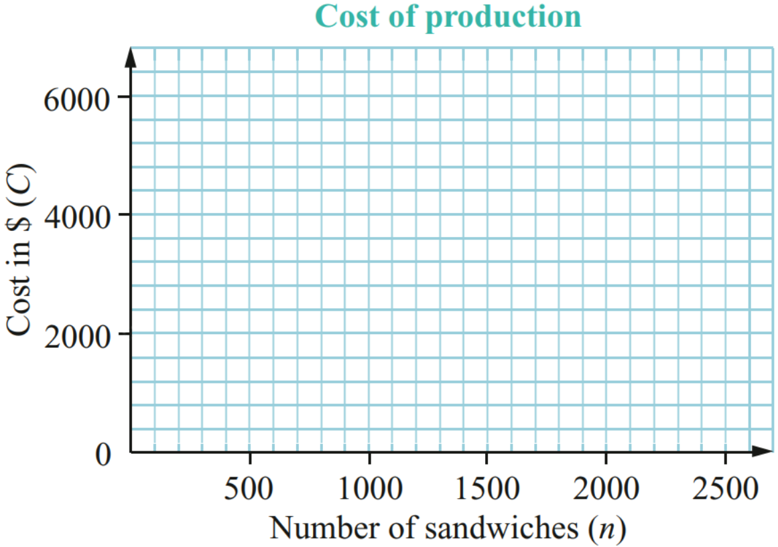
  - Draw the straight-line graph for this linear model.
$$n$$ | 0 | 500 | 1000 | 1500
$$c$$

  - Use the graph to find the number
of sandwiches made if the cost is $3500.

  - Use the equation to find the sandwiches
made if the cost is $3500. Which answer
is more accurate?

1250. The equation.
- The cost of hiring a taxi is $6 flagfall and $3.60 per kilometre travelled.
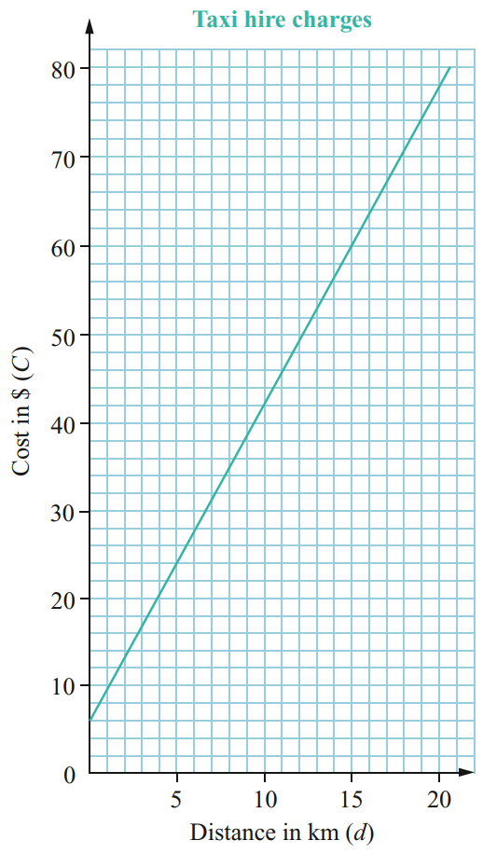
  - Write a linear equation to relate cost $C$
and distance $d$ travelled.

$C=3.6d+6$
  - Use the equation to determine how
far you could travel for $75.
How does this compare with the graph?

19.17 km
Matches the graph.

Development
- The weekly wage, $$w$, of a vacuum cleaner salesperson consists of a fixed sum of $350 plus $20 for each cleaner sold. If $n$ cleaners are sold per week,
  - Write an equation that describes the weekly wage of the salesperson.
$$w=20n+350$$
  - How much would the salesperson make if he sold 23 vacuums that week?
$810
  - How many cleaners would he have to sell to make at least $1215 in a week?

44 vacuums
- A telecommunications company’s rates for local calls from private telephones consist of a quarterly rental fee of $40 plus 25c for every call.
  - Write an equation that describes the quarterly rental fee.
$$C=40+0.25n$$
  - How many calls could you make for $90.50?

202
- Blake converted 100 Australian dollars (AUD) to 60 euros (EUR).
  - Draw a conversion graph with AUD on the $x$ axis and EUR on the $y$ axis.
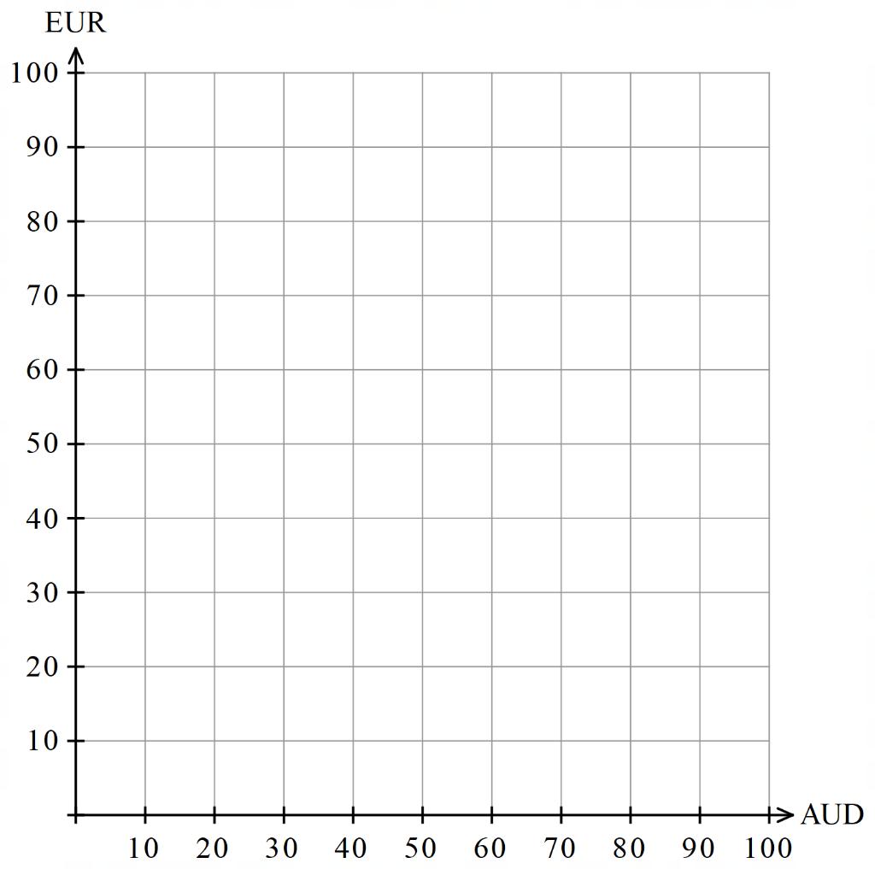
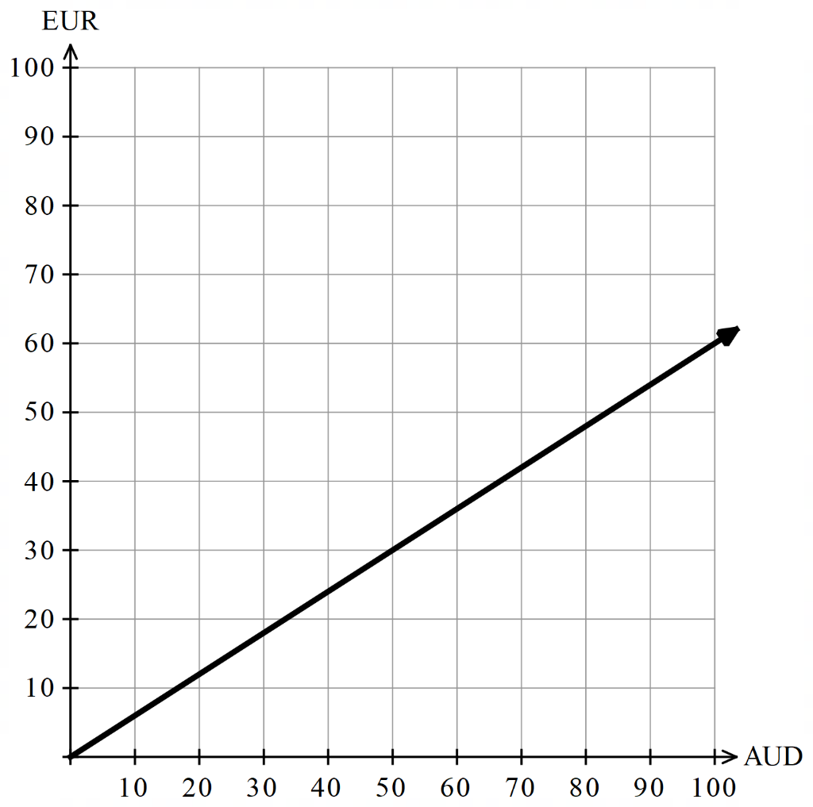
  - How many euros is 25 Australian dollars?
€15
  - How many Australian dollars is 45 euros?
$75
  - Determine the gradient. What is its meaning?

0.6, how much EUR for 1 AUD
  - Determine the $y$-intercept.
What is its meaning?

0. How much EUR for 0 AUD
  - Write an equation relating AUD to EUR.
EUR = 0.6 AUD
  - How much EUR can be purchased with $1855 AUD?

$1113

Mastery
- A petrol tank holds 66 litres of fuel. If it contains 12 litres of petrol initially and the petrol pump fills it at 3 litres every 10 seconds, find:
  - linear equation for the amount of fuel ($F$ litres) in the tank after $t$ minutes
$$F=12+18x$$
  - how long it will take to fill the tank.

$3$ minutes
  - how long it will take to put 45 litres into the petrol tank.

2 min 30 sec
- A tank is initially full with 4000 L of water and water is being used at a rate of 20 L per minute.
  - Write a rule for the volume, $V$ litres, of water after $t$ minutes.
$$V=4000-20x$$
  - Calculate the volume after 1.5 hours.

$$2200 L$$
  - How long will it take for the tank to be emptied?

$200$min
  - How long will it take for the tank to have only 500 L?

175 min

- The rule for distance travelled, $d$ km, over a given time, $t$ hours, for a moving vehicle is given by $d=50+80t$.
  - What is the speed of the vehicle?
80 km/h
  - If the speed was 70 km per hour, how would this change the rule? Give the new rule.
$$d=50+70t$$
- The altitude, $h$metres, of a helicopter $t$ seconds after it begins its descent is given by $h=350-20t$.
  - What is the helicopter’s initial height?
350 m
  - How is the helicopter’s height changing?
Decreasing by 20 m/s
  - If instead the rule was $h=350+20t$, describe what the helicopter would be doing.
Ascending by 20 m/s
- 2020 HSC Standard 2 Band 5
A plumber charges a call-out fee of $90 as well as $2 per minute while working.
Suppose the plumber works for $t$ hours.
What equation expresses the amount the plumber charges ($c) as a function of time ($t$ hours)?

$$C=90+120t$$
- HSC Standard 2 Sample Question Band 5
The average height, $h$, in centimetres, of a girl between the ages of 6 years and 11 years can be represented by a line with equation $C=6A+79$, where $A$ is age in years.
For this line, the gradient is 6.
What does this indicate about the heights of girls aged 6 to 11?

Increases by 6 cm per year.
Give ONE reason why this equation is not suitable for predicting heights of girls older than 12.

In teenage years, puberty changes the growth rate.

- 2007 HSC Standard 2 Band 5
A clubhouse uses four long-life light globes for five hours every night of the year.
The purchase price of each light globe is $6.00 and they each cost $$d$ per hour to run.
Write an equation for the total cost ($\$c$) of purchasing and running these four light globes for one year in terms of $d$.

$$C=4\left(6+1825d\right) or C=24+7300d$$
Find the value of $d$ (correct to three decimal places) if the total cost of running these four light globes for one year is $250.

$$d=\$0.031$$
If the use of the light globes increases to ten hours per night every night of the year, does the total cost double? Justify your answer with appropriate calculations.

No, as $C=4\left(6+3650d\right)$ is not double $C=4\left(6+1825d\right)$

Parallel and Perpendicular Gradients

- Parallel and Perpendicular Gradients
Parallel lines have the same gradient.
Perpendicular lines have gradients that multiply to $-1$.
Consider two lines $y=m_{1}x+c_{1}$ and $y=m_{2}x+c_{2}$.
Parallel Lines  $$m_{1}=m_{2}$$ | 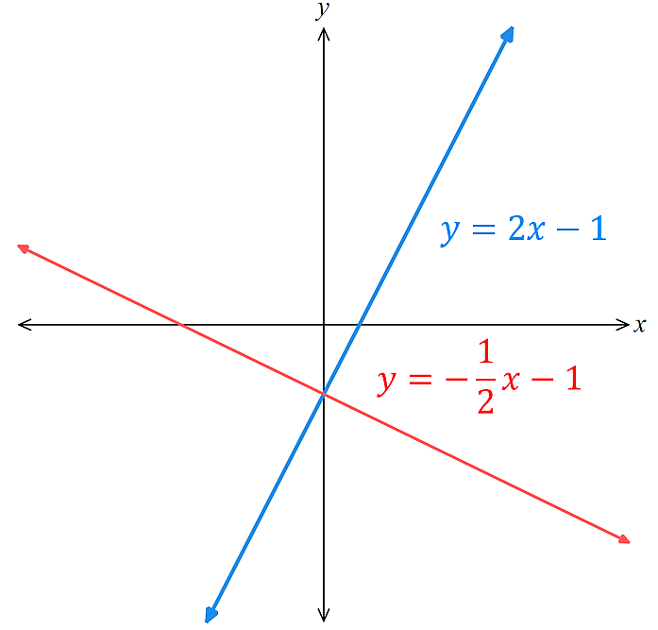  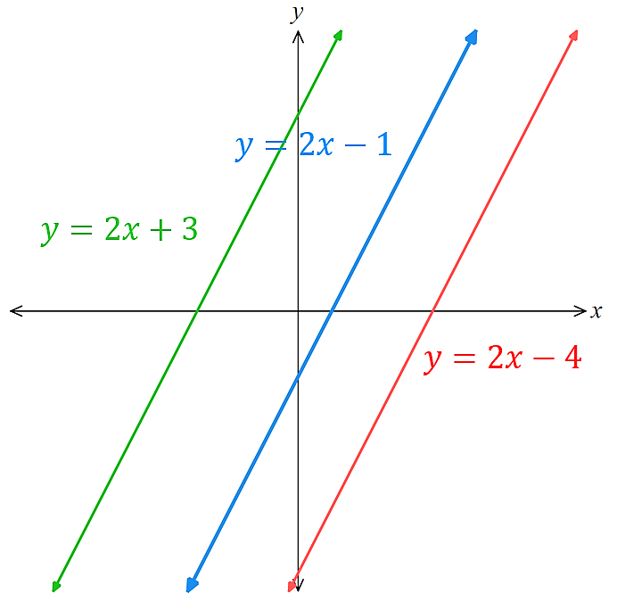  Perpendicular Lines  $$m_{1}×m_{2}=-1 \\ m_{1}=-\frac{1}{m_{2}}$$

- Identify whether two lines are parallel, perpendicular, or neither
$y=3x-1$ $m_{1}=3$  $y=3x+4$ $m_{2}=3$  Parallel | $y=4x-2$ $m_{1}=4$  $y=-\frac{1}{4}x+3$ $m_{2}=-\frac{1}{4}$  Perpendicular | $y=2x+1$ $m_{1}=2$  $y=-2x-5$ $m_{2}=-2$  Neither
Decide whether these lines are parallel, perpendicular, or neither.
- $y=-\frac{1}{5}x+1$  $$y=5x+2$$ | - $y=2x+1$  $$y=2x-100$$ | - $y=7x-2$  $$y=-7x+2$$
- $y=10-2x$  $$y=10+2x$$ | - $y=$ $\frac{3}{4}$ $x$  $$y=-\frac{4}{3}x$$ | - $y=3$  $$x=3$$

- Key Ideas
- ……………… lines have the same gradient i.e., $m_{1}=m_{2}$
- Perpendicular lines have gradients that are the n………………… r…………………… of each other, i.e. $m_{2}=-\frac{1}{m_{1}}$

Foundation
- Find the gradient the lines that are parallel to each line.
- $y=4x+6$  $m_{par}=4$ | - $y=-7x-1$  $$-7$$ | - $y=-\frac{3}{4}x+2$  $$-\frac{3}{4}$$ | - $y=\frac{8x}{7}-\frac{1}{2}$  $$\frac{8}{7}$$
- Find the gradient the lines that are perpendicular to each line.
- $y=3x-1$  $m_{perp}=-$ $\frac{1}{3}$ | - $y=-2x+6$  $$\frac{1}{2}$$ | - $y=\frac{7}{8}x-\frac{2}{3}$  $$-\frac{8}{7}$$ | - $y=\frac{-4x}{9}-\frac{4}{7}$  $$\frac{9}{4}$$

- Decide if these gradients would make the lines parallel, perpendicular, or neither.
 | Gradient Line 1 | Gradient Line 2 | Parallel / Perpendicular / Neither? |  | Gradient Line 1 | Gradient Line 2 | Parallel / Perpendicular / Neither?
 | $$5$$ | $$6$$ | Neither |  | $$-\frac{5}{8}$$ | $$-5.8$$ | Neither
 | $$5$$ | $$5$$ | Parallel |  | $$-\frac{5}{8}$$ | $$5.8$$ | Neither
 | $$5$$ | $$-5$$ | Neither |  | $$-\frac{5}{8}$$ | $$\frac{5}{8}$$ | Neither
 | $$5$$ | $$-\frac{1}{5}$$ | Perpendicular |  | $$-\frac{5}{8}$$ | $$-\frac{5}{8}$$ | Parallel
 | $$5$$ | $$\frac{1}{5}$$ | Neither |  | $$-\frac{5}{8}$$ | $$-\frac{8}{5}$$ | Neither
 | $$0.5$$ | $$\frac{1}{5}$$ | Neither |  | $$-\frac{5}{8}$$ | $$\frac{8}{5}$$ | Perpendicular
 | $$0.2$$ | $$\frac{1}{5}$$ | Parallel |  | $$-\frac{5}{8}$$ | $$1.6$$ | Perpendicular
 | $$-0.2$$ | $$\frac{1}{5}$$ | Neither |  | $$-\frac{5}{8}$$ | $$-0.625$$ | Parallel
 | $$-5$$ | $$\frac{1}{5}$$ | Perpendicular |  | $$1$$ | $$-1$$ | Perpendicular
 | $$5$$ | $$\frac{1}{5}$$ | Neither |  | $$1$$ | $$0$$ | Neither

Development
- Decide if these pairs of lines are parallel, perpendicular, or neither.
- $y=3x-1$  $y=3x+7$  parallel | - $y=\frac{1}{2}x-6$  $y=\frac{x}{2}-4$  parallel | - $y=-\frac{2}{3}x+1$  $y=\frac{2}{3}x-3$  neither
- $y=-8x+4$  $y=\frac{1}{8}x-2$  perpendicular | - $x-y=4$  $y=-x+\frac{1}{2}$  perpendicular | - $3x-y=2$  $x+3y=5$  perpendicular

- Show that $y=5x-7$ is perpendicular to $5y=10-x$
Line 1: $y=5x-7$
Line 2: $5y=10-x$
$$y=2-\frac{x}{5}$$
Gradients are $5$and $-\frac{1}{5}$, which have a product of $-1$
- Beca says that $y=8x+\sqrt{25}$ and $y=5+8x$ are parallel. Marta says they are not.
Who do you agree with? Explain your answer.

Yes. Both have gradient of 8
- Write an equation of a line that is parallel to $y=$ $\frac{5x+9}{4}$.

Any line with gradient $\frac{5}{4}$
- By finding the product of the gradients, show that each pair of lines are perpendicular.
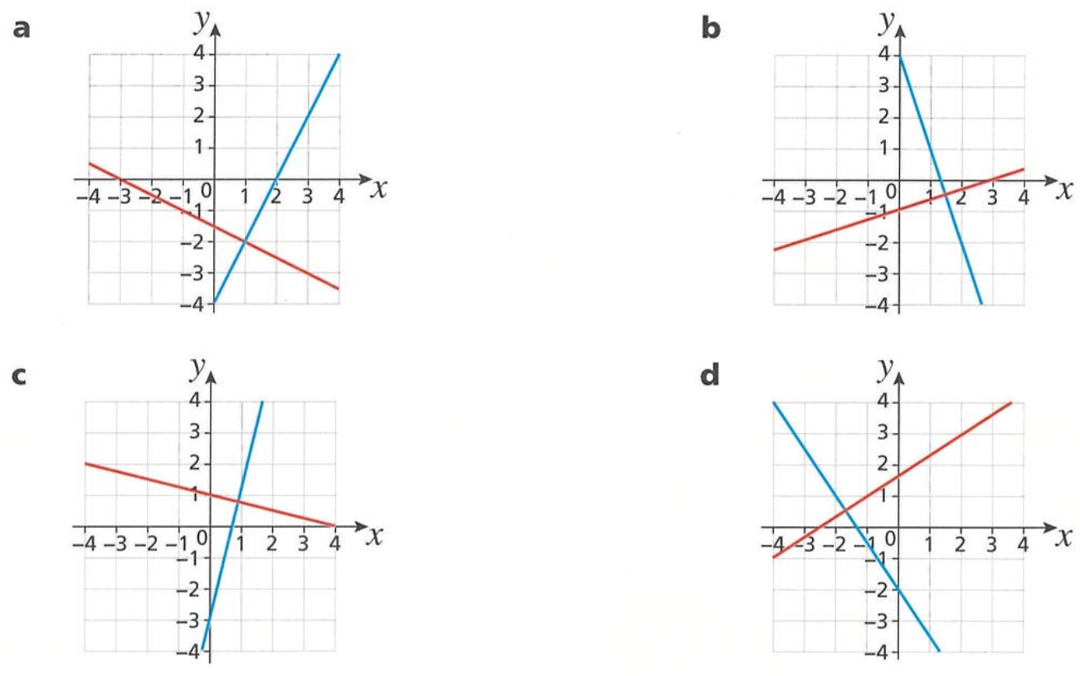  $$m_{blue}=2$$  $$m_{red}=-\frac{1}{2}$$  $$m_{blue}×m_{red}=-1$$ | $$m_{blue}=-3$$  $$m_{red}=\frac{1}{3}$$  $$m_{blue}×m_{red}=-1$$
$$m_{blue}=4$$  $$m_{red}=-\frac{1}{4}$$  $$m_{blue}×m_{red}=-1$$ | $$m_{blue}=-\frac{3}{2}$$  $$m_{red}=\frac{2}{3}$$  $$m_{blue}×m_{red}=-1$$

Finding Parallel and Perpendicular Lines

- Finding the Equation of a Parallel Line
- $m_{orig}$ Identify gradient of original line.
- $m_{par}$ Use this same gradient for the parallel line.
- $c_{par}$ Identify the $y$-intercept of the parallel line (given in the question).
- Write the equation $y=m_{par}x+c_{par}$

- Example Find the equation of a line that is parallel to another
Find the equation of a line that is parallel to $y=3x-1$ and passes through $(0,4)$  1. $m_{orig}=3$  2. $m_{par}=3$  3. $c_{par}=4$  4. $y=3x+4$ | The gradient of $y=3x-1$ is $3$ because the gradient is the ……………… of $x$.  $m_{par}=3$because parallel lines have ……………… gradients.  $c_{par}=4$ because (0,4) was …………… by the question  The $y$-intercept of the original line was $-1$, but this is irrelevant because only the ……………… must match.

- Guided Practice
Find the equation of the line that is parallel to:
- $y=2x+3$ passing through $(0,1)$  1. $m_{orig}=$ …………  2. $m_{par}=$ …………  3. $c_{par}=$ …………  4. $y=$ … $x$ $+$ …  $$y=2x+1$$ | - $y=-x+2$ passing through $(0,5)$  1.  2.  3.  4.  $$y=-x+5$$
- $y=\frac{2x}{3}-4$ passing through $(0,-5)$  $$y=\frac{2x}{3}-5$$ | - $y=-\frac{5}{3}x+7$ passing through $(0,-1.5)$  $$y=-\frac{5}{3}x-1.5$$
- Finding the Equation of a Perpendicular Line
- $m_{orig}$ Identify gradient of original line.
- $m_{perp}$ Find the perpendicular gradient. It is the negative reciprocal of the original.
- $c_{perp}$ Identify the $y$-intercept of the parallel line (given in the question).
- Write the equation $y=m_{perp}x+c_{perp}$

- Example Find the equation of a line that is perpendicular to another
Find the equation of a line that is perpendicular to $y=2x-3$ and passes through $(0,-1)$  1. $m_{orig}=2$  2. $m_{perp}=-\frac{1}{2}$  3. $c_{perp}=-1$  4. $y=$ $-$ $\frac{1}{2}$ $x-1$ | $m_{perp}=-\frac{1}{2}$because the perpendicular gradient is the ………………… ……………… of the original.  $c_{perp}=-1$ because $(0,-1)$ was …………… by the question  The $y$-intercept of the original line was $-3$, but this is irrelevant because only the ……………… matters.

- Guided Practice
Find the equation of the line that is perpendicular to:
- $y=3x-2$ passing through $(0,5)$  1. $m_{orig}=$ …………  2. $m_{perp}=$ …………  3. $c_{perp}=$ …………  4. $y=$ … $x$ $+$ …  $$y=-\frac{x}{3}+5$$ | - $y=-2x+3$ passing through $(0,-4)$  $$y=\frac{x}{2}-4$$
- $y=\frac{3x}{2}+9$ passing through $(0,11)$  $$y=-\frac{2}{3}x+11$$ | - $y=x+1$ passing through $(0,2.8)$  $$y=-x+2.8$$

Foundation
- Write down the equation of the line that:
  - passes through (0, 2) and is parallel to another line with gradient 4.
$m_{par}=4, c_{par}=2$ $y=$ …… $x$ $+$ ………
$$y = 4x + 2$$
  - passes through (0, 4) and is parallel to another line with gradient 2.
$$y = 2x + 4$$
  - passes through (0, −3) and is parallel to another line with gradient −1.
$$y = -x - 3$$
  - passes through (0, 3) and is perpendicular to another line with gradient 2.
$$y = -\frac{1}{2}x + 3$$
  - passes through (0, −5) and is perpendicular to another line with gradient 3.
$$y = -\frac{1}{3}x - 5$$
  - passes through (0, −10) and is perpendicular to another line with gradient $\frac{1}{2}$.
$$y = -2x - 10$$
  - passes through (0, 6) and is perpendicular to another line with gradient $\frac{1}{6}$.
$$y = -6x + 6$$
  - passes through (0, −7) and is perpendicular to another line with gradient $-\frac{1}{4}$.
$$y = 3x - 7$$
- A straight line is parallel to $y=10x+14$ and intersects the y-axis at $(0,-21)$.
Write the equation of the line.

$$y = 10x - 21$$
- Find the equation of the line that is perpendicular to $y=8x+9$ and passes through $(0,-1)$

$$y = -\frac{1}{8}x - 1$$
- Find the equation of the line that is perpendicular to $y=5-\frac{1}{4}x$ and passes through $(0, 28)$

$$y = 4x + 28$$

Development
- Find the equation of the line parallel and perpendicular to each of the following that passes through the given point.
- $y=3x-2$ $\left(0, 3\right)$  Parallel:  $$y = 3x + 3$$  Perpendicular:  $$y = -\frac{x}{3} + 3$$ | - $y=5x-4$ $\left(0, 7\right)$  Parallel:  $$y = 5x + 7$$  Perpendicular:  $$y = -\frac{x}{5} + 7$$ | - $y=-2x+3$ $\left(0,-4\right)$  Parallel:  $$y = -2x - 4$$  Perpendicular:  $$y =\frac{x}{2} - 4$$
- $y=-7x+2$ $\left(0,-\frac{1}{2}\right)$  Parallel:  $$y = -7x -\frac{1}{2}$$  Perpendicular:  $$y =\frac{x}{7} -\frac{1}{2}$$ | - $y=$ $\frac{3x}{2}$ $-5$ $\left(0,-5\right)$  Parallel:  $$y =\frac{3x}{2} - 5$$  Perpendicular:  $$y = -\frac{2x}{3} - 5$$ | - $y=10-$ $\frac{7}{8}$ $x$ $\left(0, 2\right)$  Parallel:  $$y = -\frac{7x}{8} + 2$$  Perpendicular:  $$y =\frac{8x}{7} + 2$$
- $8-x=y$ $\left(0, 5\right)$  Parallel:  $$y = -x + 5$$  Perpendicular:  $$y = x + 5$$ | - $y=$ $\frac{7x}{2}$ $+2$ $\left(0,-1.5\right)$  Parallel:  $$y =\frac{7x}{2} - 1.5$$  Perpendicular:  $$y = -\frac{2x}{7} - 1.5$$ | - $y=-$ $\frac{x}{19}$ $\left(0, 5\right)$  Parallel:  $$y = -\frac{x}{19} + 5$$  Perpendicular:  $$y = 19x + 5$$
- Write the equation of the line:
- parallel to $y=4$ passing through $\left(0,1\right)$  $$y=1$$ | - parallel to $y=4$ through $\left(-3,-2\right)$  $$y=-2$$
- parallel to $x=-2$ through $\left(3,0\right)$  $$x=3$$ | - parallel to $x=-2$ through $\left(-3,-5\right)$  $$x=-3$$
- perpendicular to $y=-2$ through $\left(2,0\right)$  $$x=2$$ | - perpendicular to $y=-2$ through $\left(0,0\right)$  $$x=0$$
- perpendicular to $x=6$ through $\left(0,7\right)$  $$y=7$$ | - perpendicular to $x=6$ through $\left(0,-\frac{1}{2}\right)$  $$y=-\frac{1}{2}$$
- parallel to $y$-axis through $(-1,4)$  $$x=-1$$ | - parallel to $x$-axis through $(0,-2)$  $$y=-2$$
- perpendicular to $y$-axis through $(5,-3)$  $$y=-3$$ | - perpendicular to $x$-axis through $(3, 21)$  $$x=3$$

Mastery
- Write an equation of a line.
  - perpendicular to $y=0.75x+5$
$y=-$ $\frac{4}{3}$ $x+c$, where $c$ can be any number
  - perpendicular to $y=0.75x+5$ that passes through $(0,18)$
$$y=-\frac{4}{3}x+18$$
  - Explain why there are infinitely many answers to part a, but only one answer to part b.

Part a has no specific point, so any $y$-intercept $c$ gives a perpendicular line.
Part b requires passing through a specific point, which determines c uniquely.
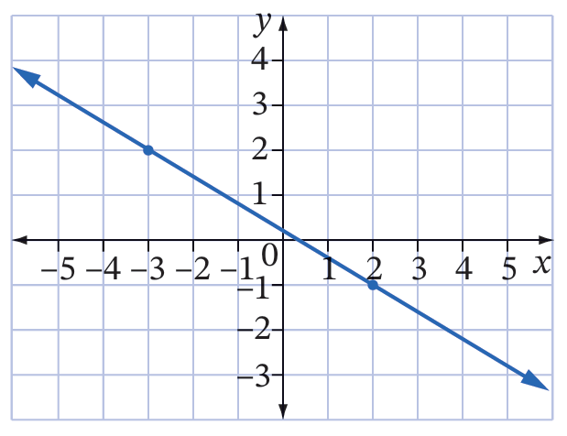
- What is the equation of the line perpendicular to the line shown and passes through $\left(0,-3\right)$?

$$y=\frac{5}{3}x-3$$
- Find an equation for a line that is perpendicular to each of these lines,
passing through the same $y$-intercept.
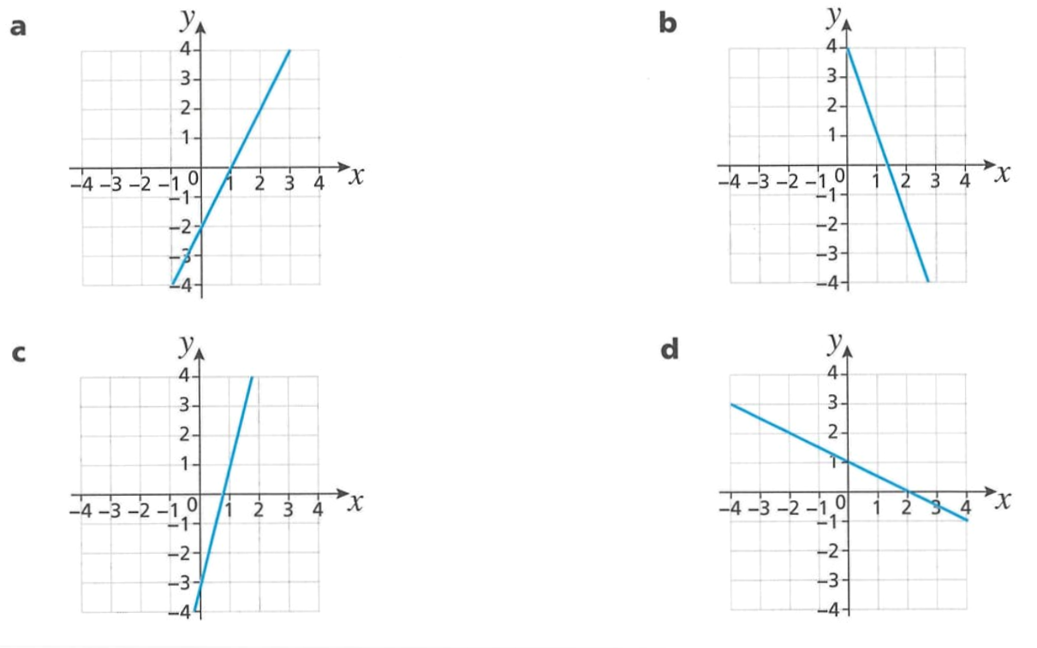  $$y=-\frac{x}{2}-2$$ | $$y=\frac{x}{3}+4$$
$$y=-\frac{x}{4}-3$$ | $$y=2x+1$$

